**Home Page**

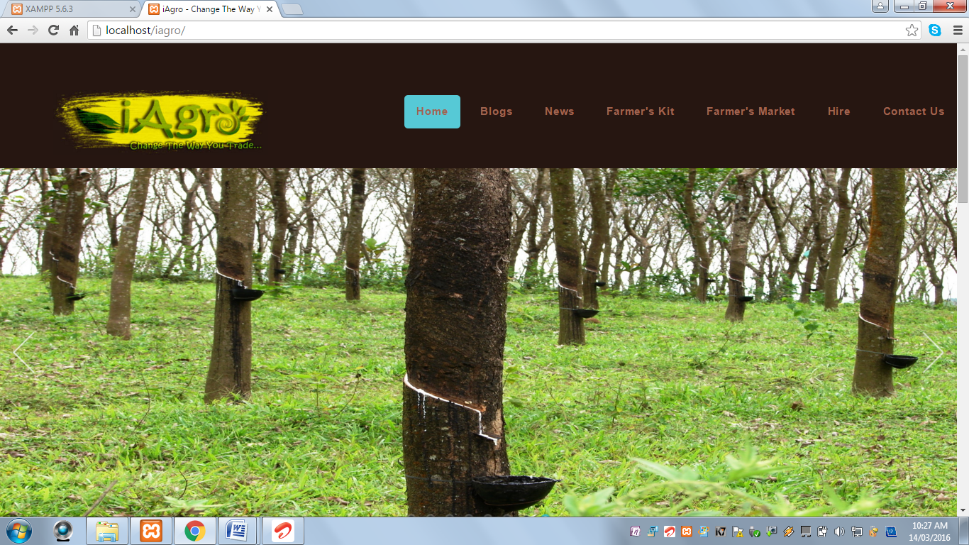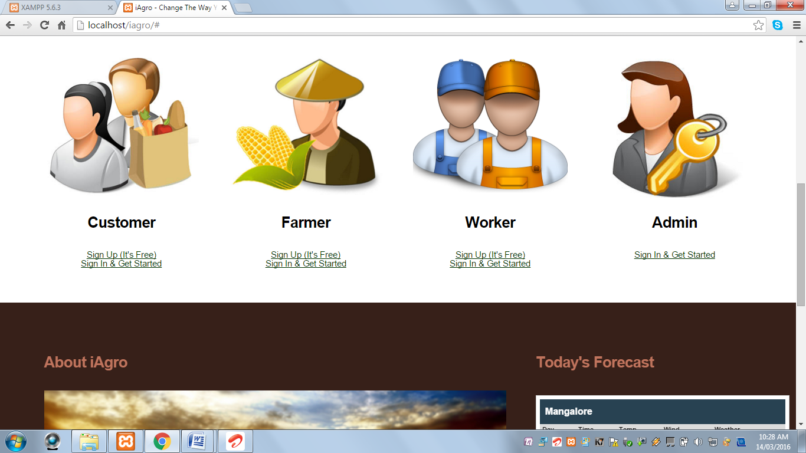

* This page displays information about “iAgro”.
* It displays the current weather forecast.
* It contains different login options.

**Blogs Page**

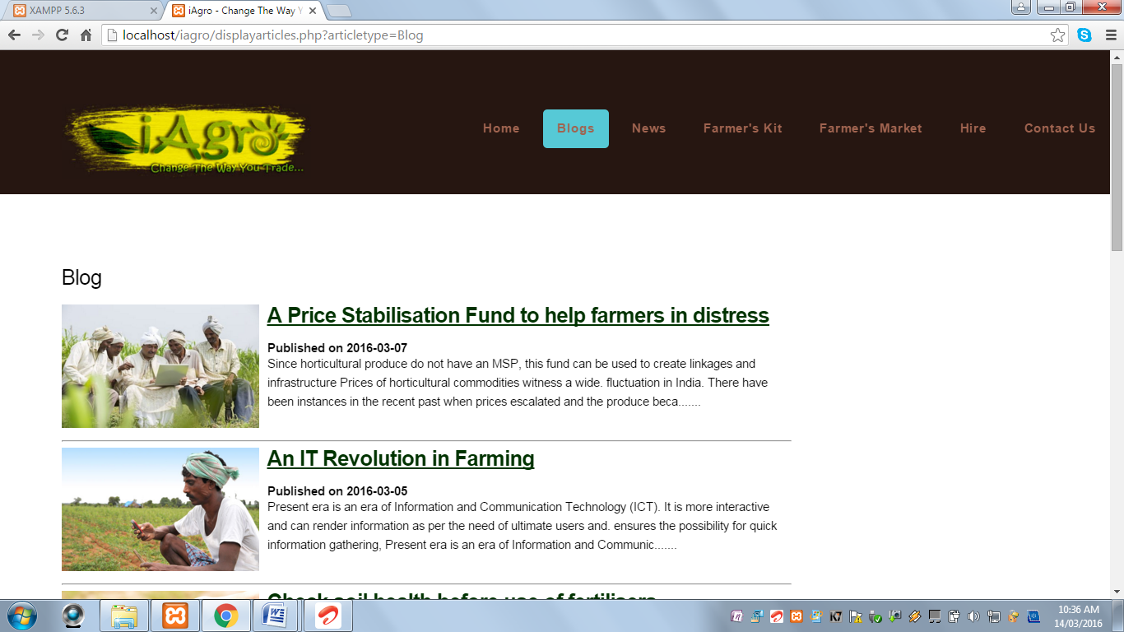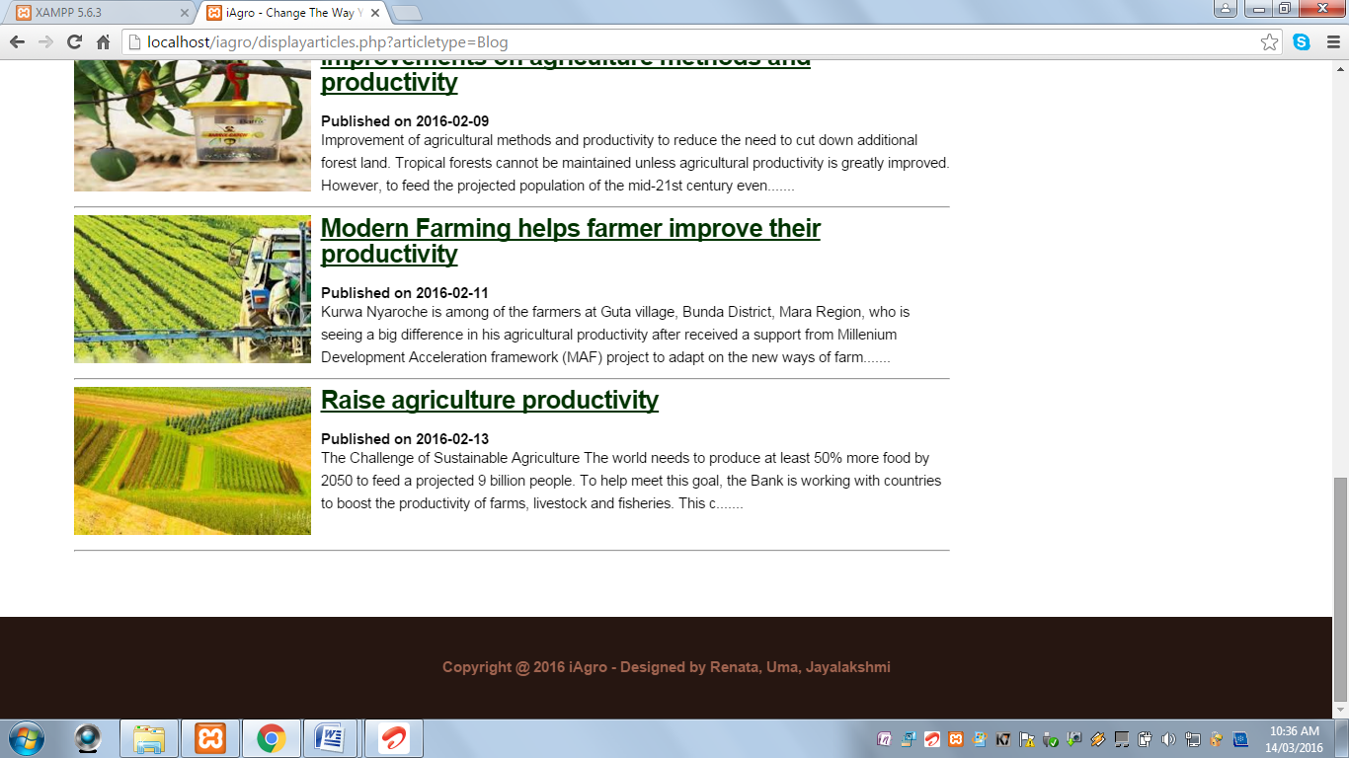

* This page displays blogs based on agriculture.

**News**

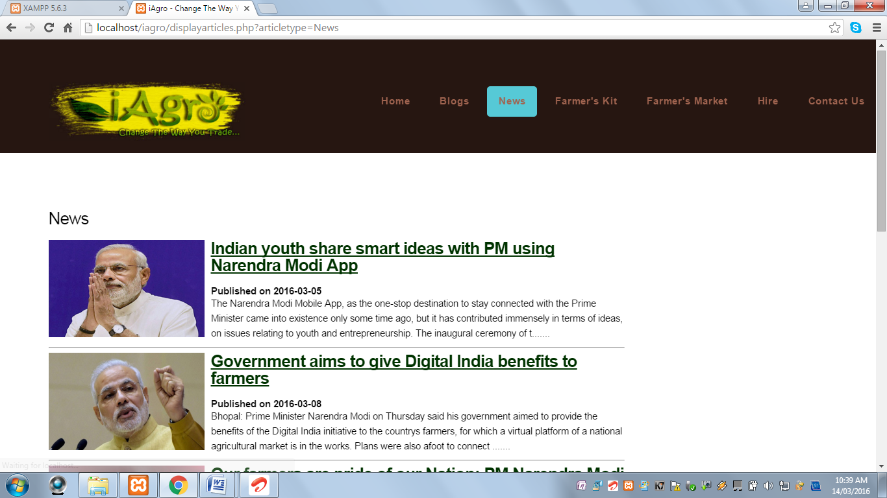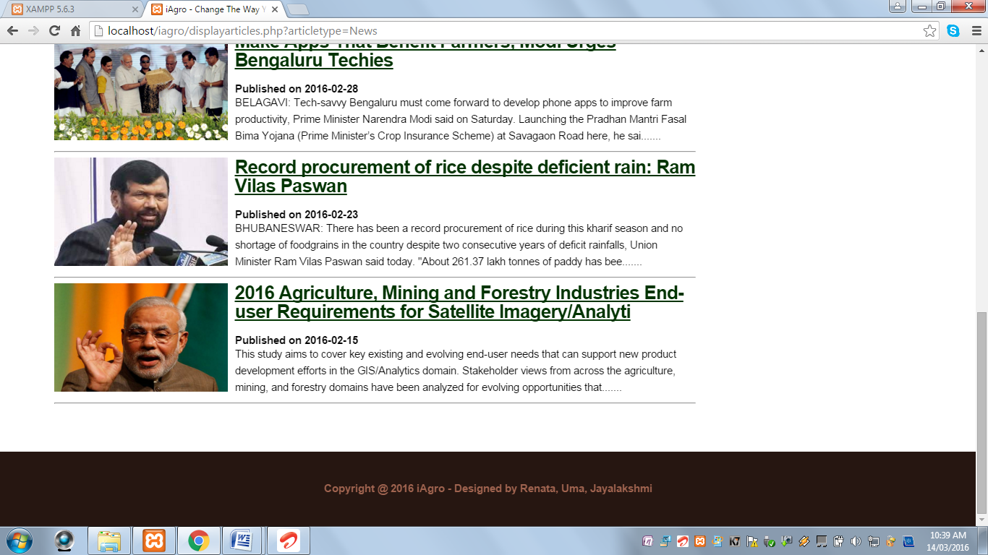

* This Page displays latest news on agriculture.

**Farmer’s Kit**

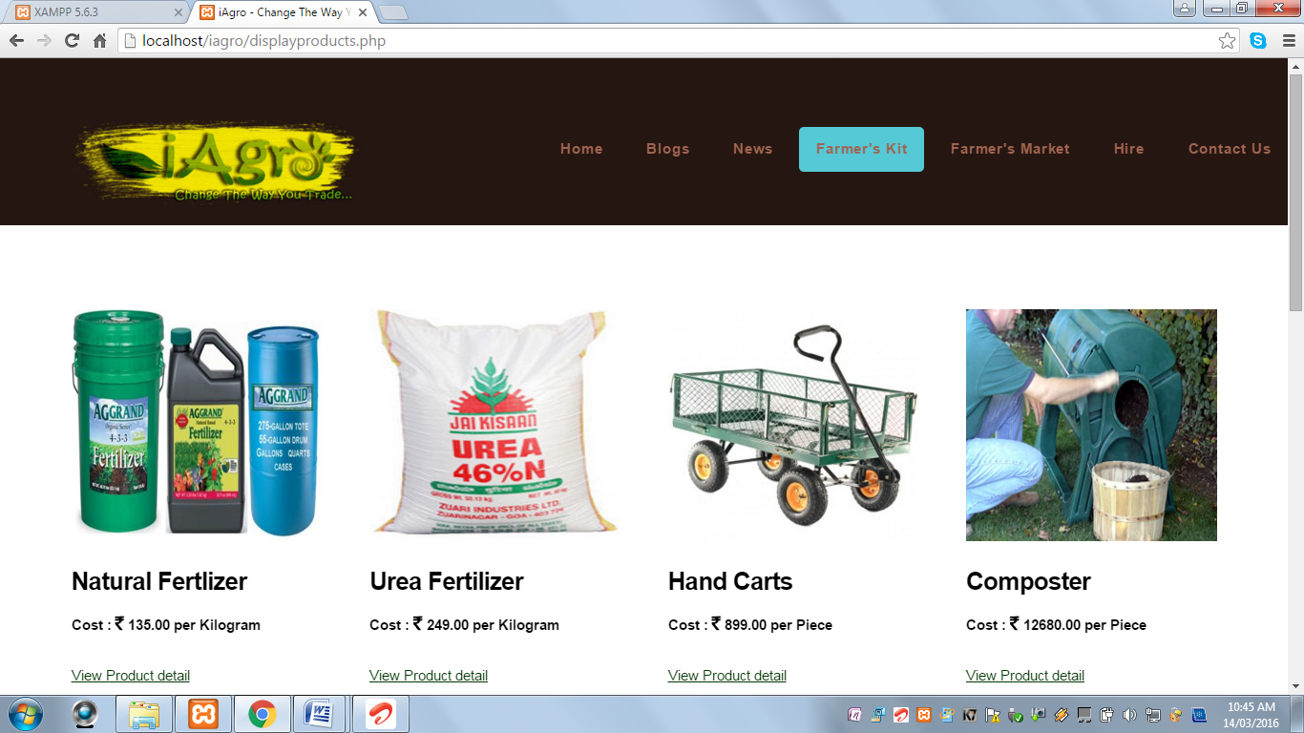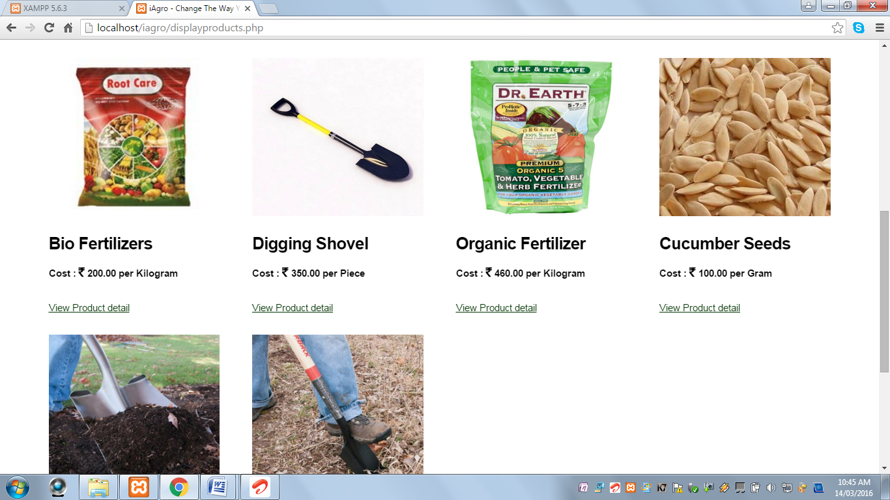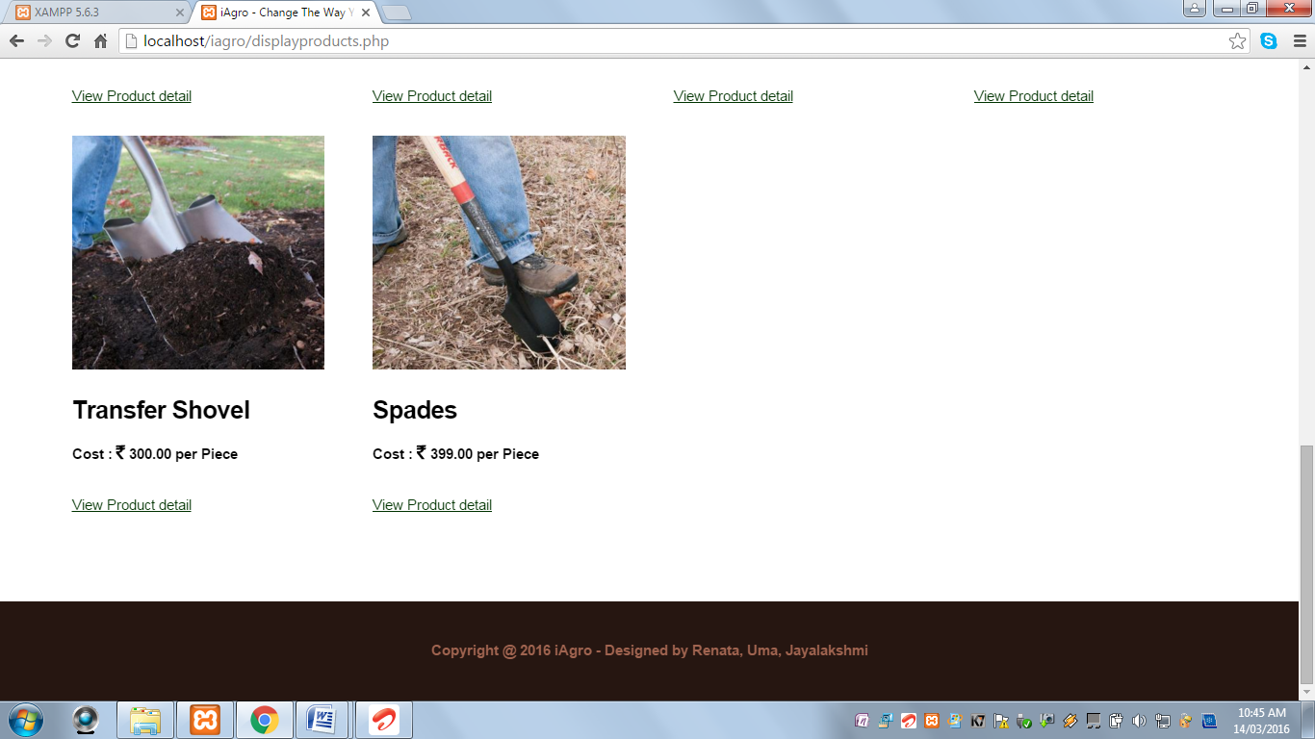

* This page displays online shop for farming fertilizers, tools and equipments.

**Farmer’s Market**

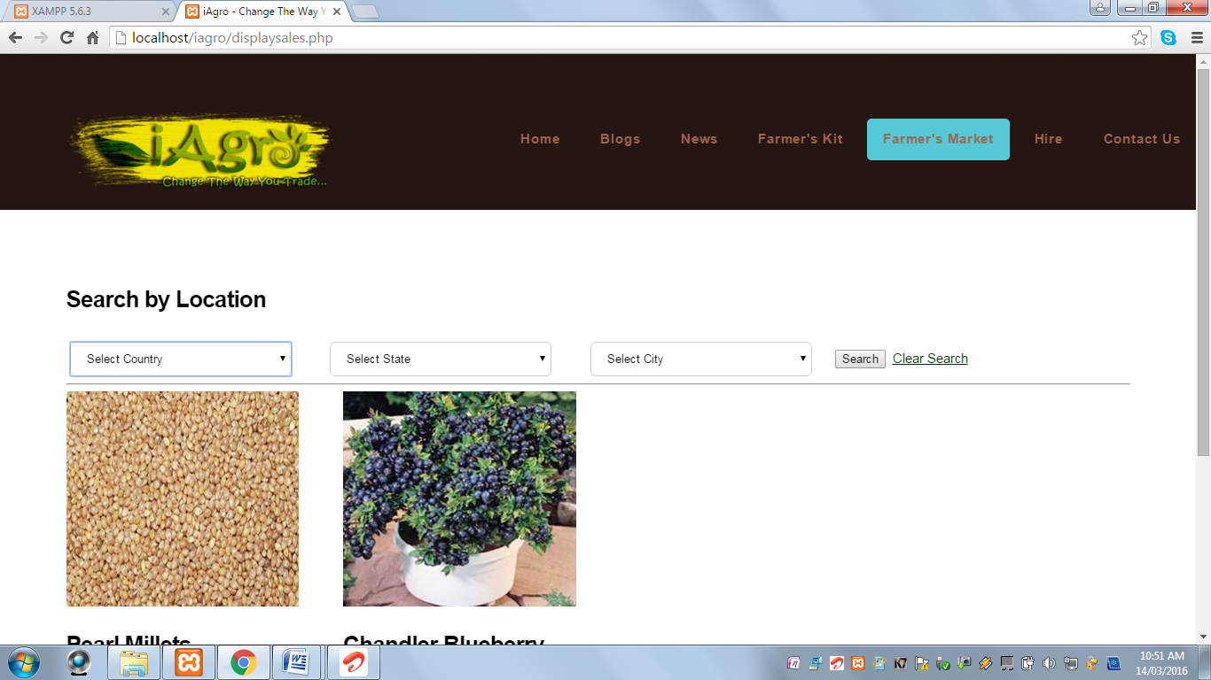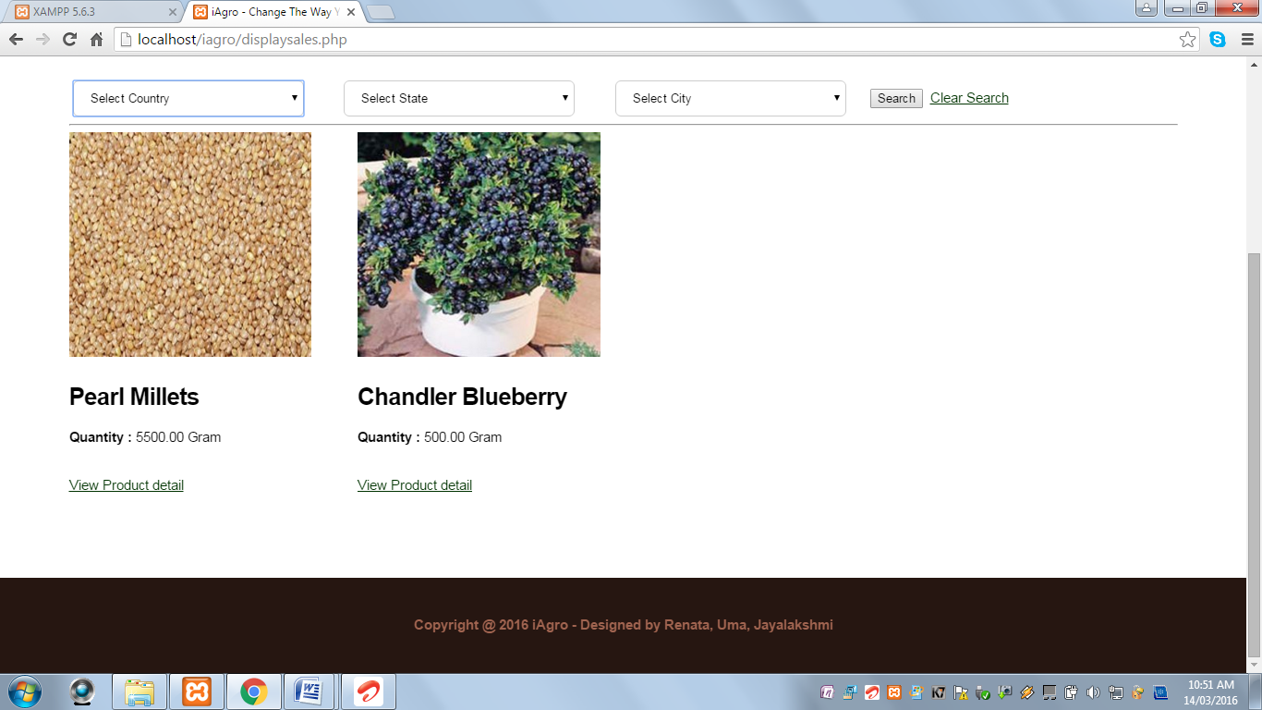

* This page displays online shop for farm produces uploaded by farmers.
* It also contains location search to display farm produce of farmers of the given location.

**Hire Page**

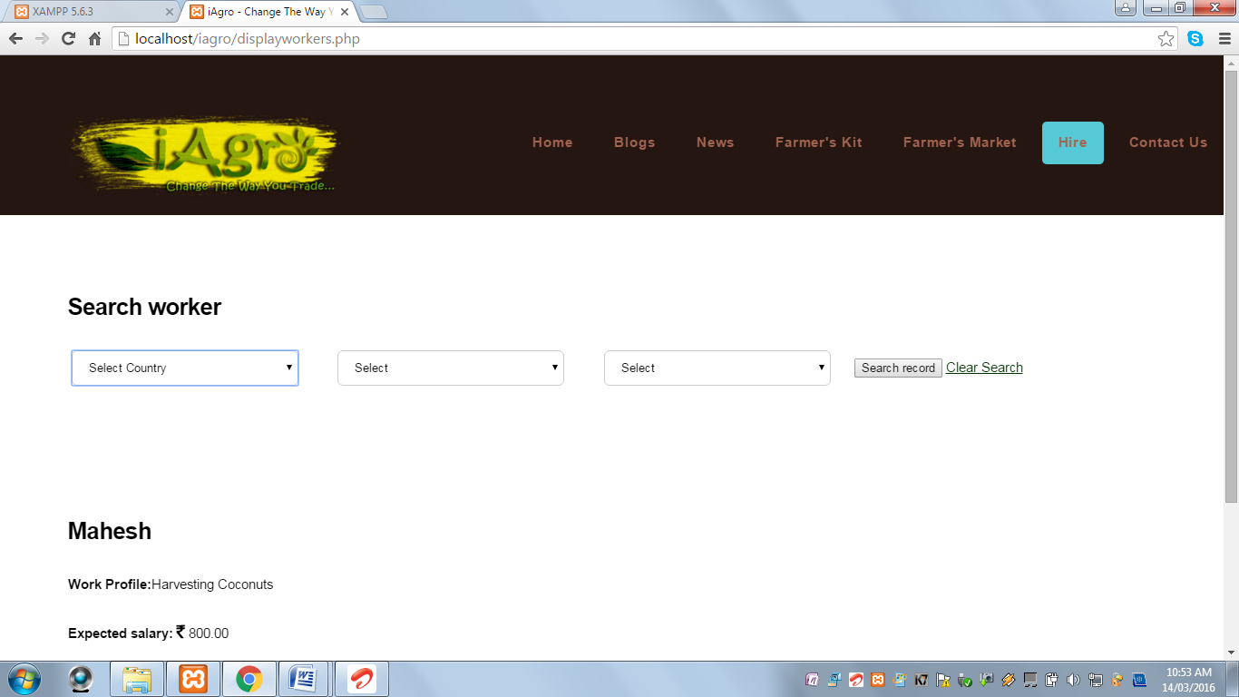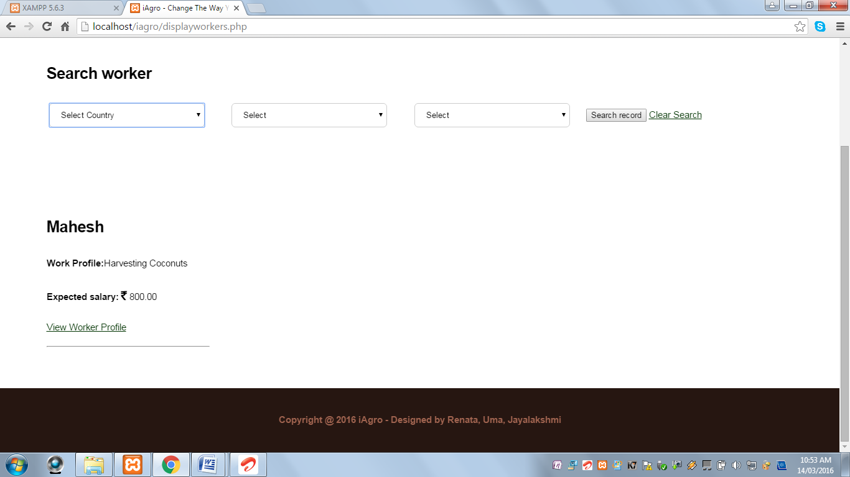

* This page displays farm labourers who have registered on the website in search of jobs.
* It also contains location search to display farm labourers of the given location.

**Contact Us Page**

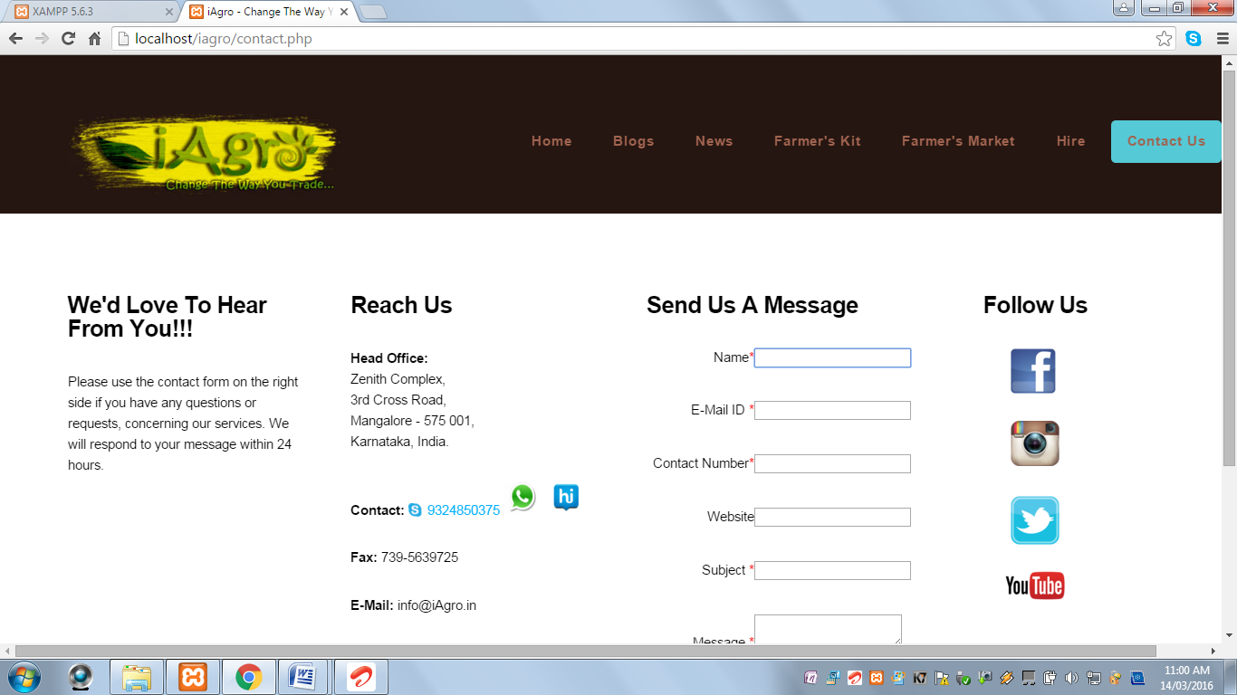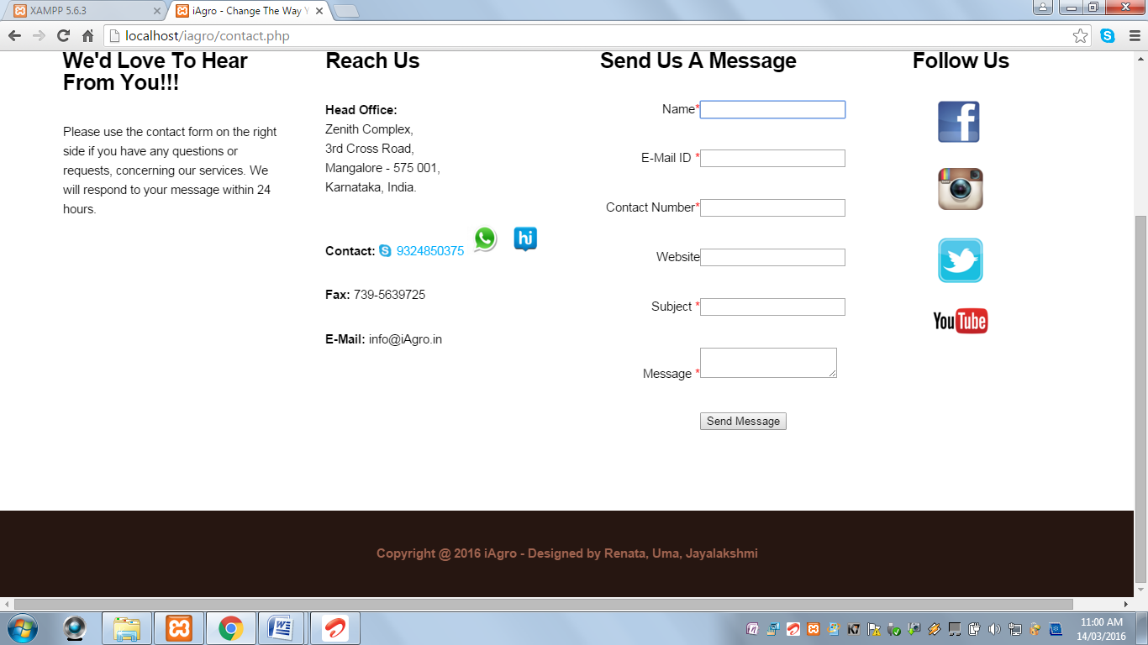

* This page displays contact information of ‘iAgro’.
* It contains ‘Send Us A Message’ form for sending feedbacks and contacting the administrator.
* When user clicks on the Sign Up link under the Customer icon, the user is redirected to the Registration Page.

**Customer Registration Page:**

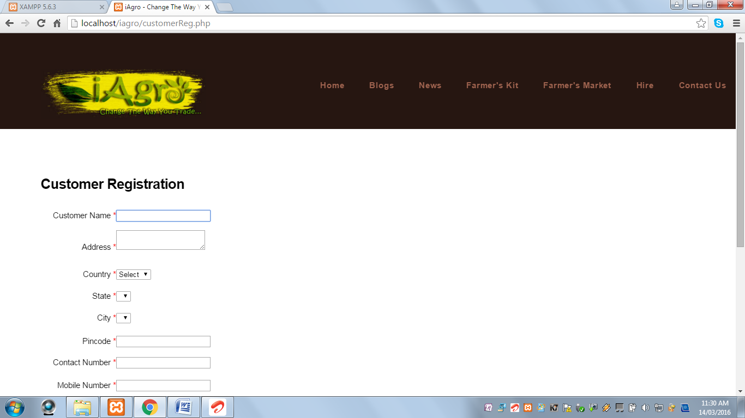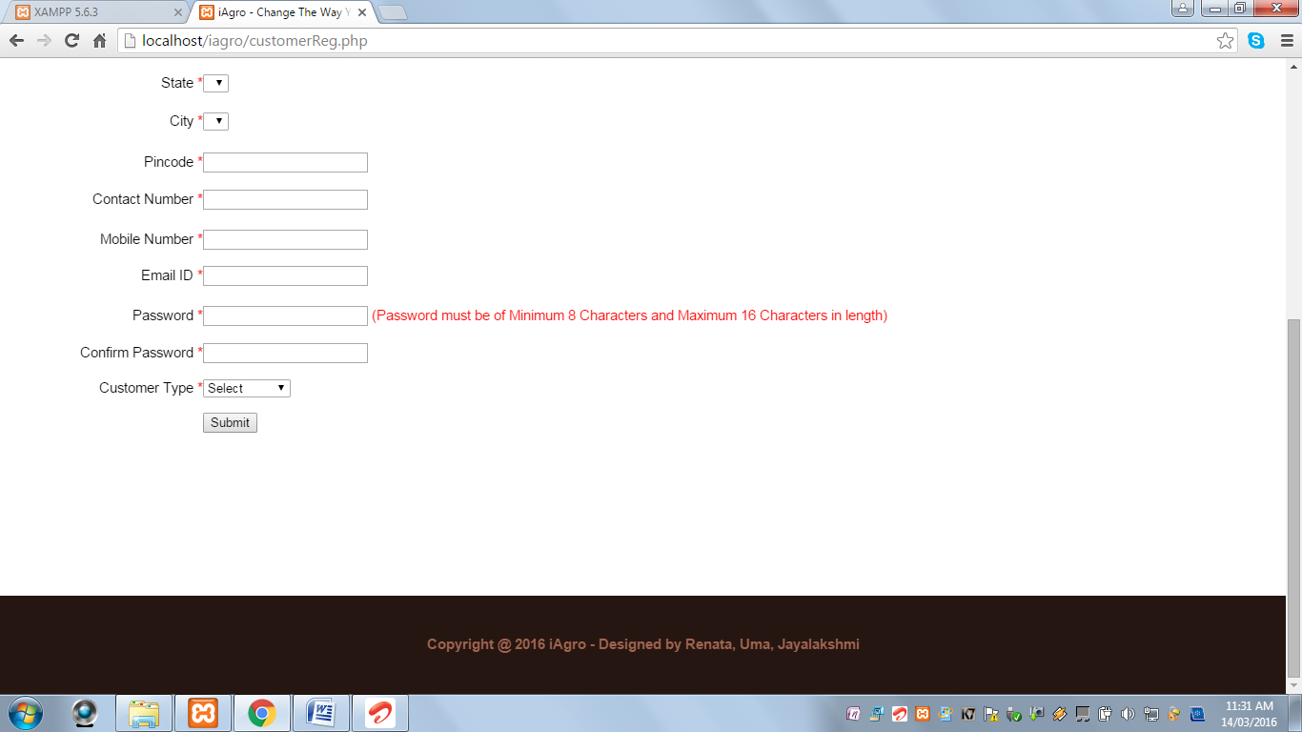

When Submit button is clicked and customer name field is blank, the following alert message is displayed:

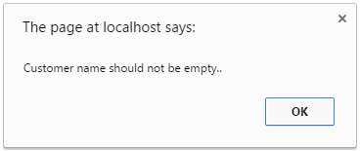

When Submit button is clicked and customer name field contains values other than alphabets and spaces, the following alert message is displayed:

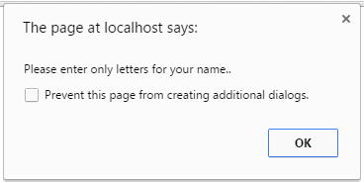

When Submit button is clicked and address field is blank, the following alert message is displayed:

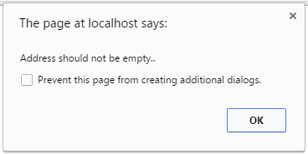

When Submit button is clicked and country field is not selected, the following alert message is displayed:

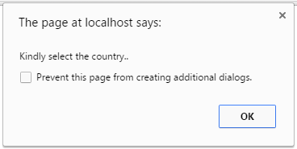

When Submit button is clicked and state field is not selected, the following alert message is displayed:

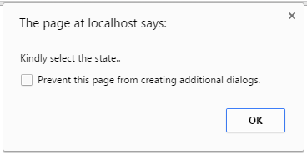

When Submit button is clicked and city field is not selected, the following alert message is displayed:

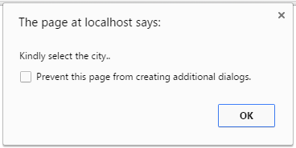

When Submit button is clicked and PIN Code is blank, the following alert message is displayed:

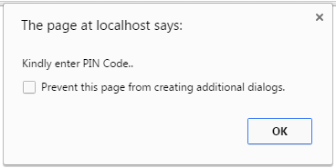

When Submit button is clicked and PIN Code contains values other than numeric values, the following alert message is displayed:

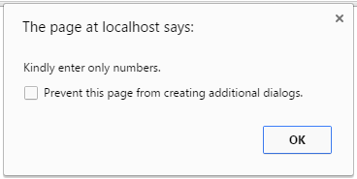

When Submit button is clicked and contact number field is blank, the following alert message is displayed;

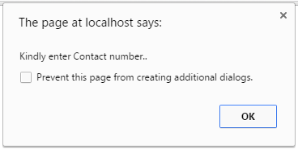

When Submit button is clicked and contact number field contains values other than numeric values, the following alert message is displayed:



When Submit button is clicked and mobile number field is blank, the following alert message is displayed:

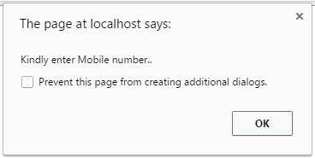

When Submit button is clicked and mobile number field contains values other than numeric values, the following alert message is displayed:



When Submit button is clicked and E-Mail ID field is blank, the following alert message is displayed:

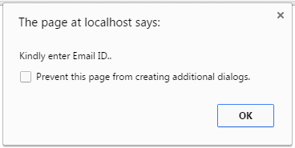

When Submit button is clicked and E-Mail ID field is blank, the following alert message is displayed:

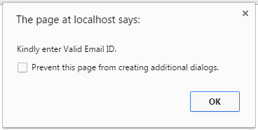

When Submit button is clicked and password field is blank, the following alert message is displayed:

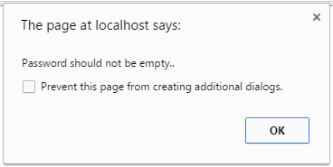

When Submit button is clicked and password length is less than 8 characters, the following alert message is displayed:

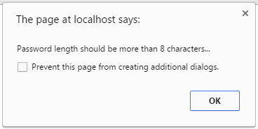

When Submit button is clicked and password length is greater than 16 characters, the following alert message is displayed:

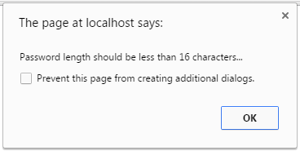

When Submit button is clicked and confirm password field is blank, the following alert message is displayed:

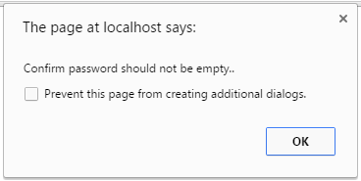

When Submit button is clicked and confirm password and password fields does not match, the following alert message is displayed:

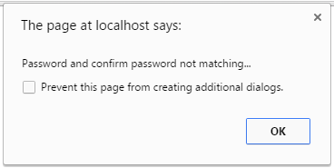

When Submit button is not selected and customer type field is not selected, the following alert message is displayed:

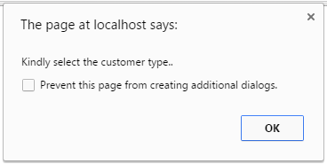

When Submit button is clicked and all the fields are successfully validated, the following alert message is displayed:

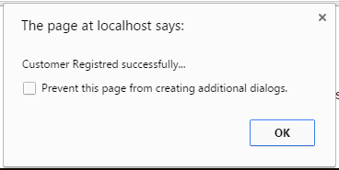

After the customer has successfully registered, the Customer Login Page is displayed:

**Customer Login Page:**

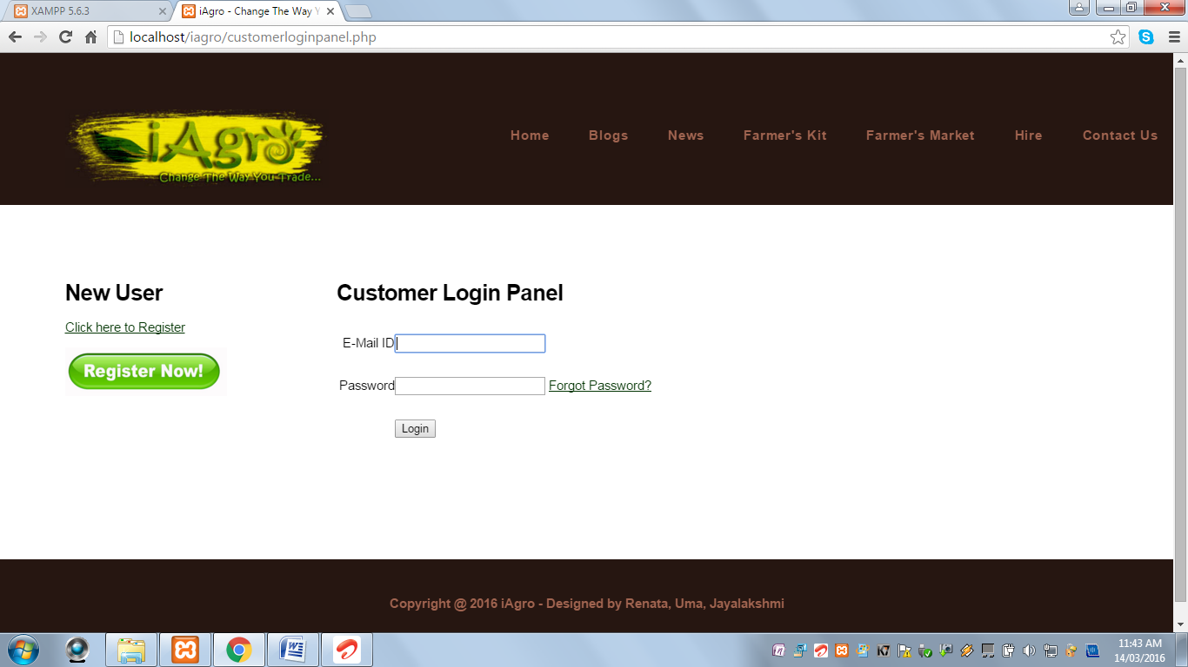

* It contains Register Now Link and Button to redirect user to the Registration Page, if the user is not registered.
* This page displays Customer Login Form.
* It contains a Forgot Password Link.

**When the registered customer clicks on the Forgot Password Link:**

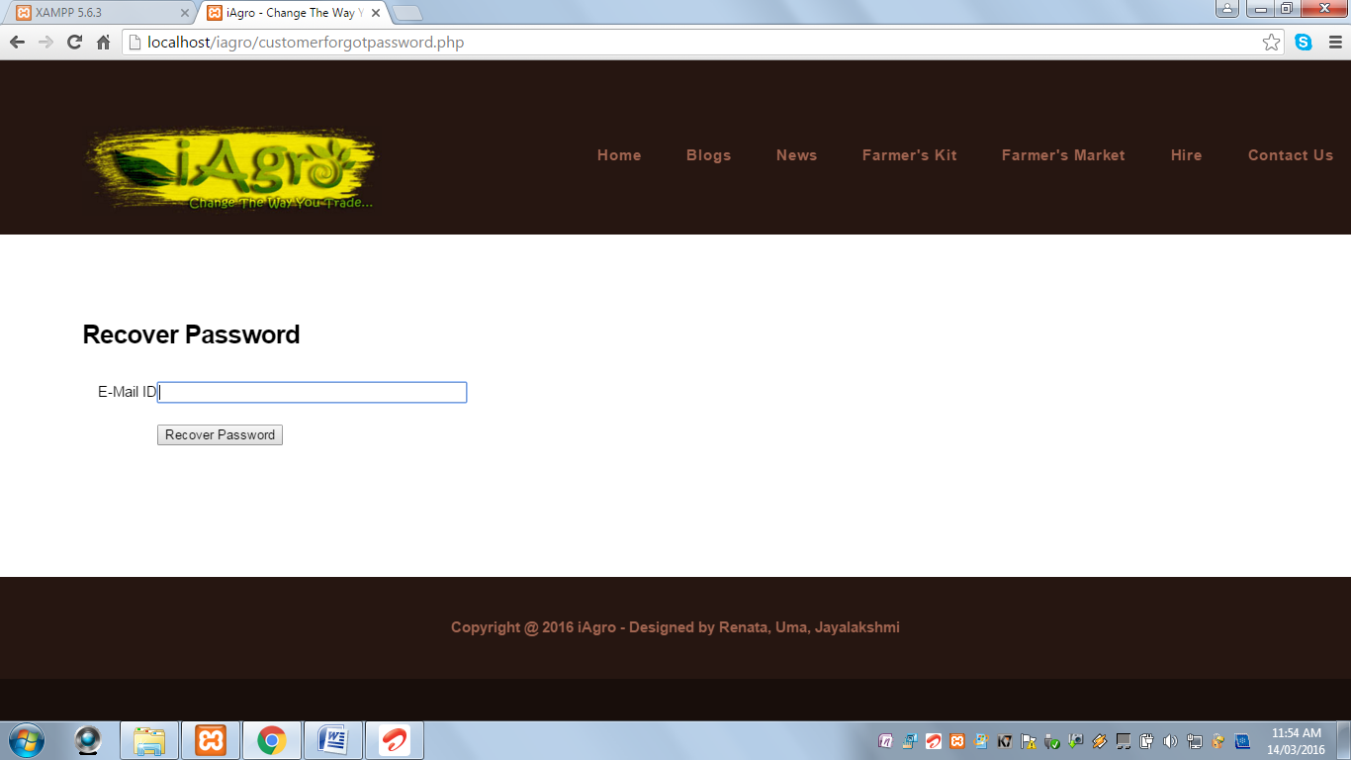

When Recover Password button is clicked and E-Mail ID field is blank, the following alert message is displayed:

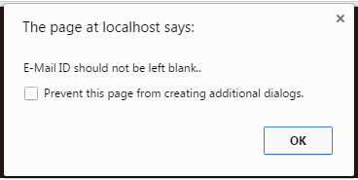

When Recover Password button is clicked and E-Mail ID field contains invalid E-Mail ID, the following alert message is displayed:

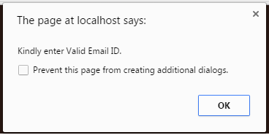

When Recover Password button is clicked and the required field successfully validated and contains a non-existing value, the following alert message is displayed:

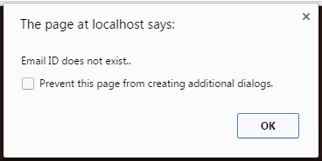

When Recover Password button is clicked and the required field is successfully validated and contains a value stored in the database, the following alert message is displayed and Login Credentials are sent to the given E-Mail ID:

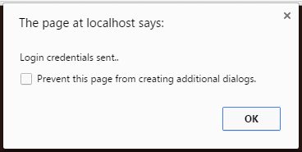

**When the registered customer is trying to login into the website:**

When Login button is clicked and Login ID field is blank, the following alert message is displayed:

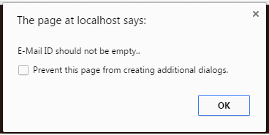

When Login button is clicked and Password field is blank, the following alert message is displayed:

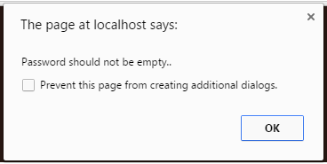

When Login button is clicked and Login ID and Password field does not match, the following alert message is displayed:

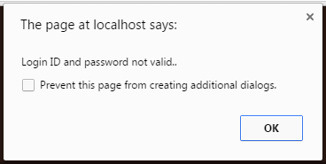

When Login button is clicked and the Login ID and Password field are valid, the user is directed to the Customer Panel Page:

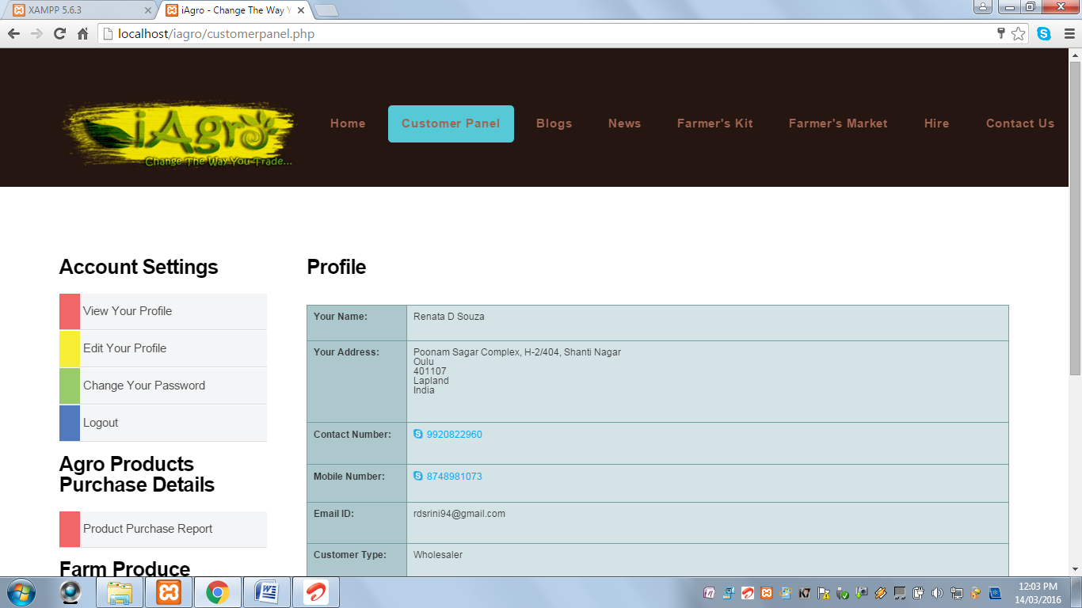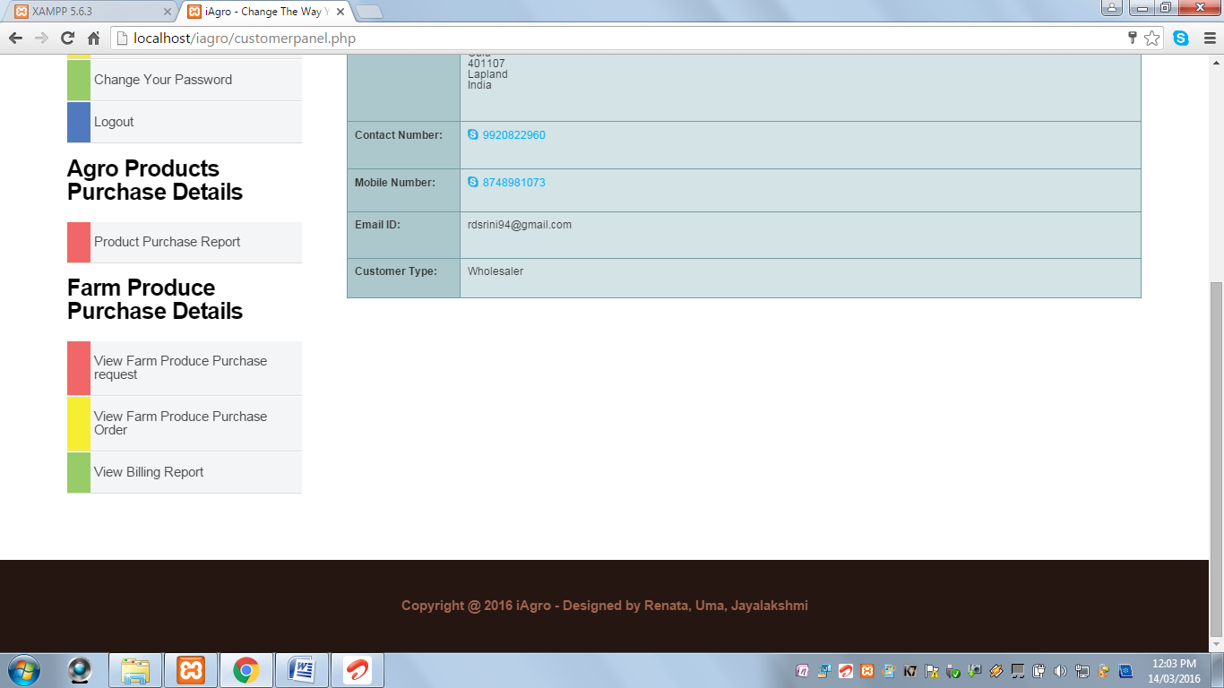

* Customer Panel Page displays Left Navigation Menu as following:

**View Your Profile:** This page displays the customer information such as name, address, contact information, Email ID and Customer Type.

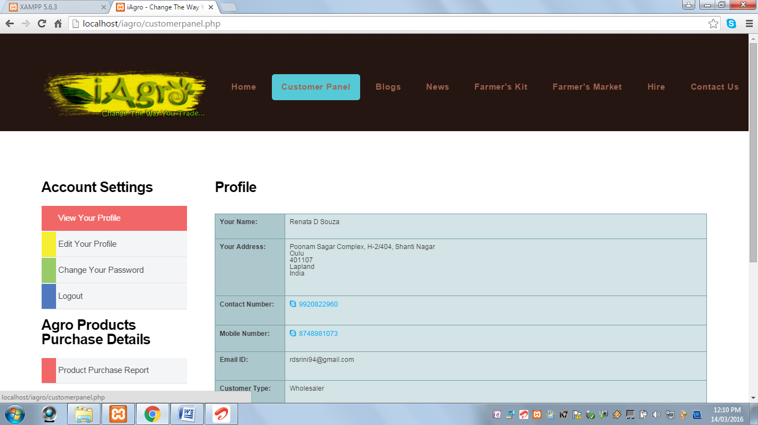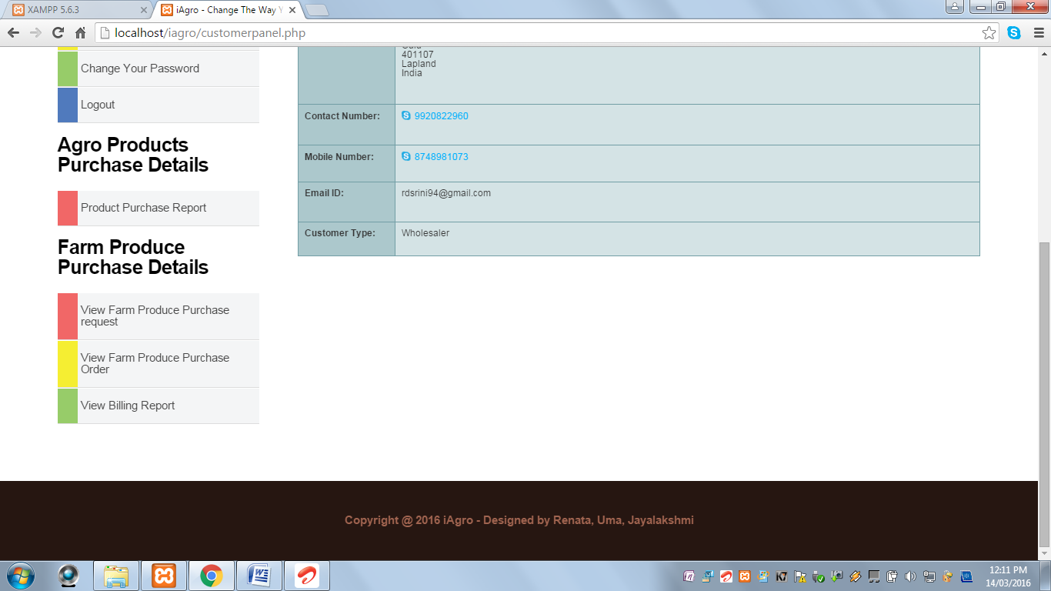

**Edit Your Profile:** This page contains a form to keep the customer information updated.

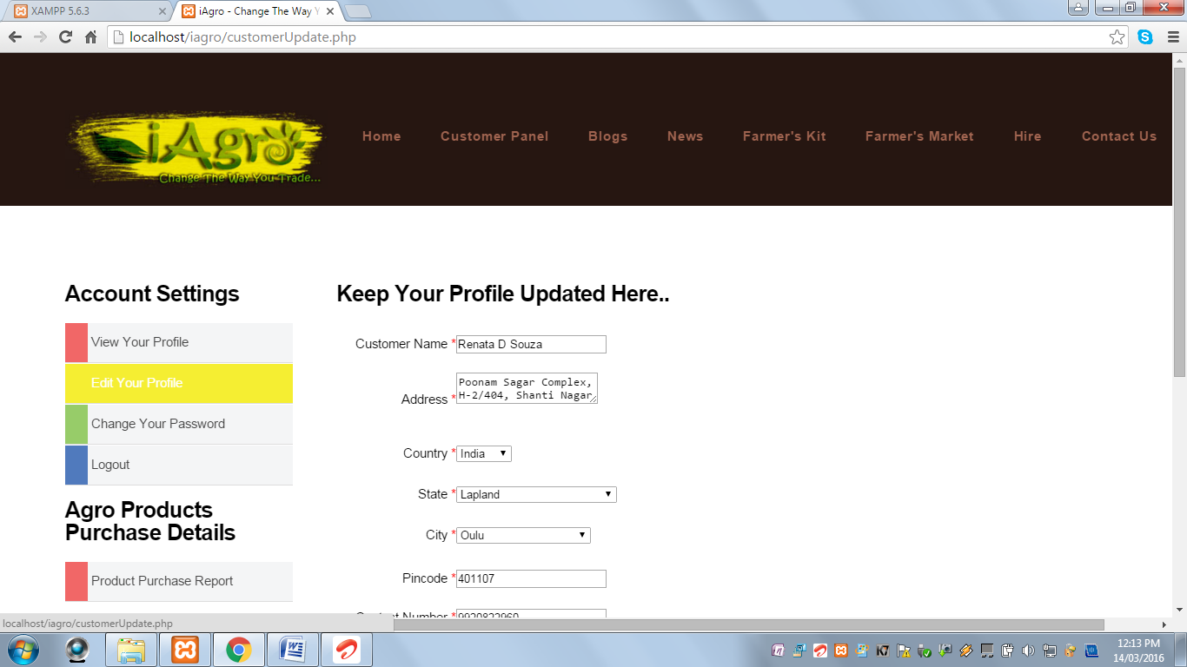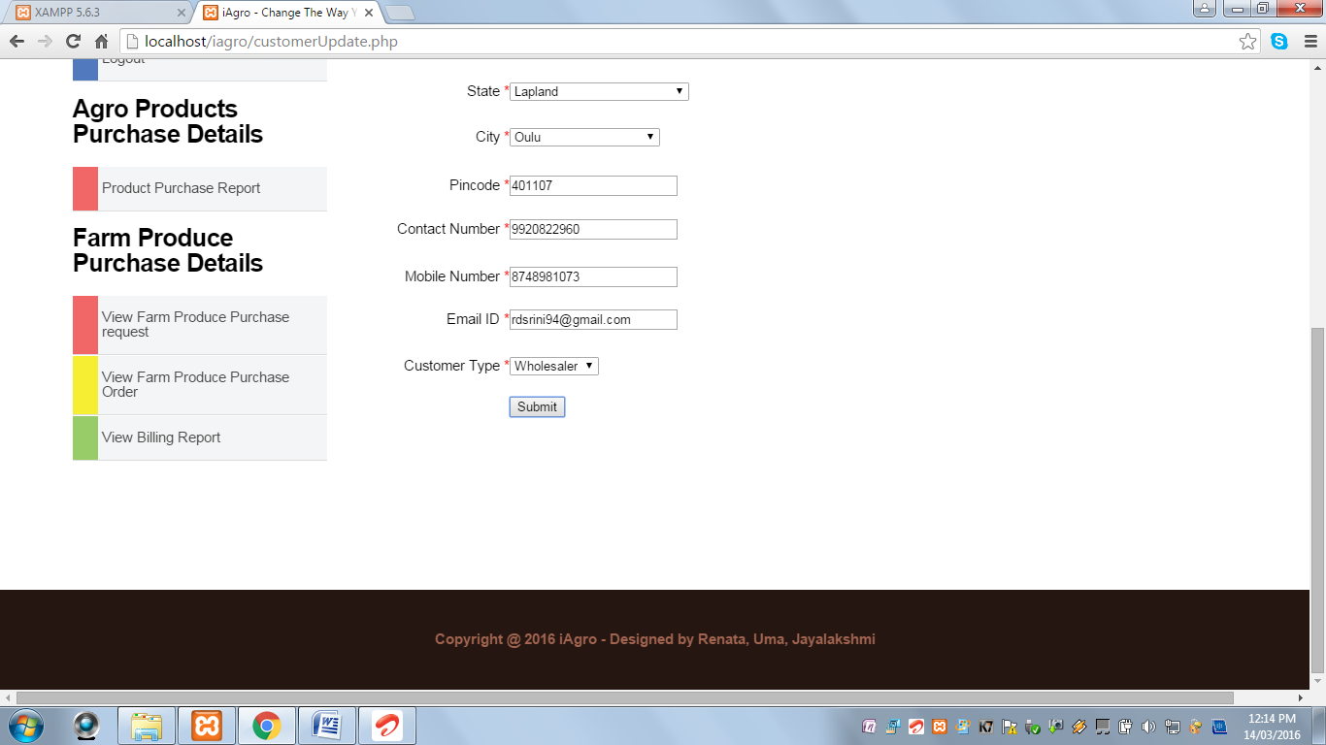

**Change Your Password:**  This page contains a form to reset the password.

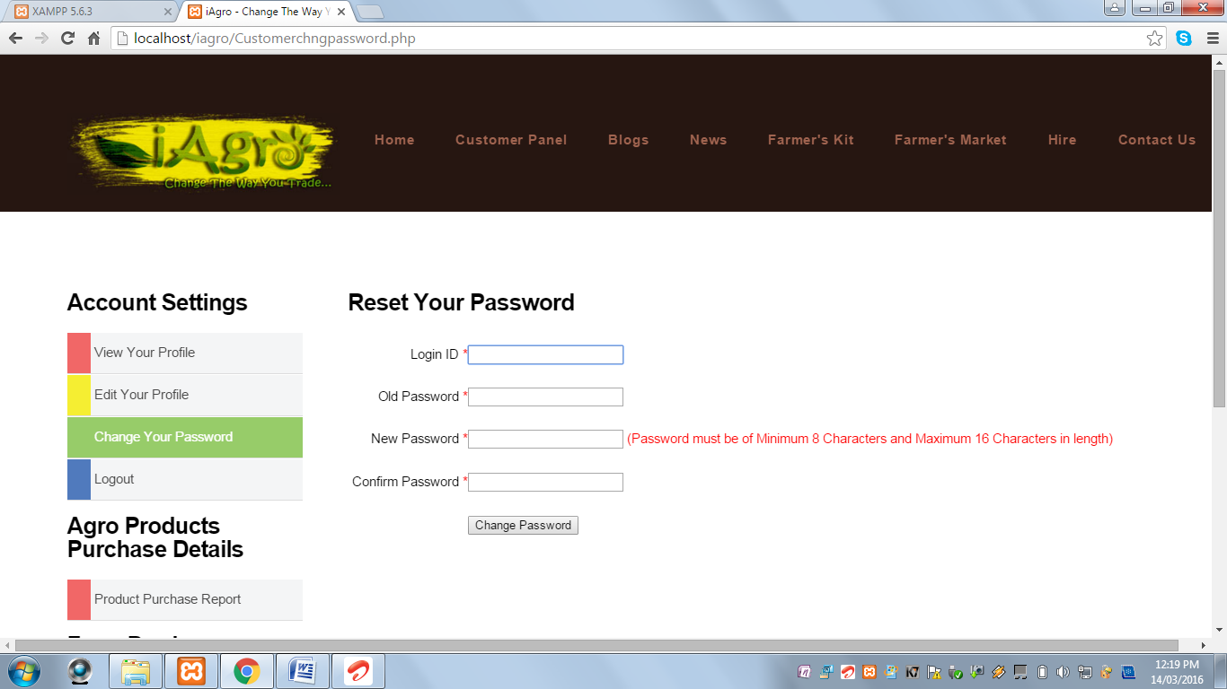 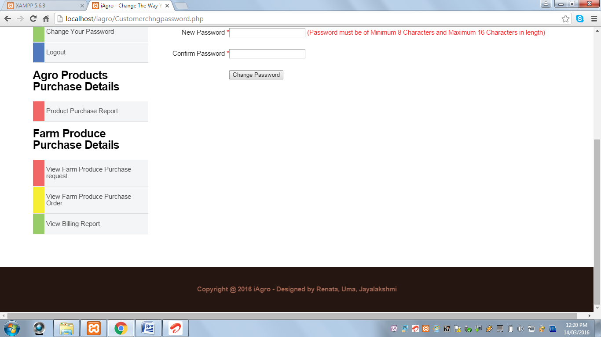

When Change Password button is clicked and Login ID field is blank, the following alert message is displayed:

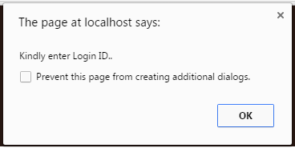

When Change Password button is clicked and Login ID field contains an invalid Login ID, the following alert message is displayed:

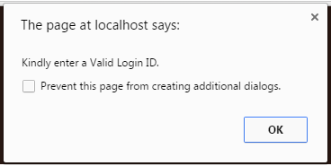

When Change Password button is clicked and Old Password field is blank, the following alert message is displayed:

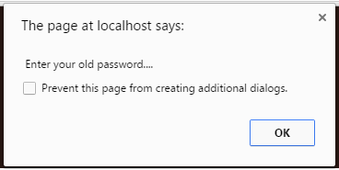

When Change Password button is clicked and New Password field is blank, the following alert message is displayed:

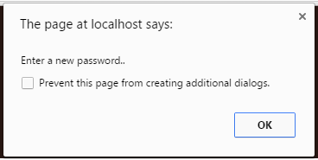

When Change Password button is clicked and Password length is less than 8 characters, the following alert message is displayed:



When Change Password button is clicked and Password length is greater than 16 characters, the following alert message is displayed:



When Change Password button is clicked and Confirm Password field is blank, the following alert message is displayed:  
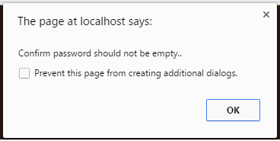

When Change Password button is clicked and New Password and Confirm Password field does not match, the following alert message is displayed:

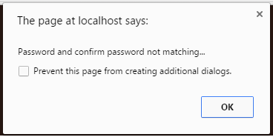

When Change Password button is clicked and all the required fields are successfully validated, the following alert message is displayed:

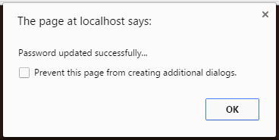

When Change Password button is clicked and the fields contain non-existing values, the following alert message is displayed:

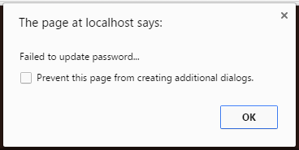

**Note:**

Similar validations for Seller Change Password, Worker Change Password & Admin Change Password.

**Logout:** Customer Logs Out.

**Product Purchase Report:** This page displays the report of all agricultural products such as fertilizer, tools, etc. purchases done by the logged in customer. It also contains View Bill link which redirects to a page which displays the bill of the corresponding purchase.

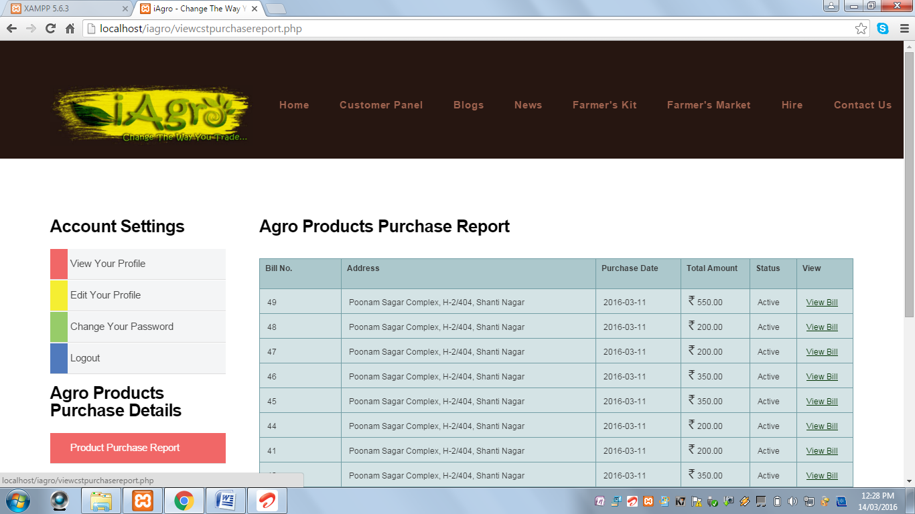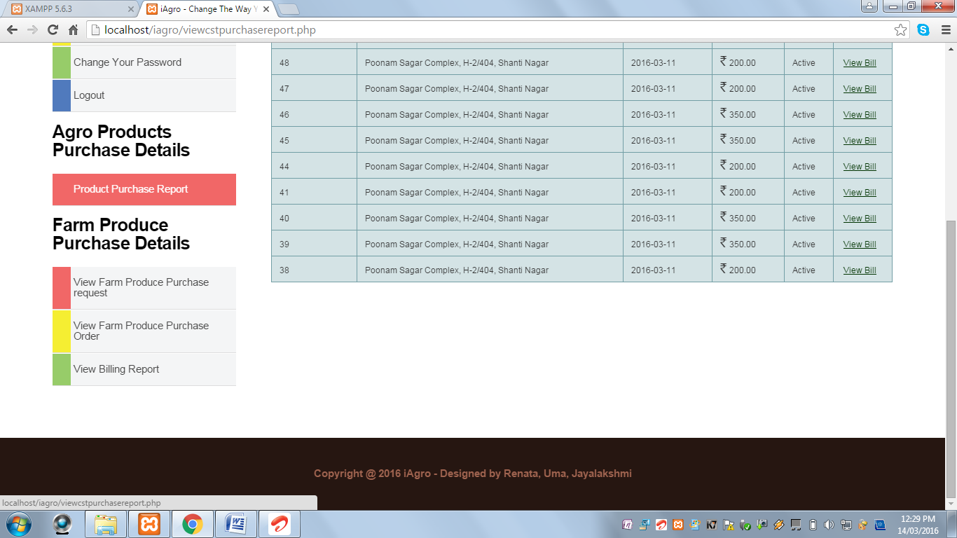

* When View Bill link is clicked, the following page is displayed with Print Bill option.

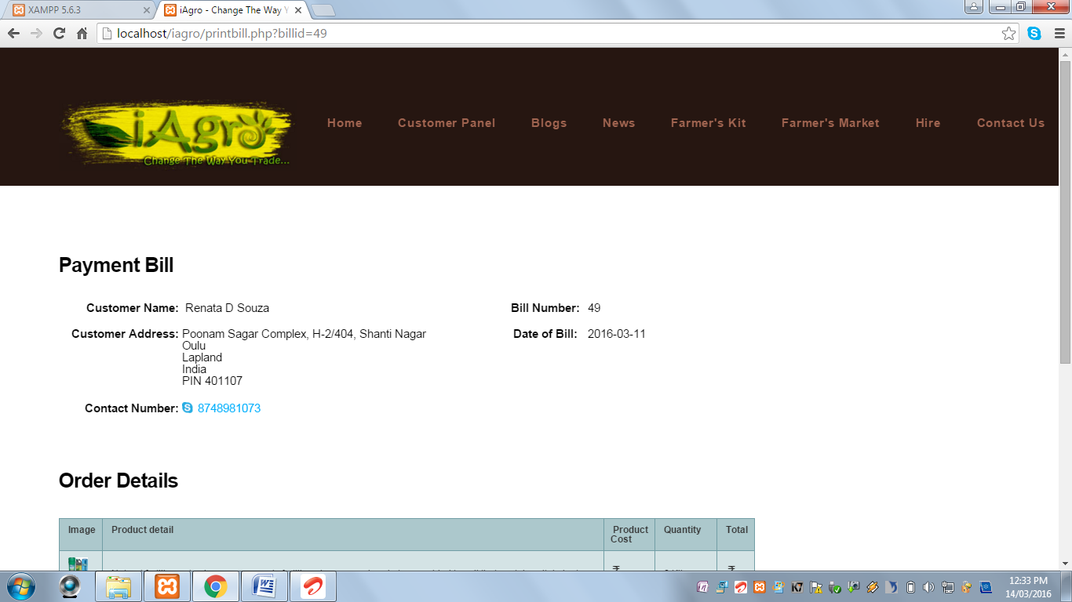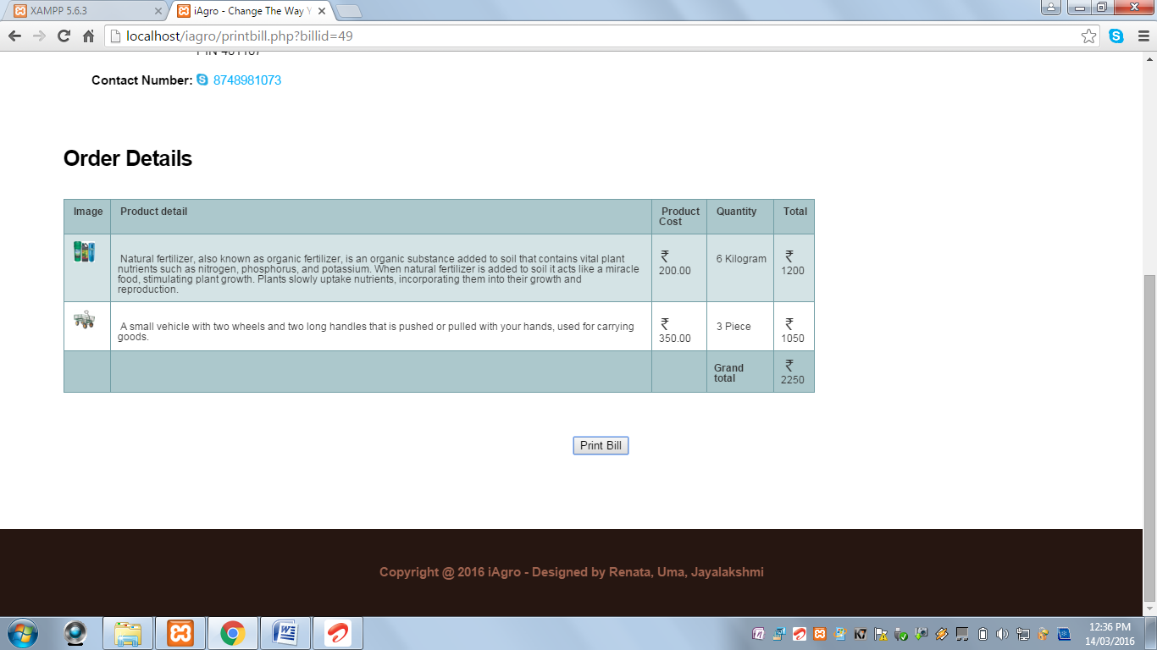

* When Print Bill button is clicked, the following window opens:

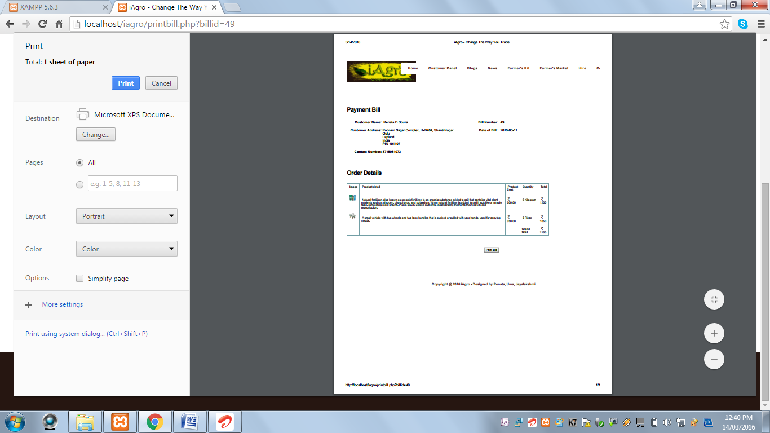

**View Farm Produce Purchase Request:** This page displays report of the purchase requests sent by the customer for different farm produces. It contains Delete option to delete the sent request.

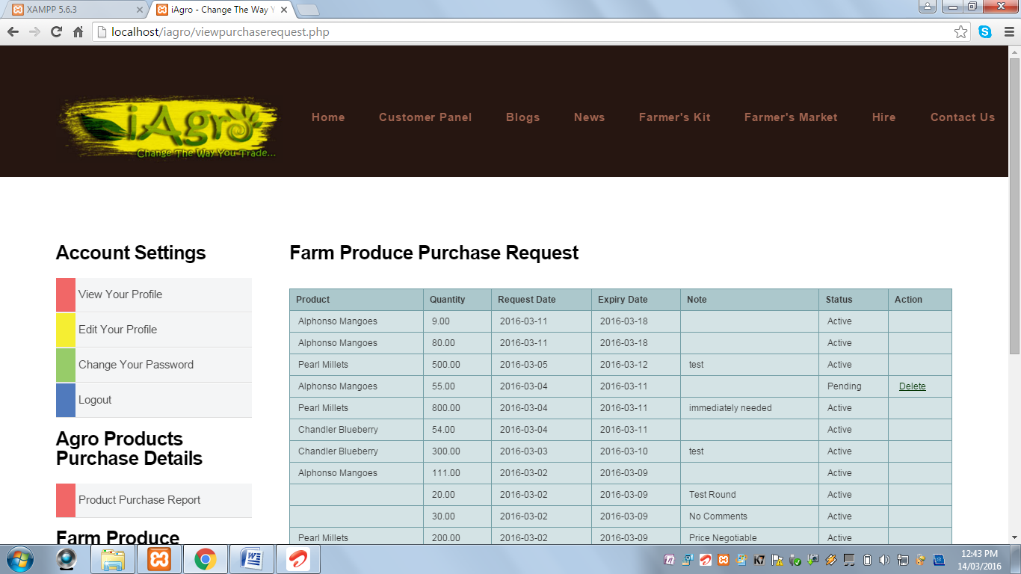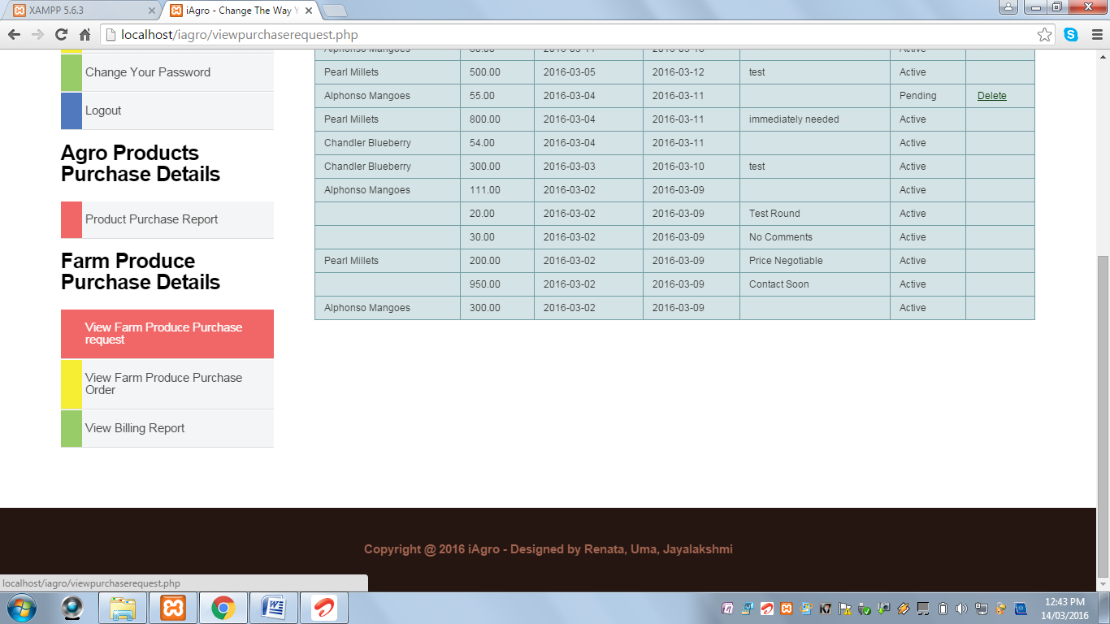

**View Farm Produce Purchase Order:** This page displays the report on the purchase orders sent by the farmer of the corresponding produce with the link for making payment.

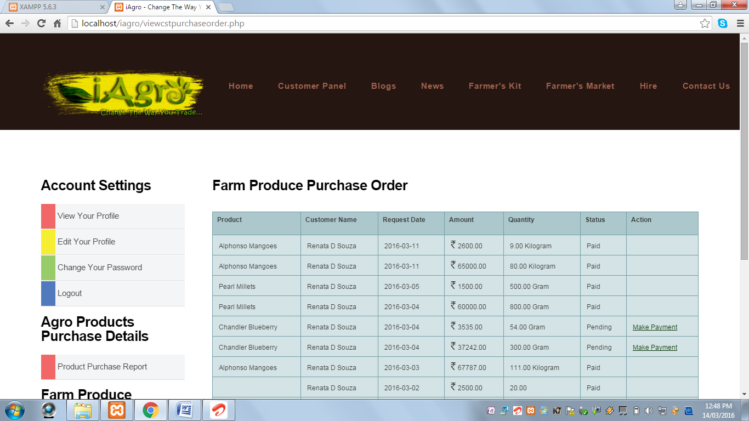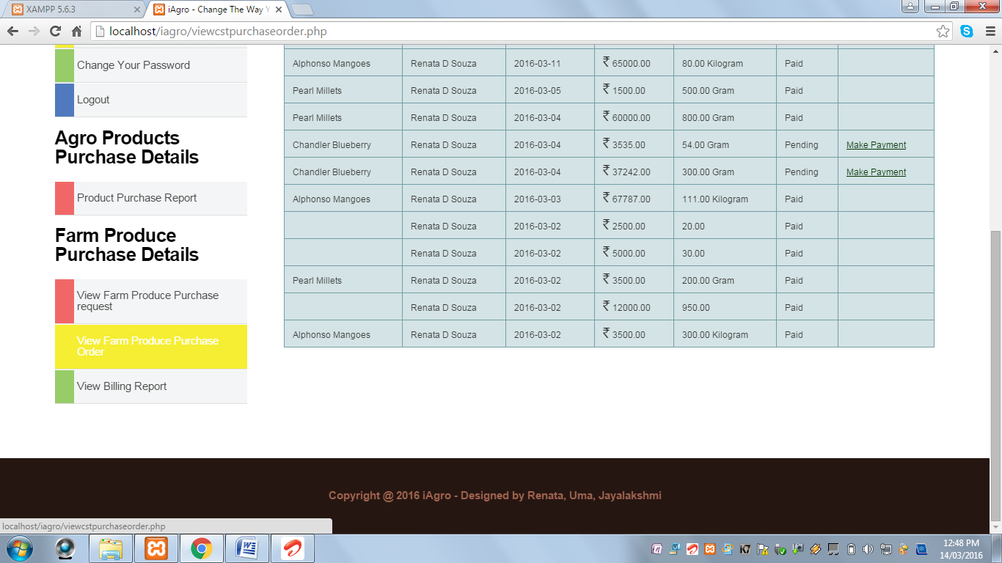

* When the customer clicks on Make Payment link, the following page is displayed:

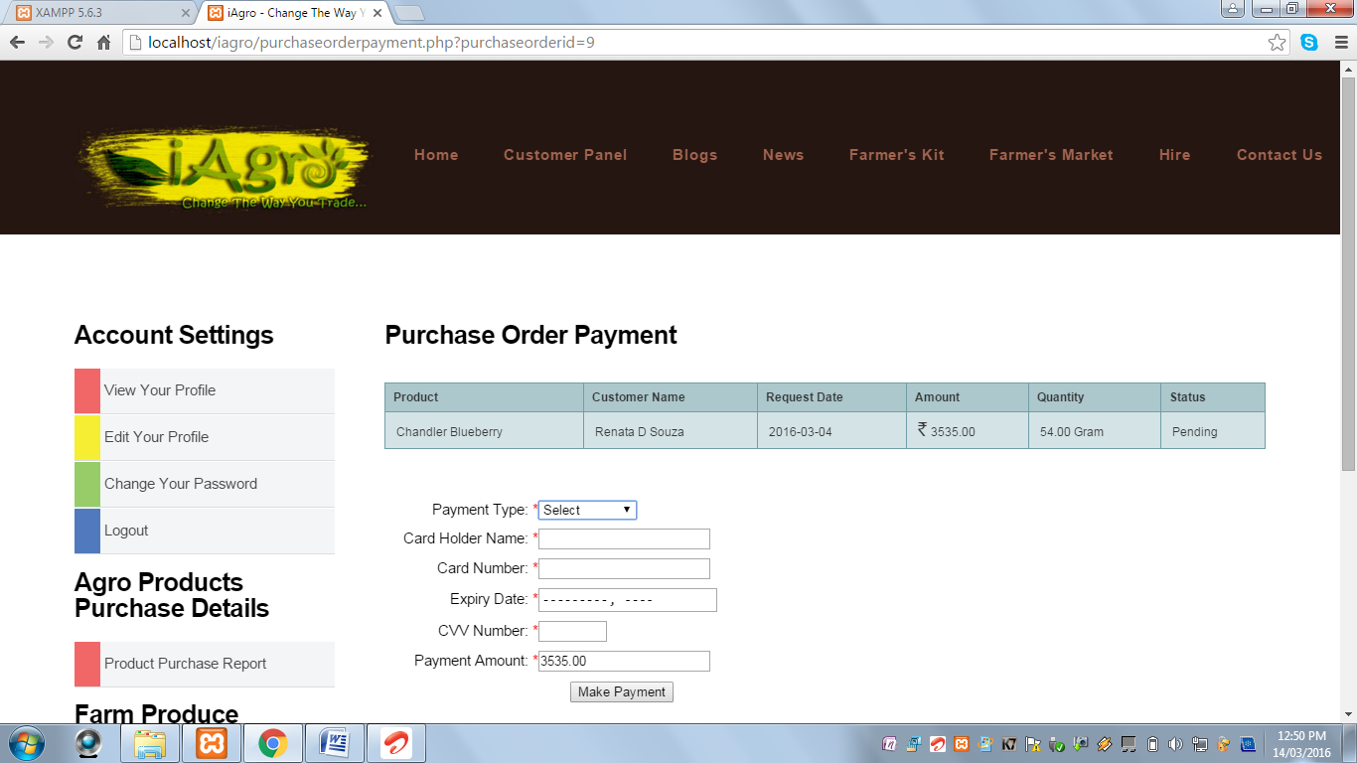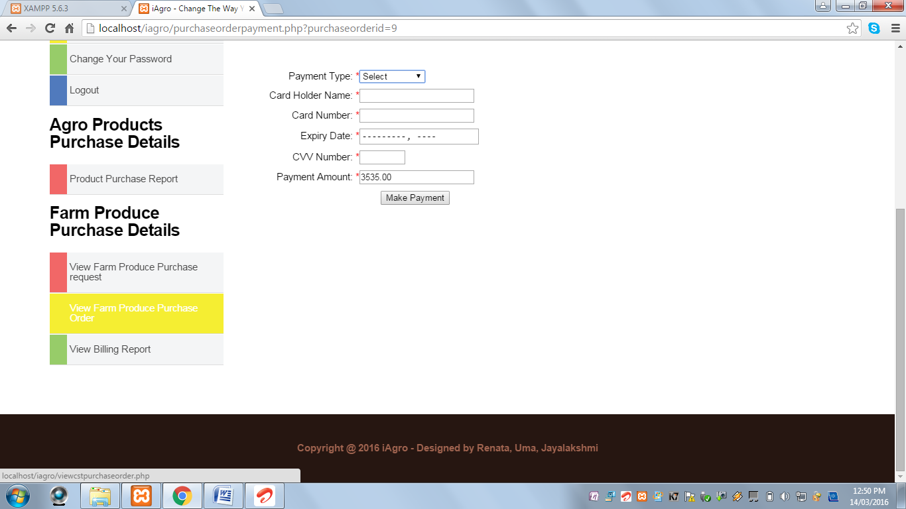

When Make Payment button is clicked and the Payment Type field is blank, the following alert message is displayed:

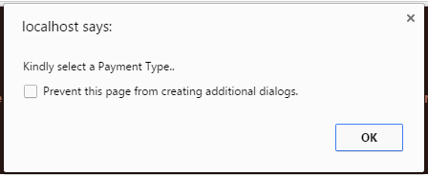

When Make Payment button is clicked and the Card Holder Name field is blank, the following alert message is displayed:

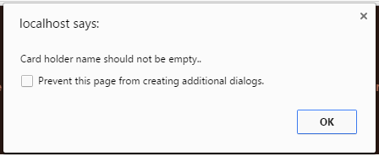

When Make Payment button is clicked and Card Holder Name field contains values other than alphabets, the following alert message is displayed:

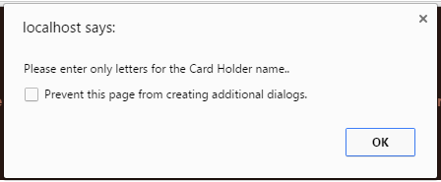

When Make Payment button is clicked and Card Number field is blank, the following alert message is displayed:

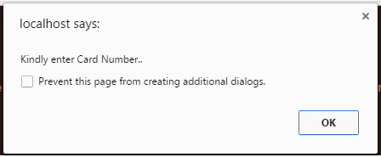

When Make Payment button is clicked and Card Number input length is not 16 digits, the following alert message is displayed:

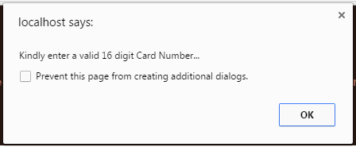

When Make Payment button is clicked and Expiry Date field is blank, the following alert message is displayed:

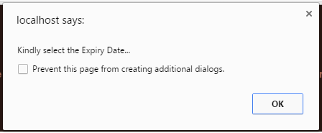

When Make Payment button is clicked and CVV Number field is blank, the following alert message is displayed:

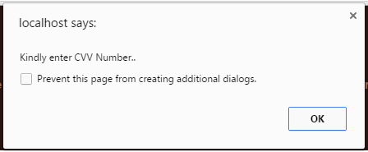

When Make Payment button is clicked and CVV Number field does not contain value between 100 and 999, the following alert message is displayed:

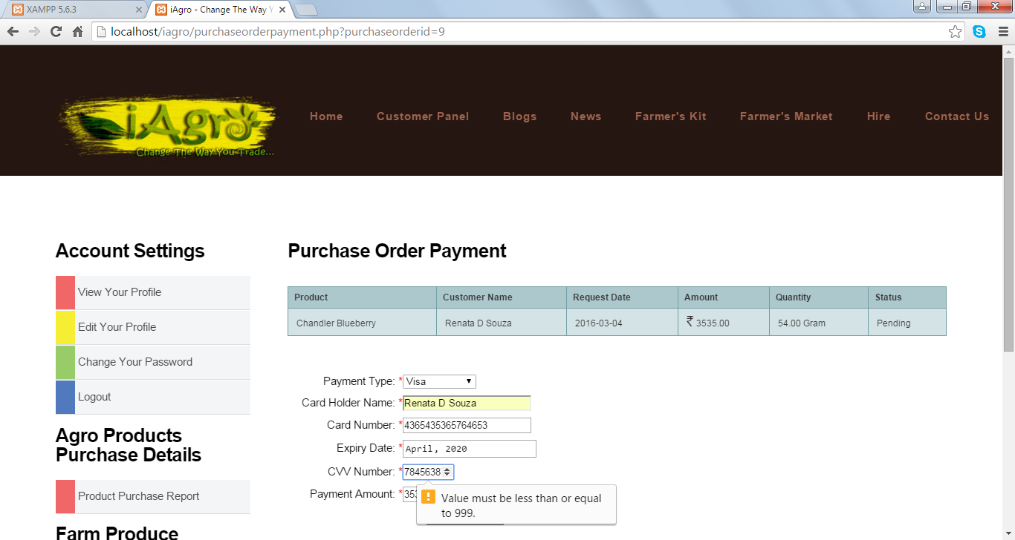

When Make Payment button is clicked and all the fields are successfully validated, the following message is displayed and redirected to a page which displays the bill with Print option:

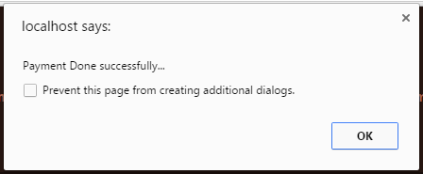

**View Billing Report:** This page displays the billing reports of farm produces purchased by the customer with an option to Print the bill.

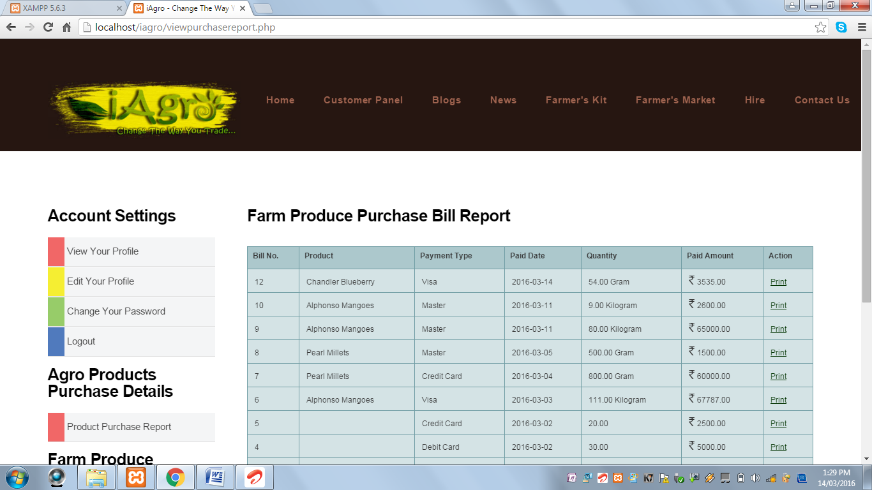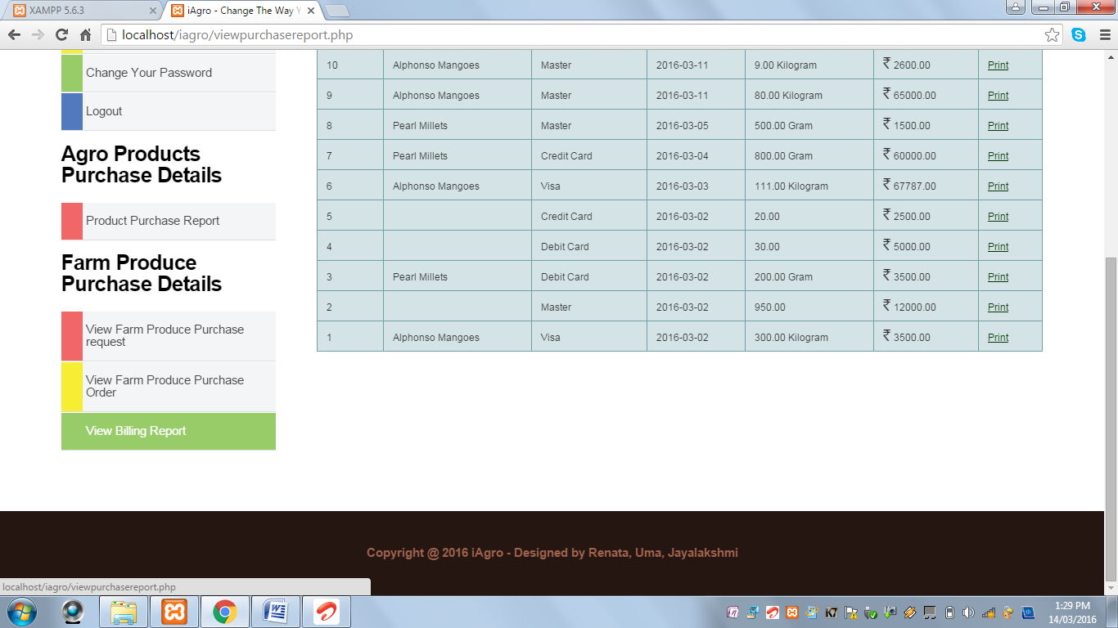

* When the customer clicks on the Farmer’s Kit tab on the header, the customer can purchase agro products online.



When the customer clicks on any one of the product, the following page is displayed:

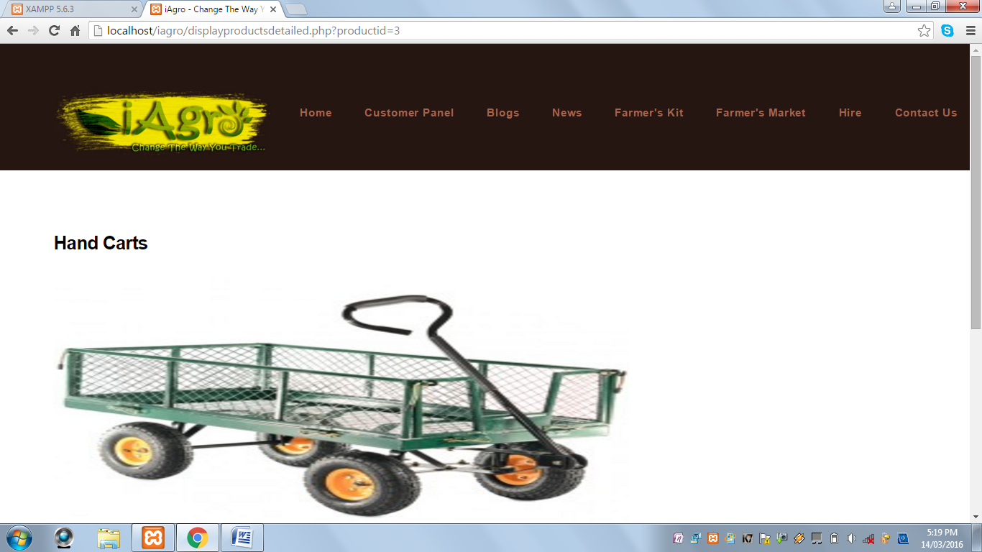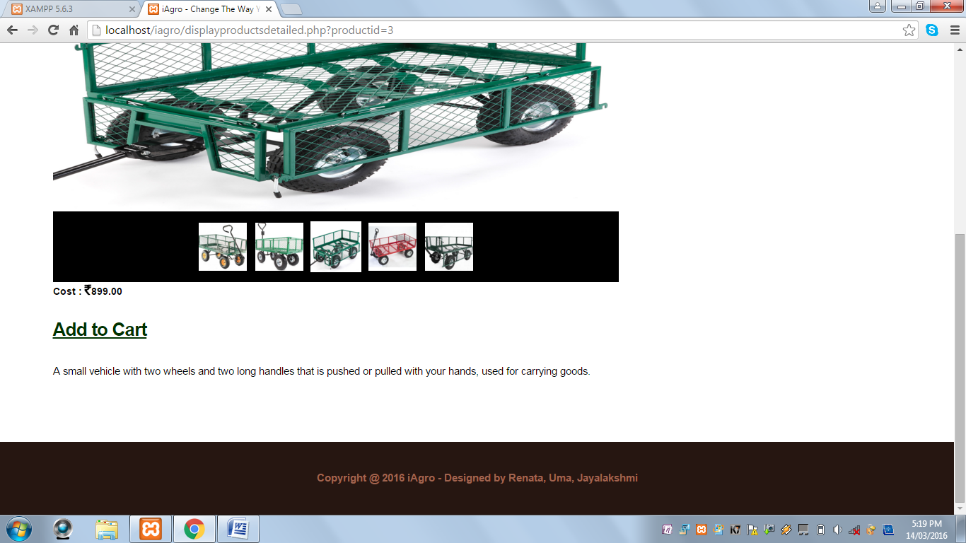

When Add To Cart option is clicked, the following alert is displayed:

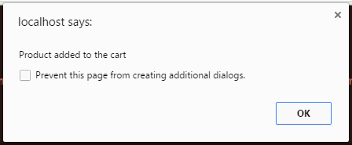

**View Cart Page:** This page displays all the items in the cart.

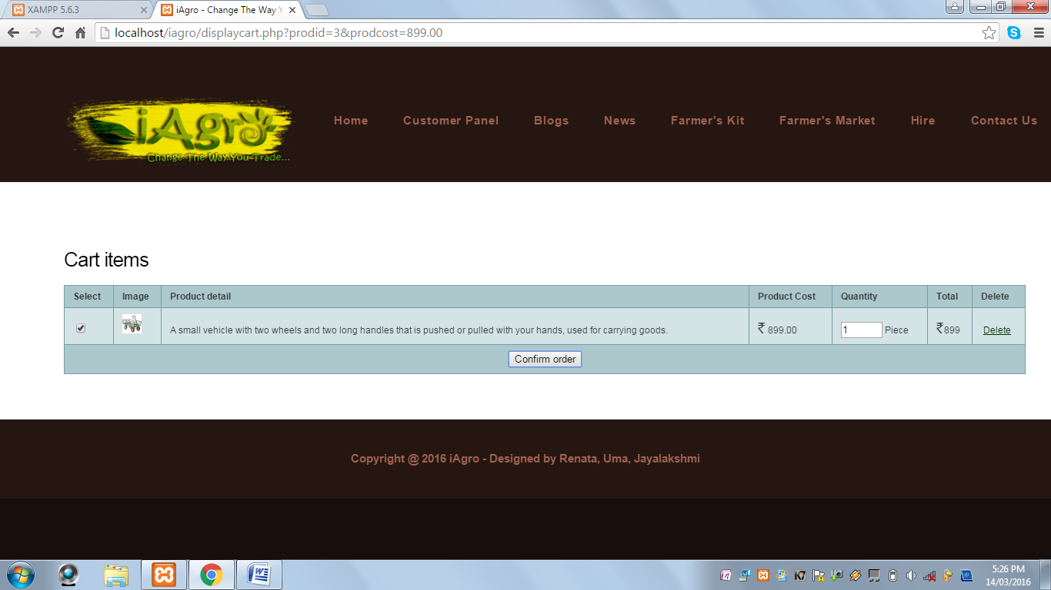

* When Order is confirmed by the customer, the following page is displayed:

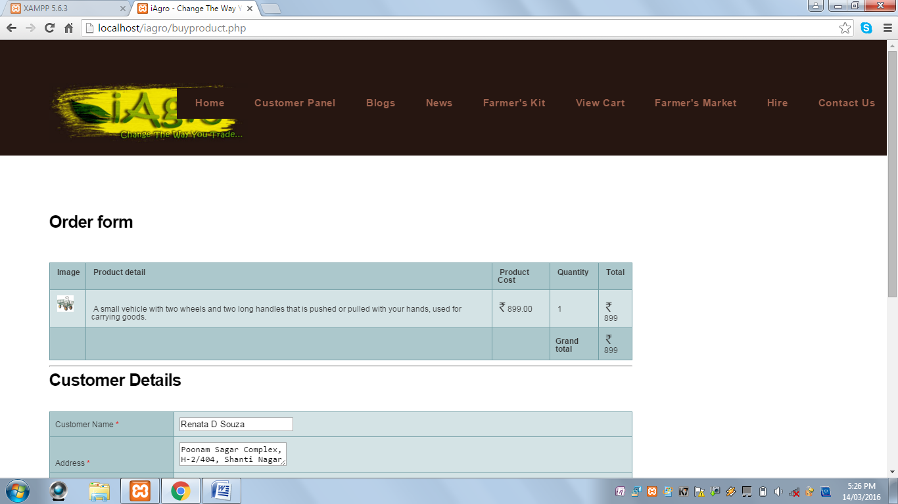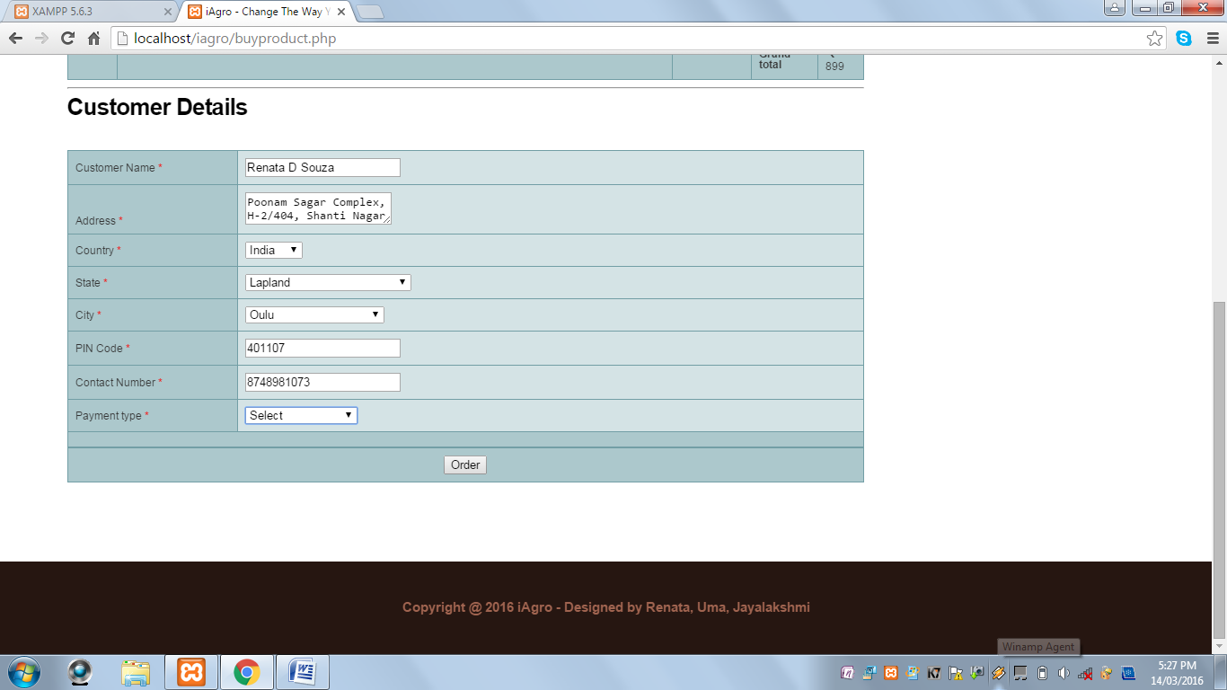

When Order button is clicked and the Payment Mode is not selected, the following alert message is displayed:

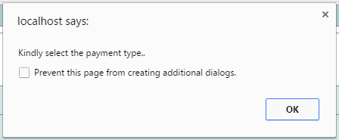

When Card Payment is selected in the Payment Mode Drop Down Box, the following extended form is displayed:

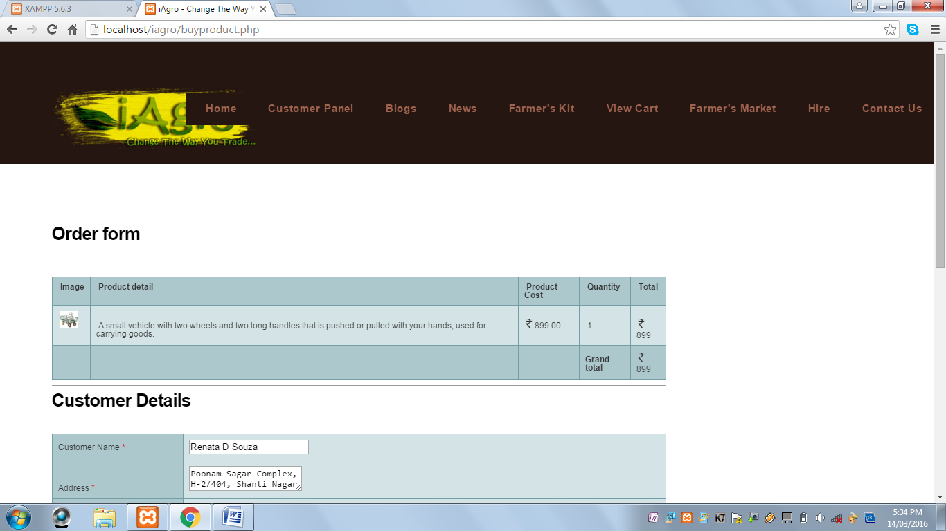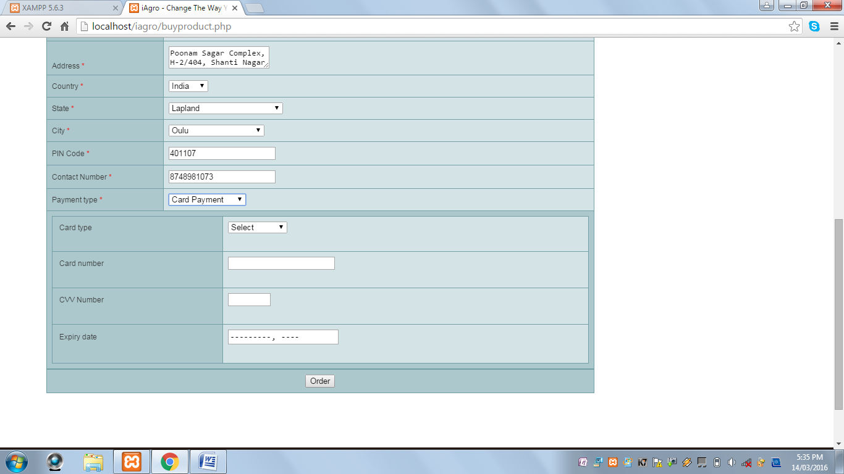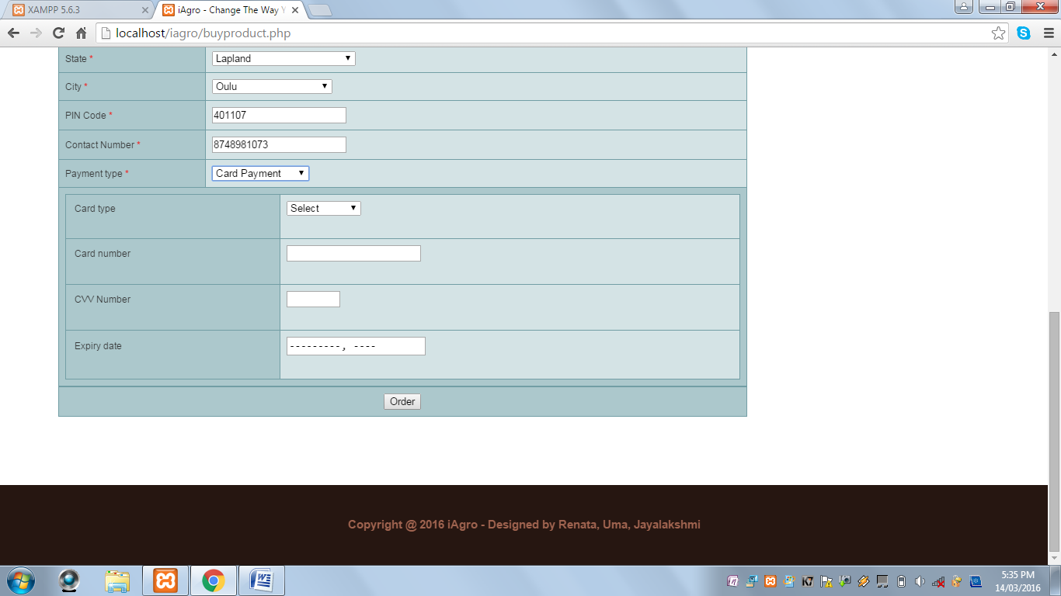

When Order button is clicked and the Card Type is not selected, the following alert message is displayed:

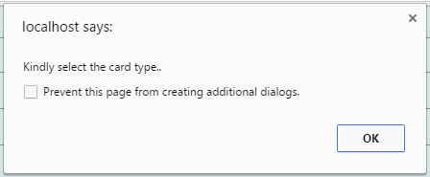

When Order button is clicked and the Card Number is blank, the following alert message is displayed:

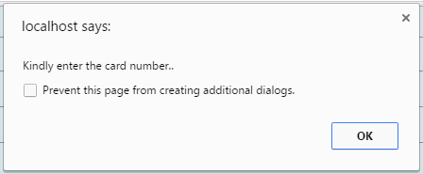

When Order button is clicked and the Card Number field does not contain a valid 16 digit card number, the following alert message is displayed:

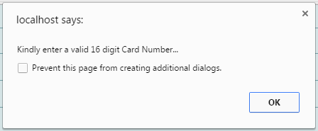

When Order button is clicked and CVV Number is blank, the following alert message is displayed:

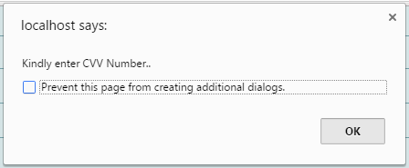

When Order Button is clicked and CVV Number field does not contain a value between 100 and 999, the following alert message is displayed:

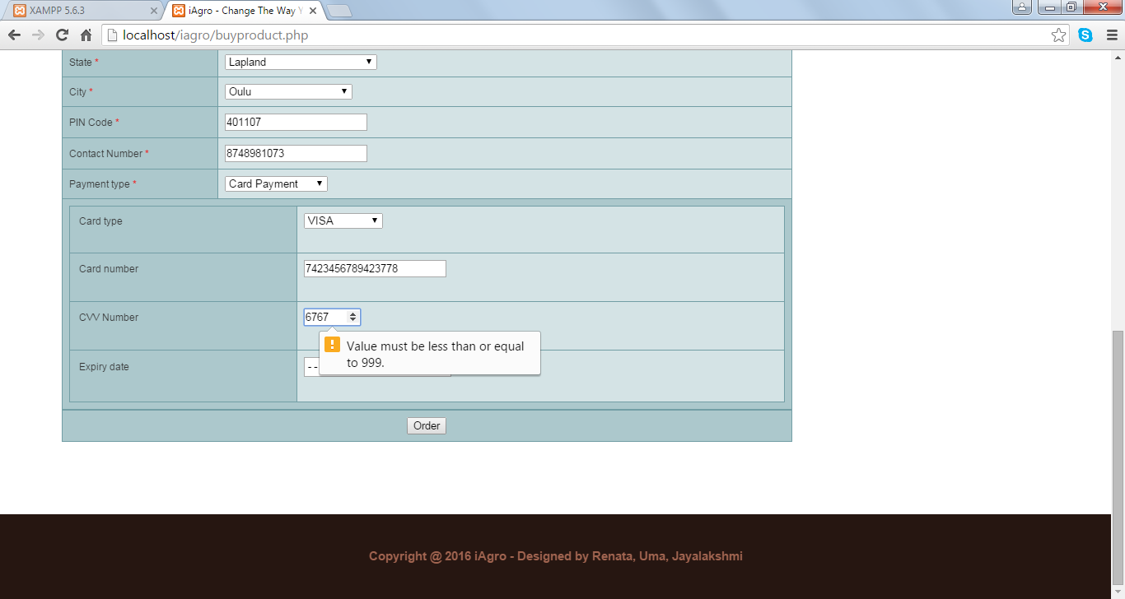

When Order button is clicked and the Expiry Date field is blank, the following alert message is displayed:

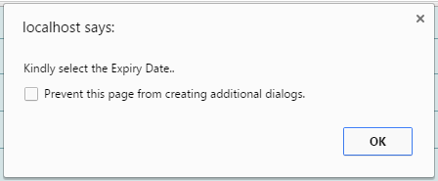

When Order button is clicked and all the fields are successfully validated, the following alert message is displayed and the bill is displayed:

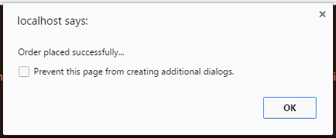

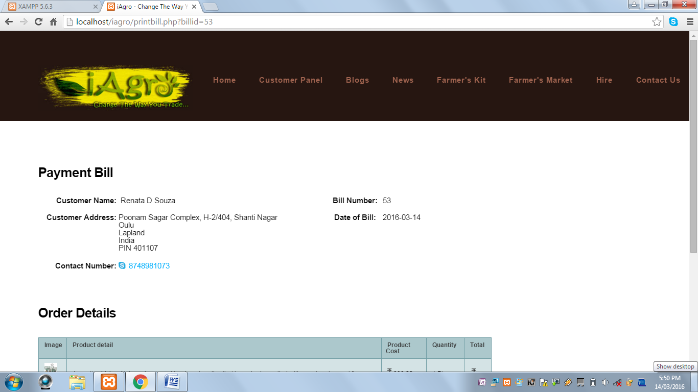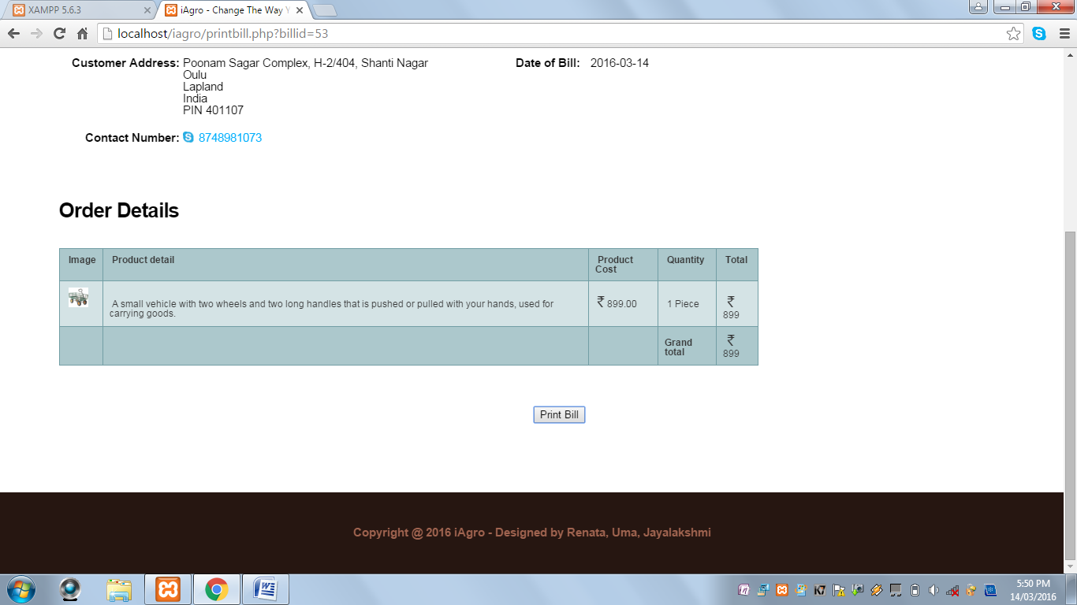

* When the Customer clicks on the Farmer’s Market tab on the header, the customer can buy farm produces uploaded by the farmers.



When the Customer clicks on any one of the produce, the following page is displayed:

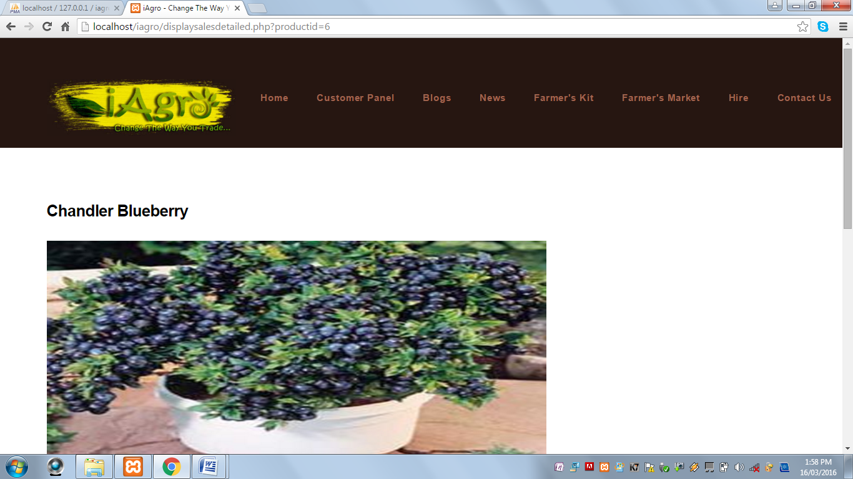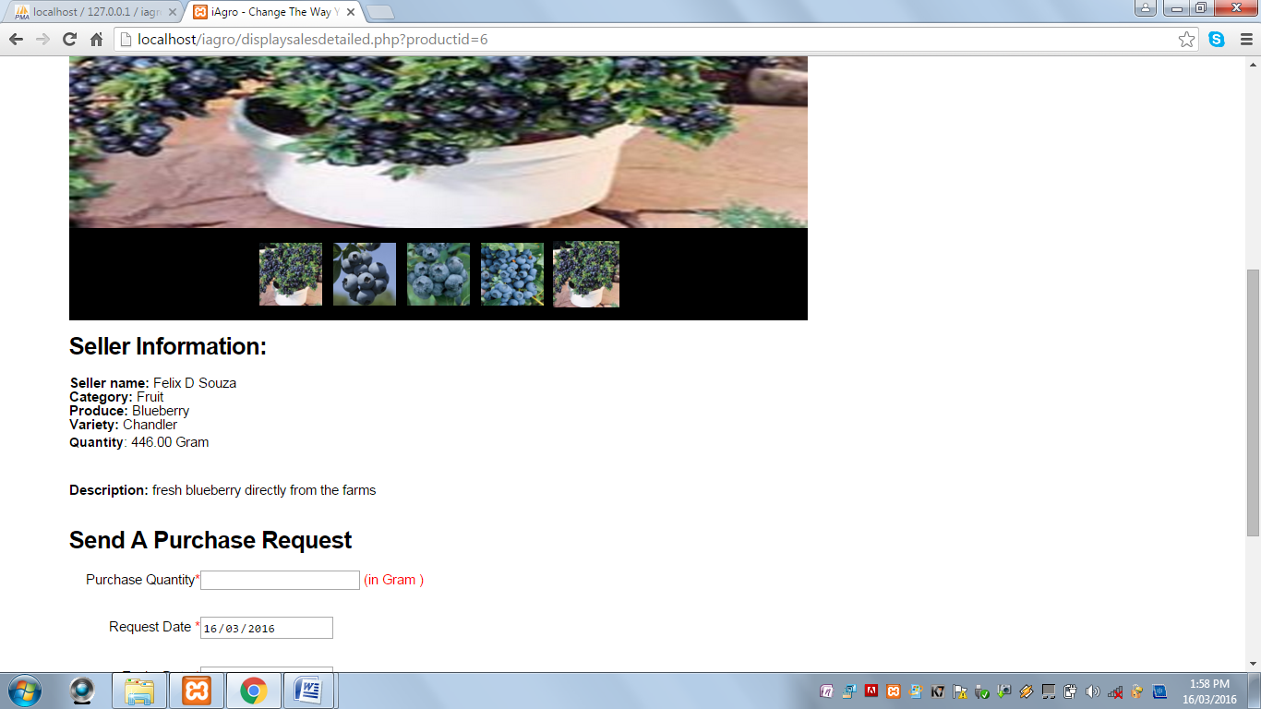 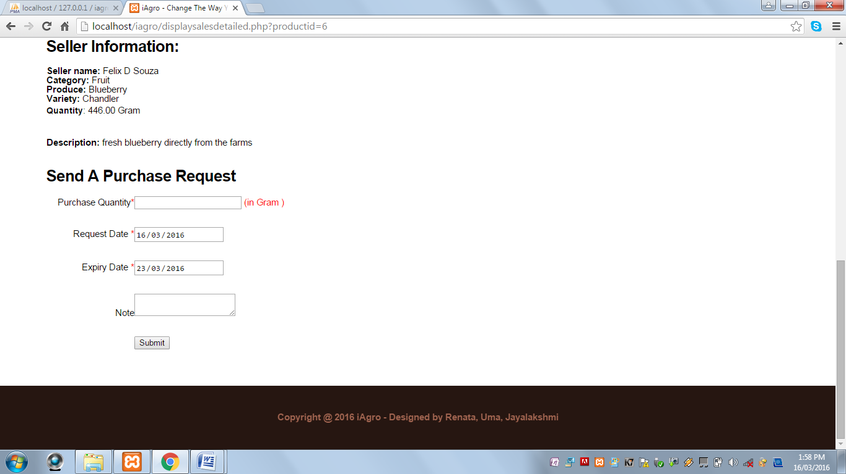

When Submit button is clicked and Purchase Quantity field is blank, the following alert message is displayed:

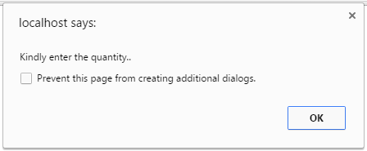

When Submit button is clicked and Purchase Quantity field contains value greater than the given quantity, then the following alert message is displayed:

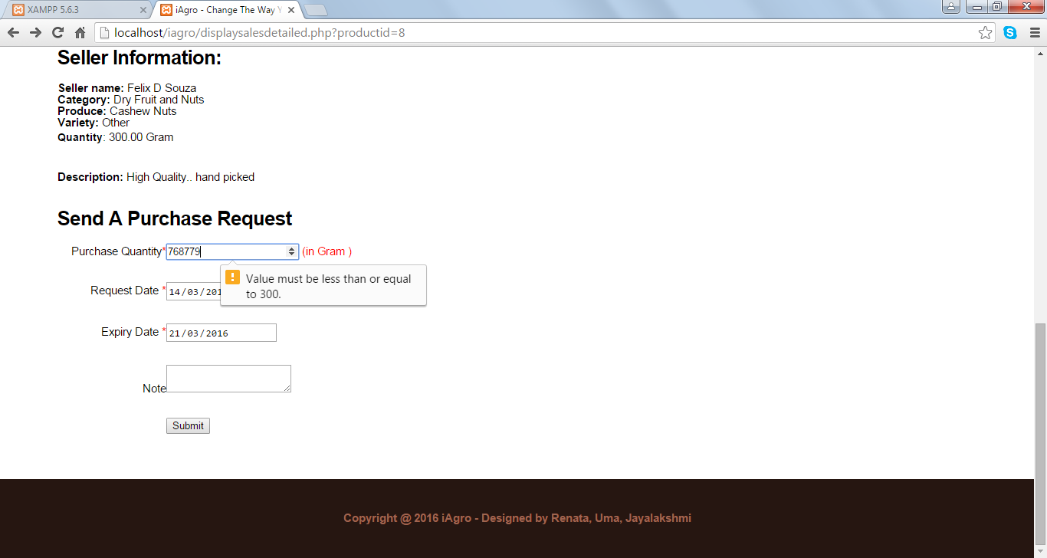

When Submit button is clicked and all the fields are successfully validated, the following alert message is displayed:

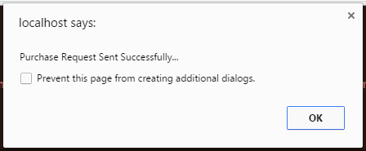

* When user clicks on the Sign Up link under the Farmer icon, the user is redirected to the Registration Page.

**Seller Registration Page:**

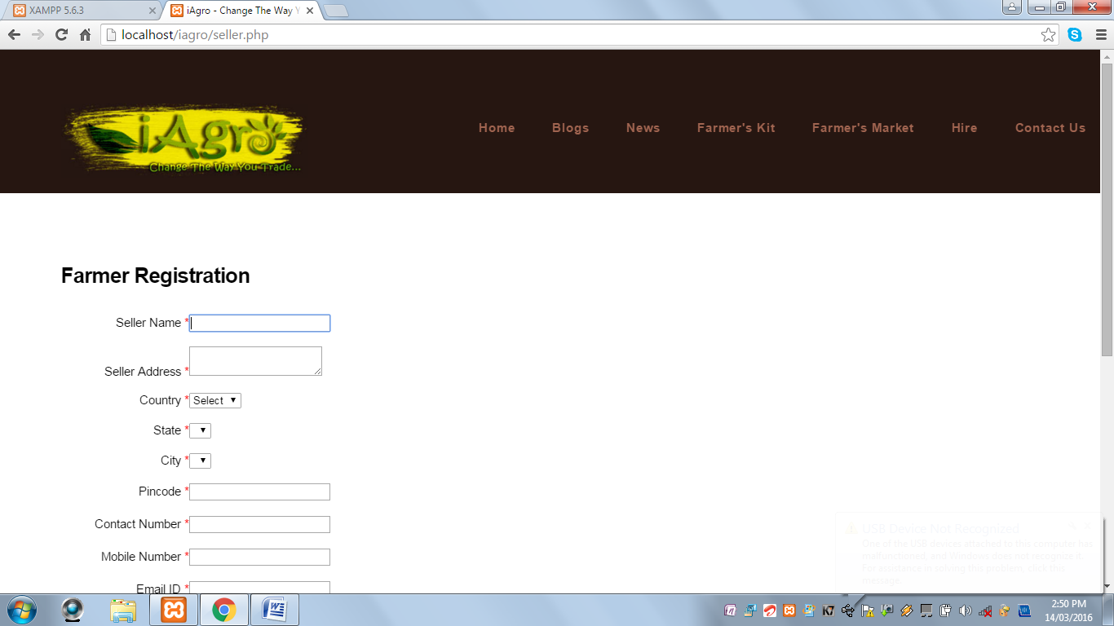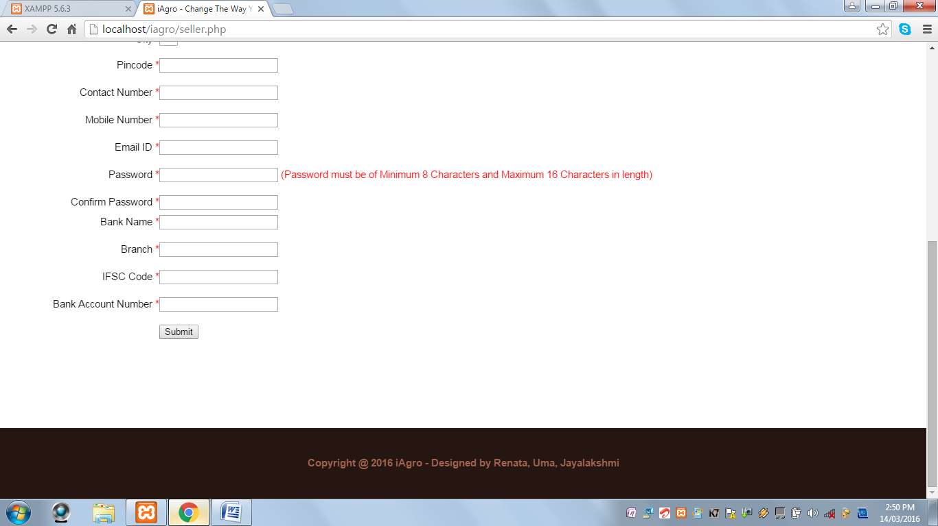

When Submit button is clicked and Seller Name field is blank, the following alert message is displayed:

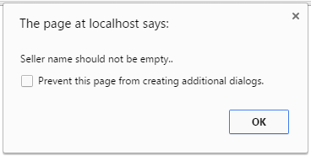

When Submit button is clicked and Seller Name contains value other than alphabets and spaces, the following alert message is displayed:



When Submit button is clicked and Seller Address field is blank, the following alert message is displayed:

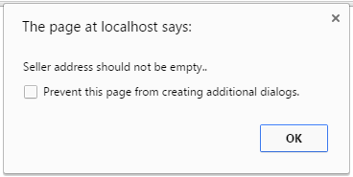

When Submit button is clicked and Country field is not selected, the following alert message is displayed:



When Submit button is clicked and State field is not selected, the following alert message is displayed:

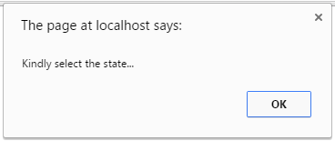

When Submit button is clicked and City field is not selected, the following alert message is displayed:



When Submit button is clicked and PIN Code field is blank, the following alert message is displayed;



When Submit button is clicked and PIN Code field contains values other than numeric values, the following alert message is displayed:



When Submit button is clicked and Contact Number field is blank, the following alert message is displayed:



When Submit button is clicked and Contact Number field contains values other than numeric values, the following alert message is displayed:



When Submit button is clicked and Mobile Number field is blank, the following alert message is displayed:



When Submit button is clicked and Mobile Number field contains values other than numeric values, the following alert message is displayed:



When Submit button is clicked and E-Mail ID field is blank, the following alert message is displayed:



When Submit button is clicked and E-Mail ID field contains an invalid E-Mail ID, the following alert message is displayed:



When Submit button is clicked and Password field is blank, the following alert message is displayed:



When Submit button is clicked and Password length is less than 8 characters, the following alert message is displayed:



When Submit button is clicked and Password length is greater than 16 characters, the following alert message is displayed:



When Submit button is clicked and Password and Confirm Password field does not match, the following alert message is displayed:



When Submit button is clicked and Bank Name field is blank, the following alert message is displayed:

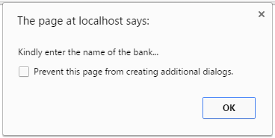

When Submit button is clicked and Bank Name field contains values other than alphabets and spaces, the following alert message is displayed:

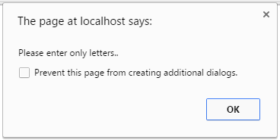

When Submit button is clicked and Bank Branch field is blank, the following alert message is displayed:

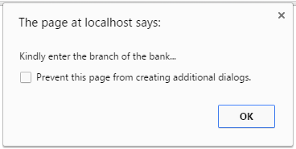

When Submit button is clicked and Bank Branch field contains values other than alphabets and spaces, the following alert message is displayed:



When Submit button is clicked and IFSC Code field is blank, the following alert message is displayed:

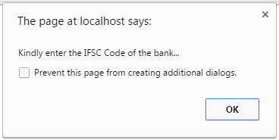

When Submit button is clicked and Bank Account Number field is blank, the following alert message is displayed:



When Submit button is clicked and Bank Account Number field contains values other than numeric values, the following alert message is displayed:

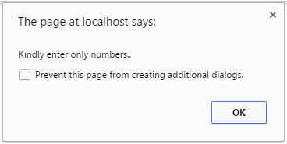

When Submit button is clicked and all the fields are successfully validated, the following alert message is displayed and the user is directed to the Seller Login Panel Page:

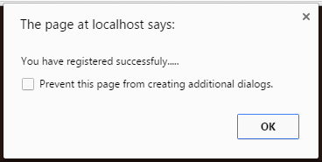

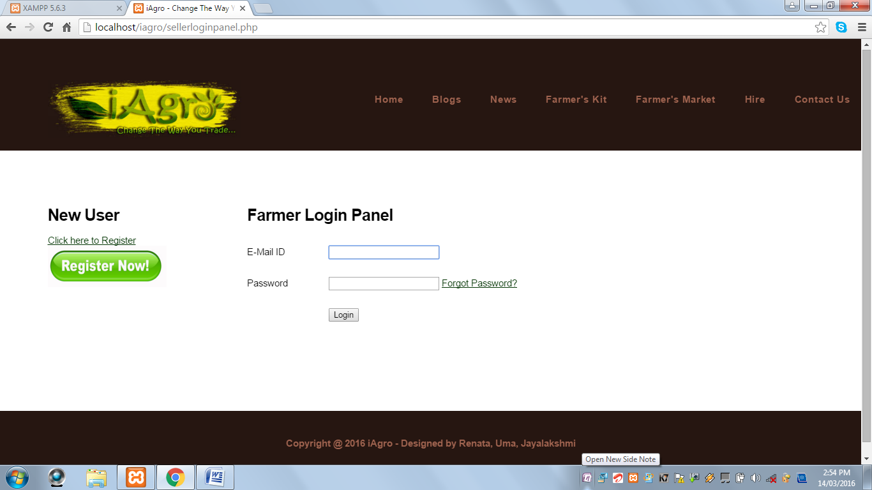

* It contains Register Now Link and Button to redirect user to the Registration Page, if the user is not registered.
* This page displays Farmer Login Form.
* It contains a Forgot Password Link.

**Farmer Panel:** This page is displayed when the farmer has successfully logged in. It contains a Left Navigation Menu with various options.

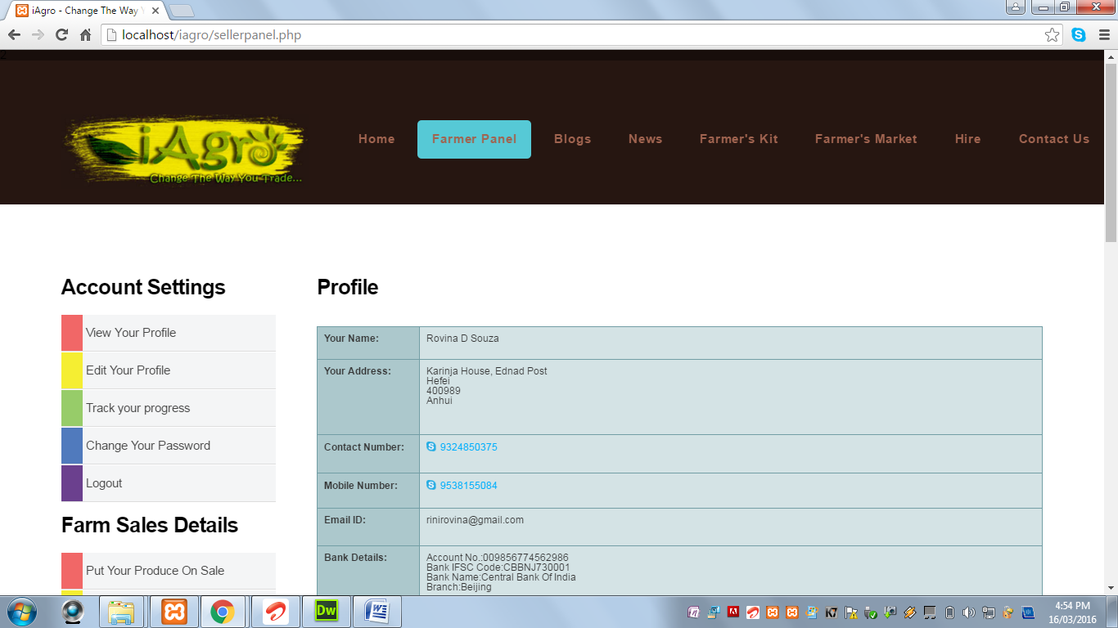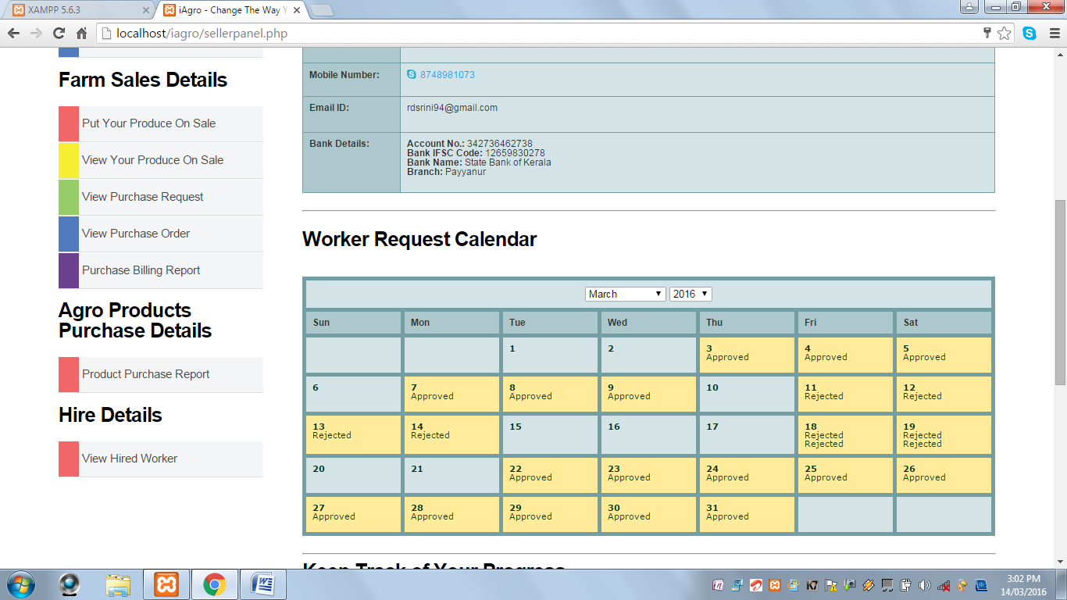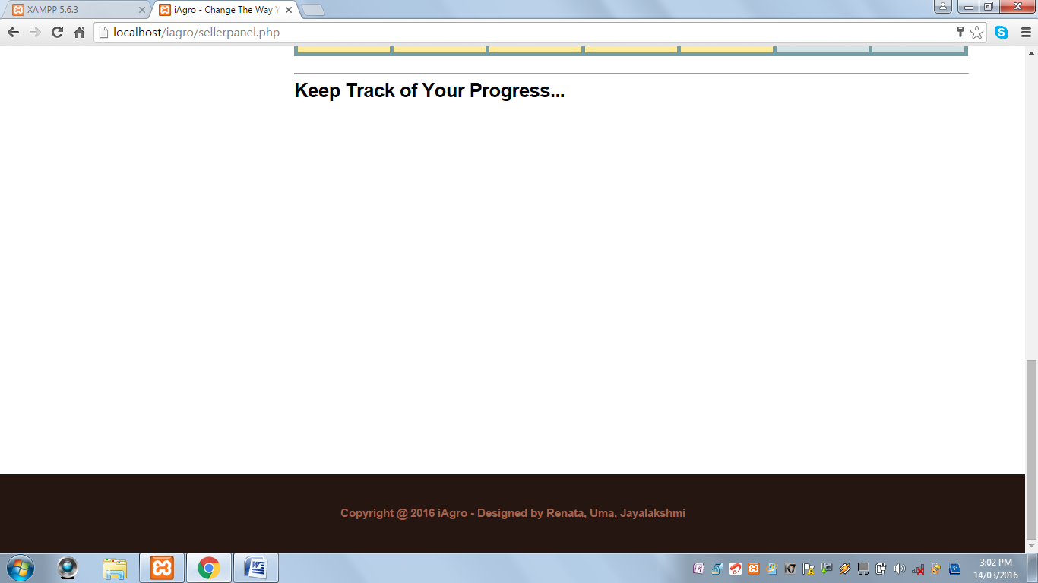

**View Your Profile:** This page displays the farmer information such as name, address, contact information and bank details, etc. It also displays a calendar with dates highlighted indicating the workers scheduled for that particular day.

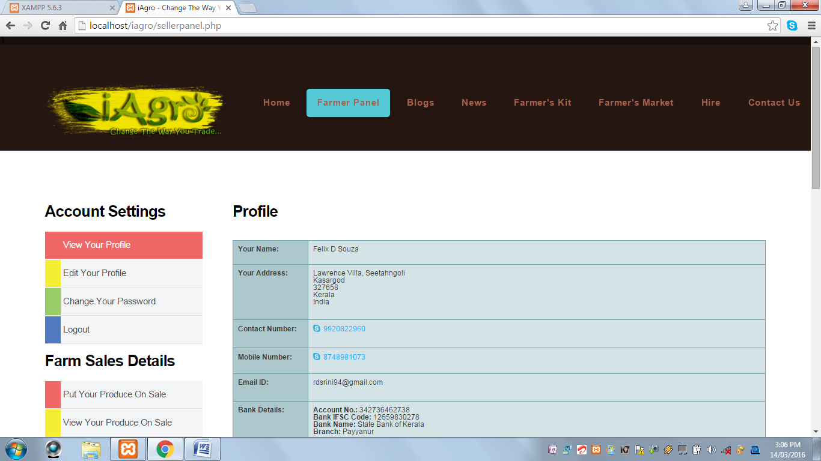

**Edit Your Profile:** This page displays a form to keep the farmer’s information updated.

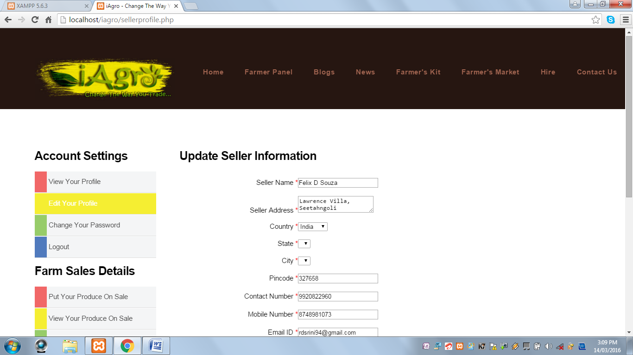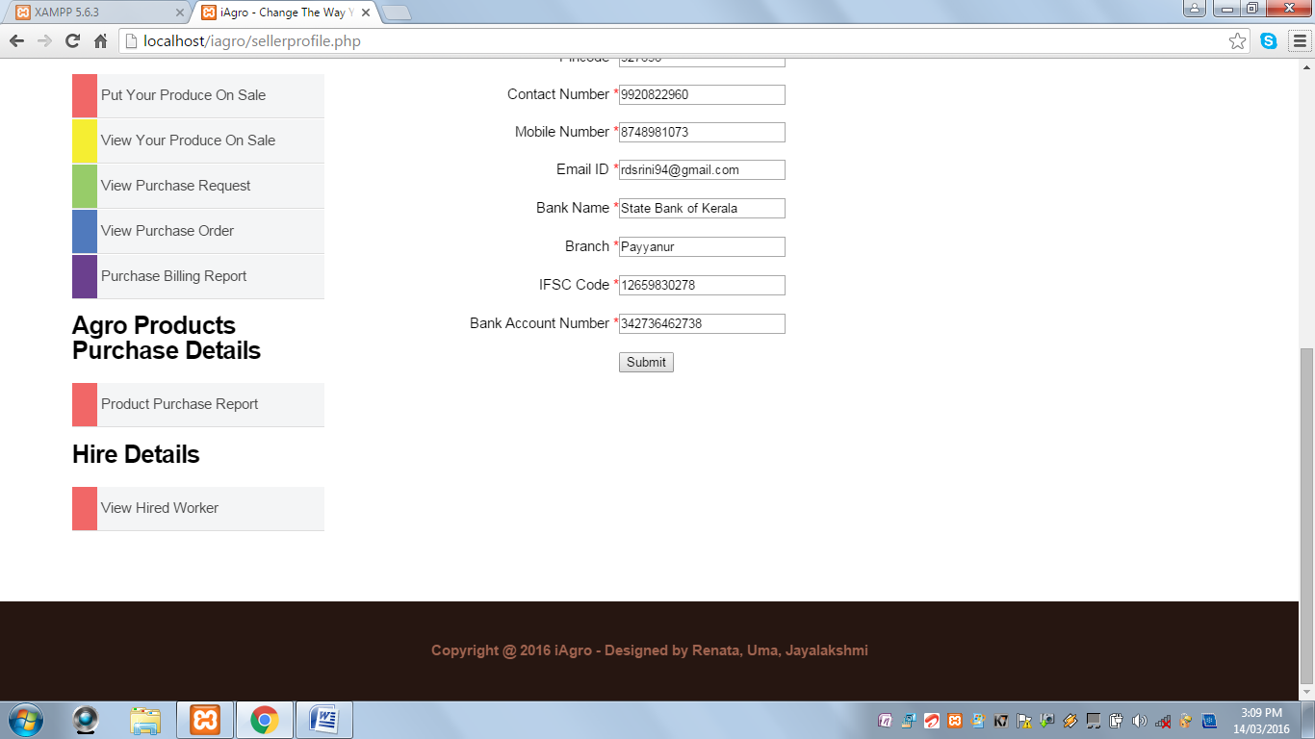

**Track Your Progress:** This page displays a dynamic graph representing produce sales of that particular farmer.

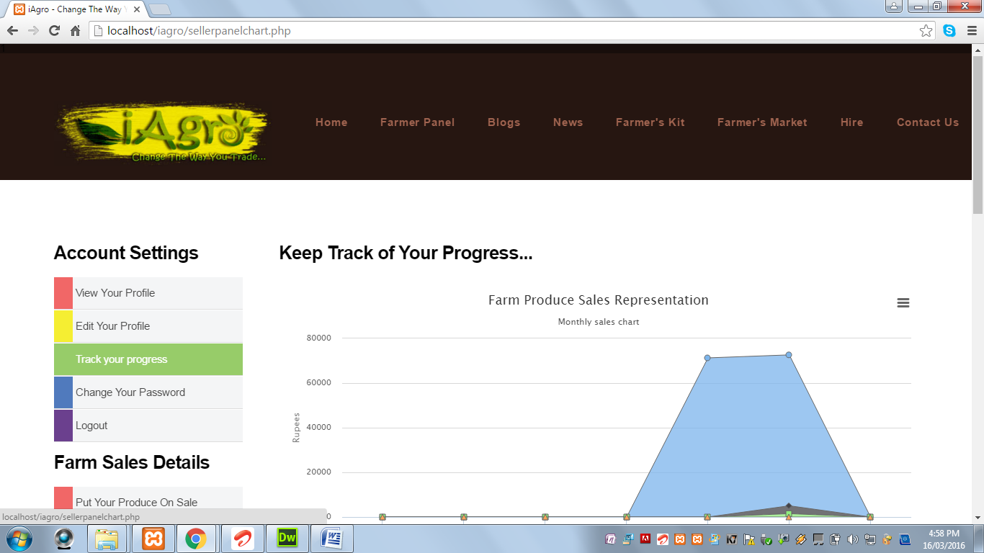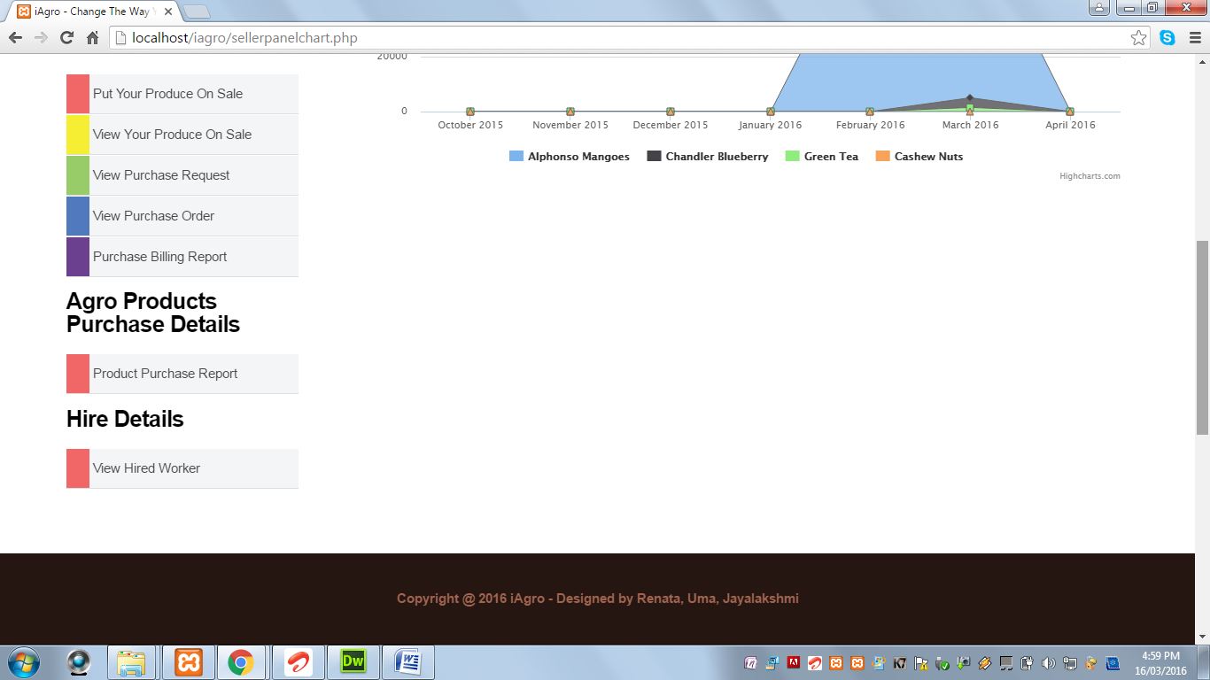

**Change Your Password:** This page displays a form to reset the password.

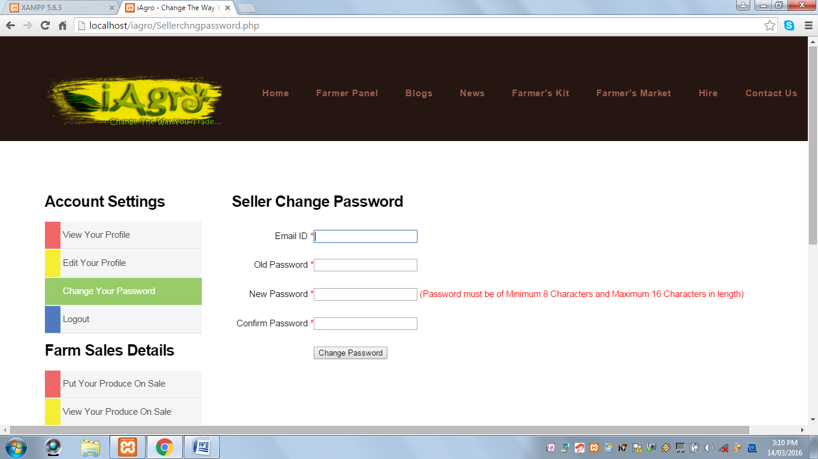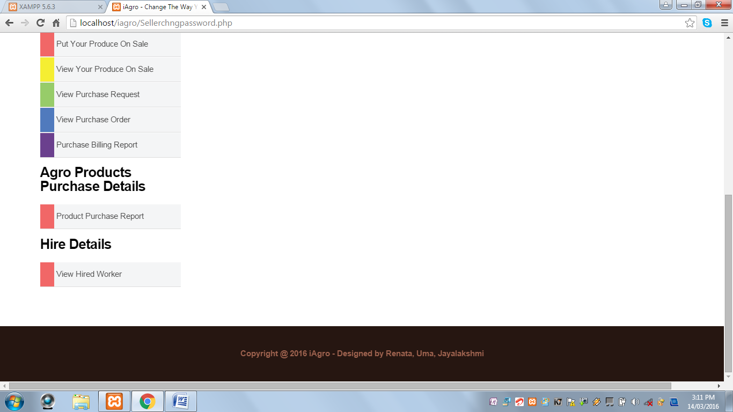

**Logout:** This option helps the farmer to log out of the account.

**Put Your Produce On Sale:** This page displays a form to upload a farm produce for online sale by the farmer.

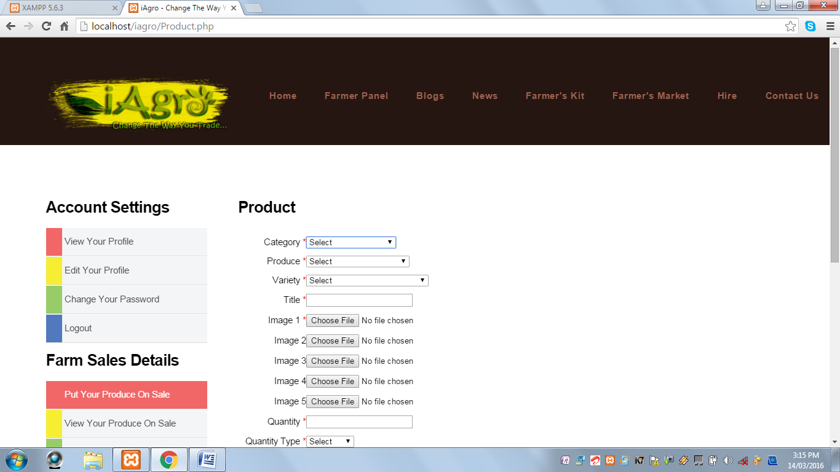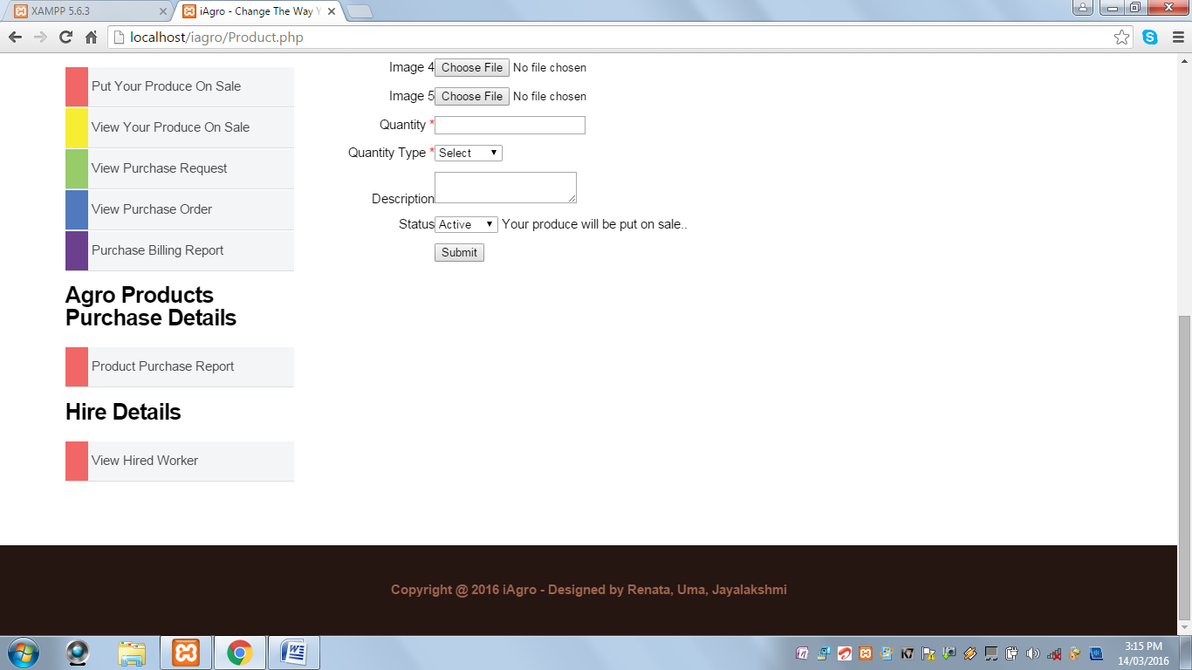

When Submit button is clicked and Category field is not selected, the following alert message is displayed:

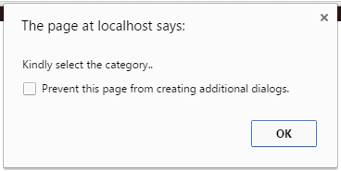

When Submit button is clicked and Produce field is not selected, the following alert message is displayed:

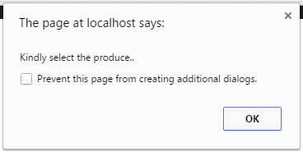

When Submit button is clicked and Variety field is not selected, the following alert message is displayed:

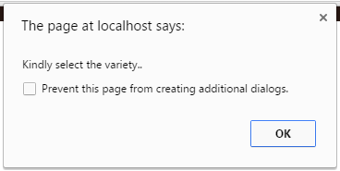

When Submit button is clicked and Title field is blank, the following alert message is displayed:

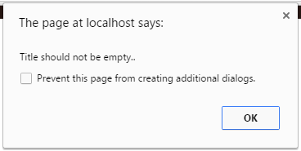

When Submit button is clicked and at least one image is not uploaded, the following alert message is displayed:

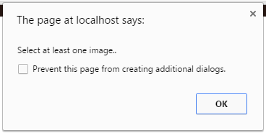

When Submit button is clicked and Quantity field is blank, the following alert message is displayed:

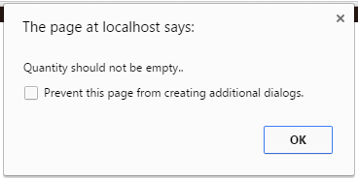

When Submit button is clicked and Quantity field contains values other than numeric values, the following alert message is displayed:

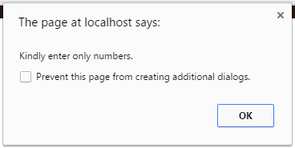

When Submit button is clicked and Quantity Type field is not selected, the following alert message is displayed:

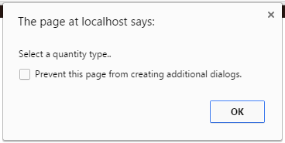

When Submit button is clicked and all the required fields are successfully validated, the following alert message is displayed:

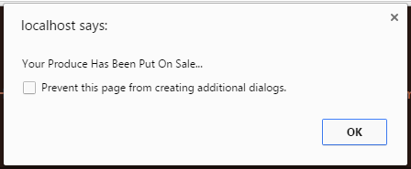

**View Your Produce on Sale:** This page displays the farm produces that the farmer has uploaded. It also contains Edit option for the farmer to Inactivate or Activate the produce put on sale and Delete option to delete the produce put on sale.

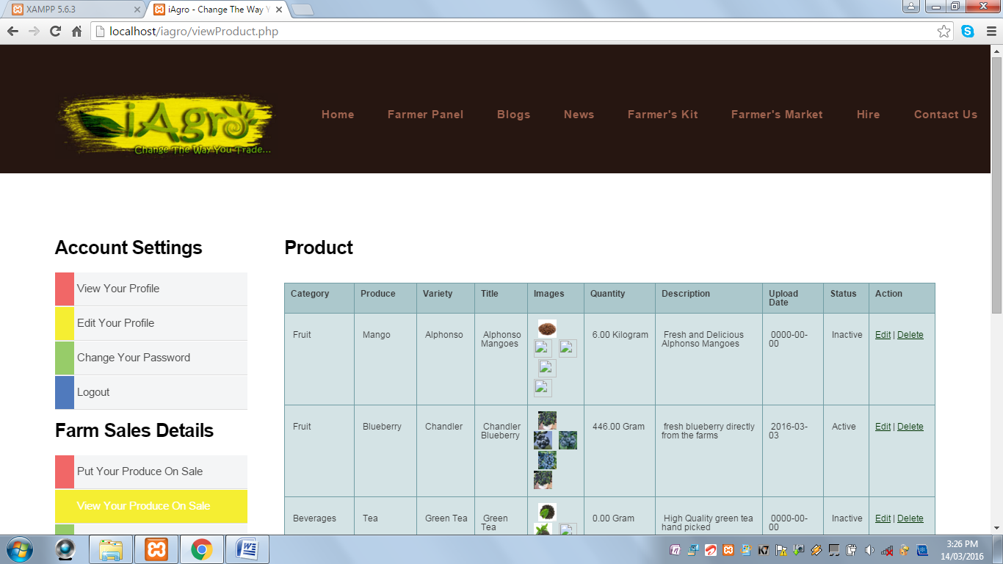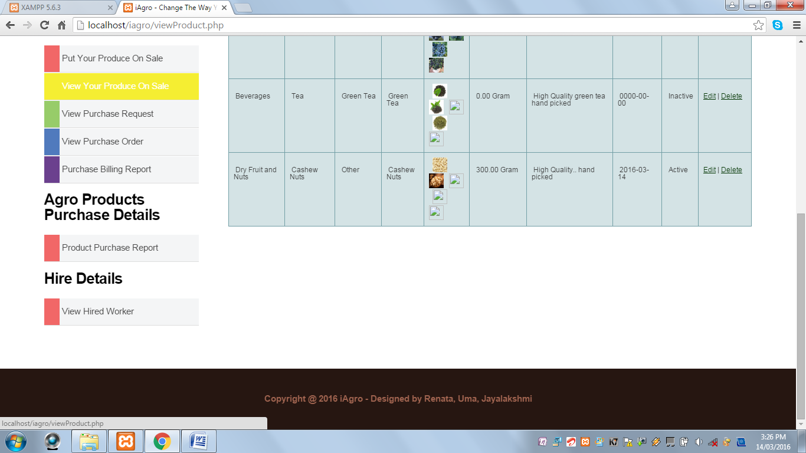

* When the Edit option is clicked, the following page is displayed:

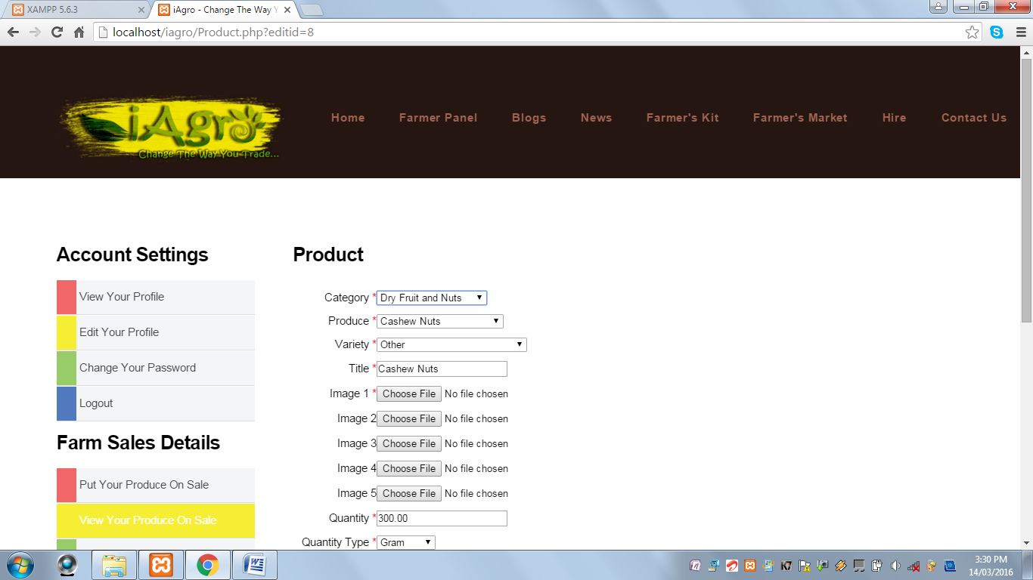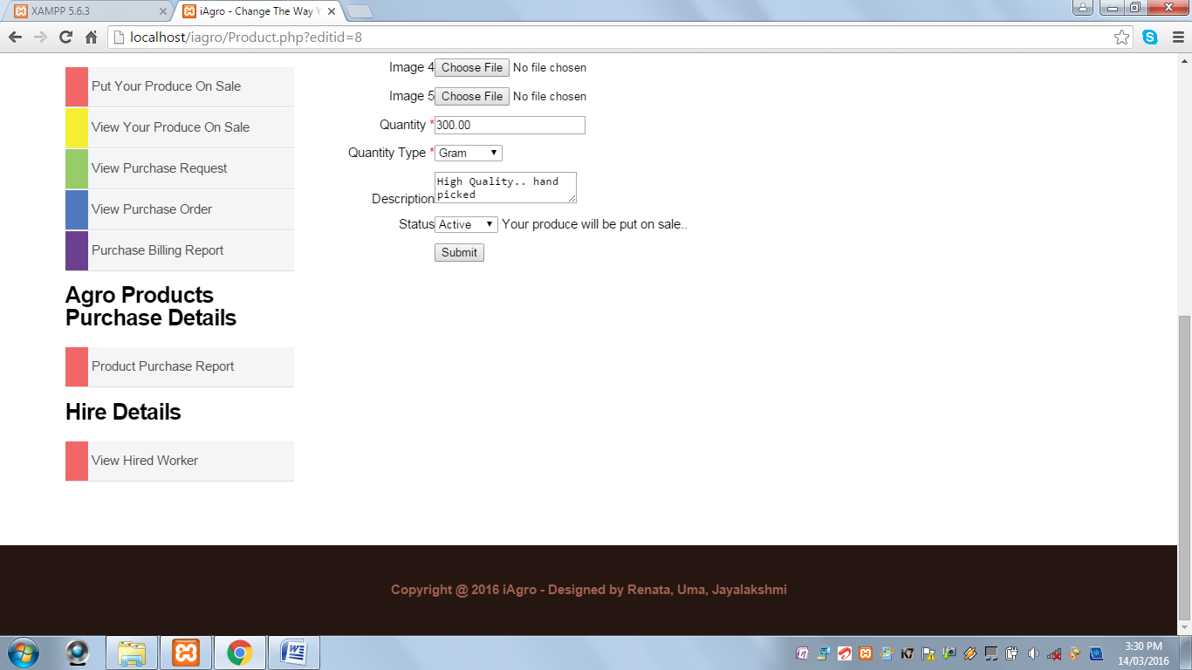

* When Delete option is clicked, the corresponding record is deleted and the produce is not on sale.

**View Purchase Request:** This page displays the produces for which the purchase request has been sent by the customers. It contains Send Purchase Order option to quote the price and Delete option to delete the purchase request.

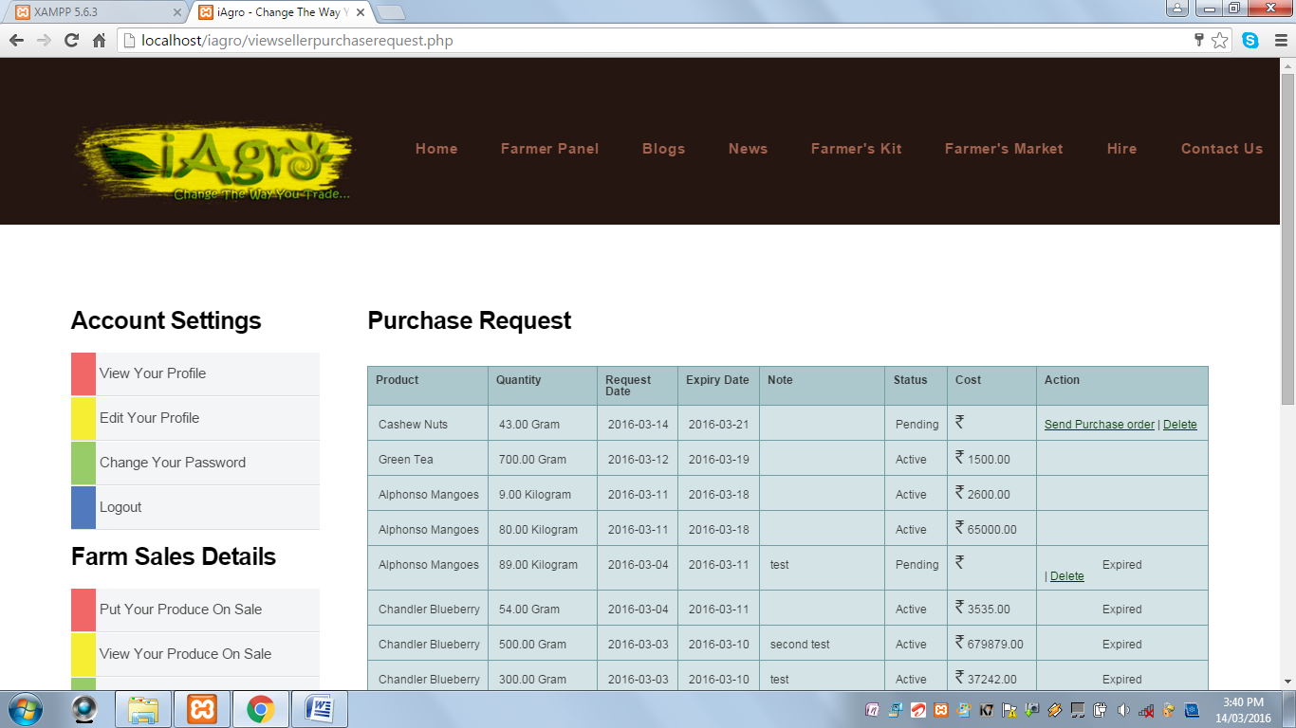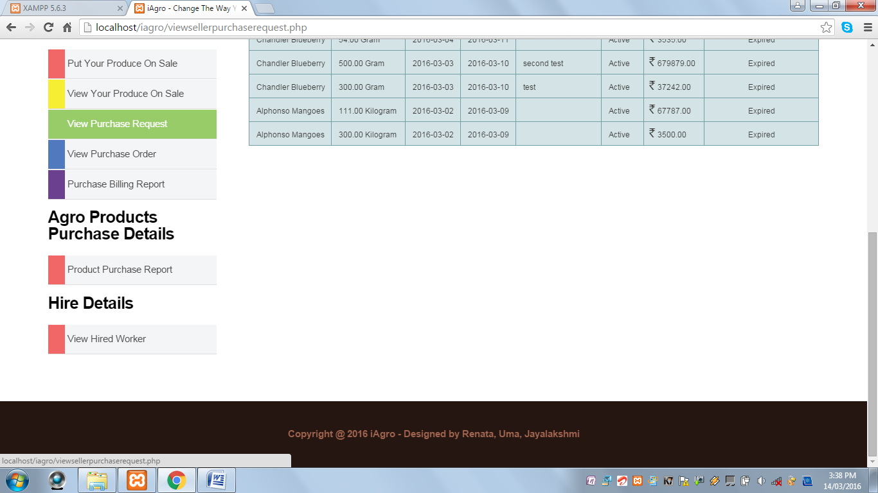

* When Send Purchase Order link is clicked, the following page is displayed:

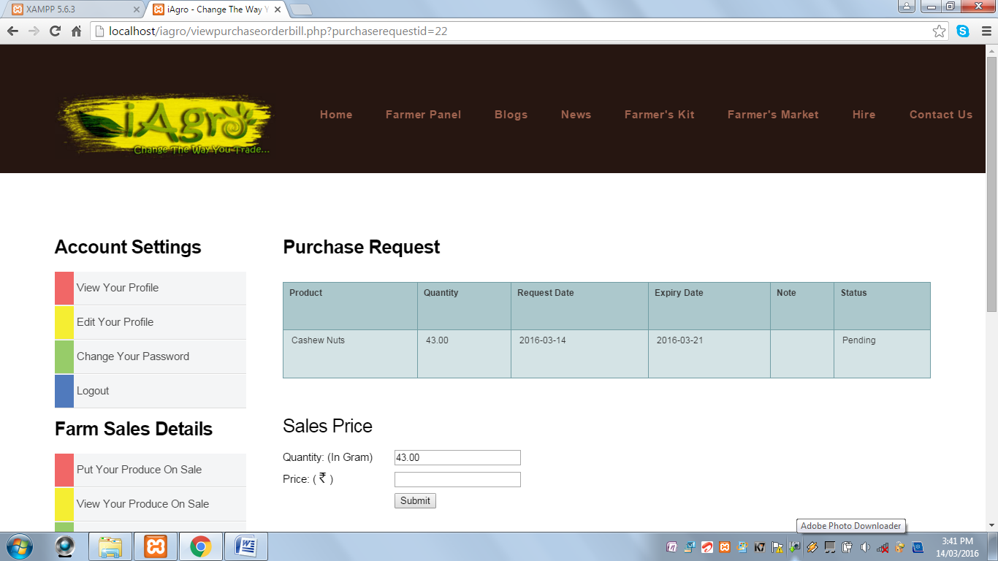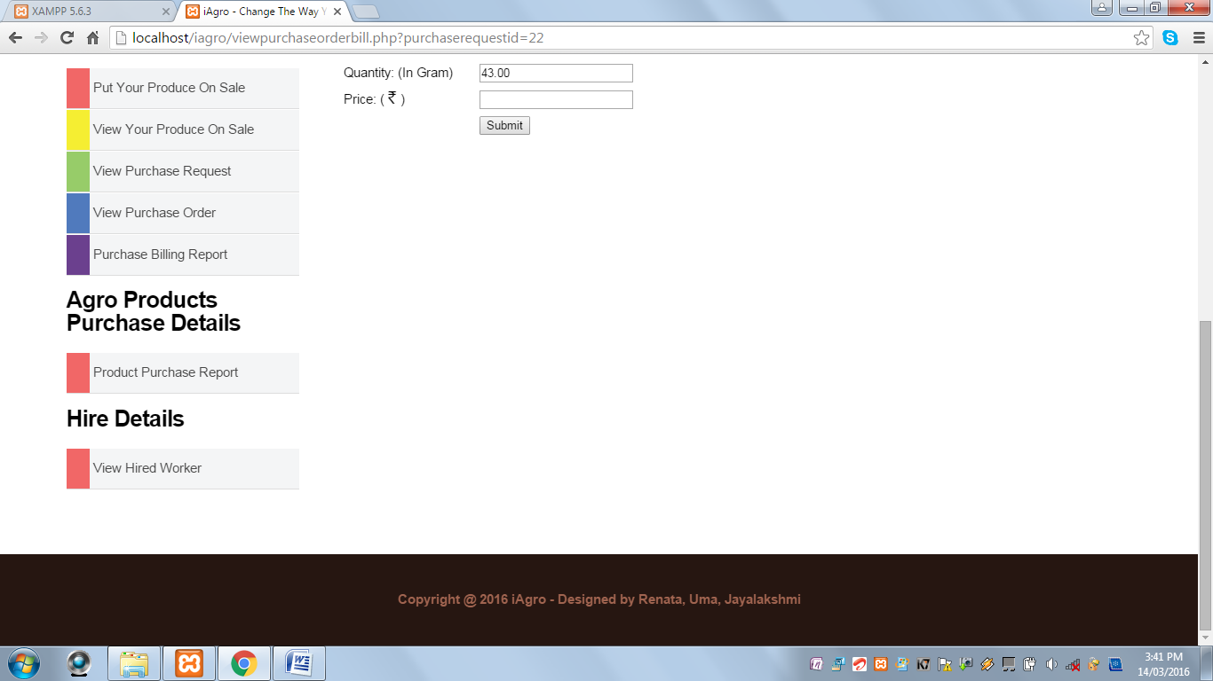

When Submit Button is clicked and Price field is blank, the following alert message is displayed:

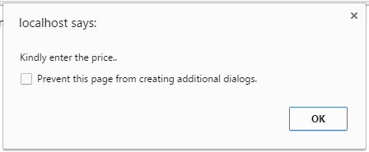

When Submit button is clicked and all the fields are successfully validated, the following alert message is displayed:

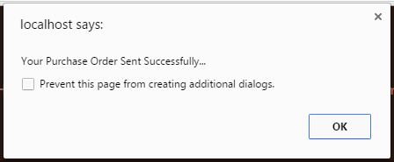

**View Purchase Order:** This page displays all the purchase orders sent by the farmer for his produce.

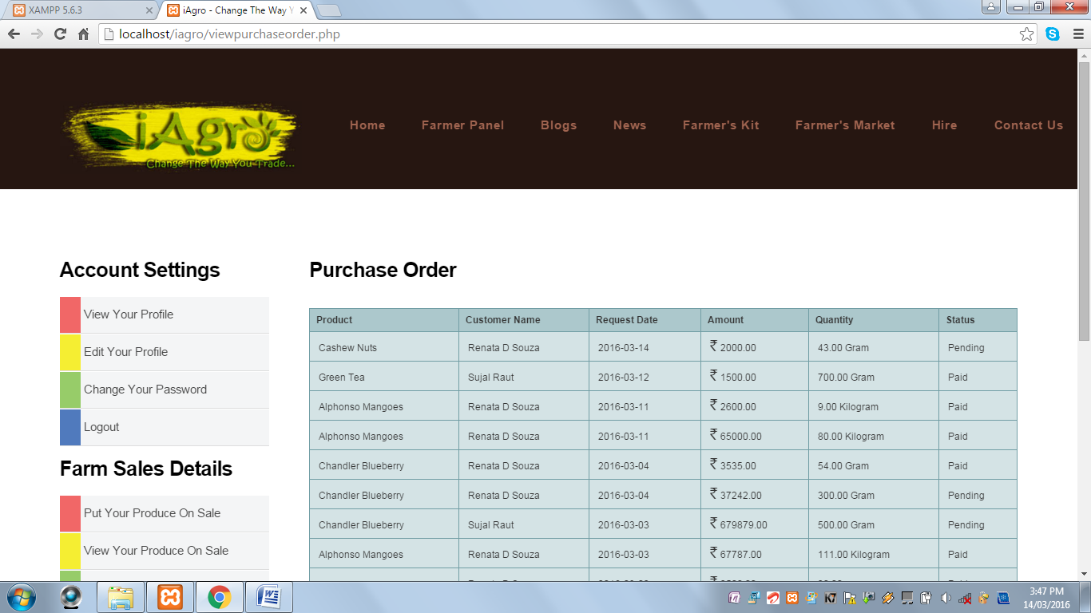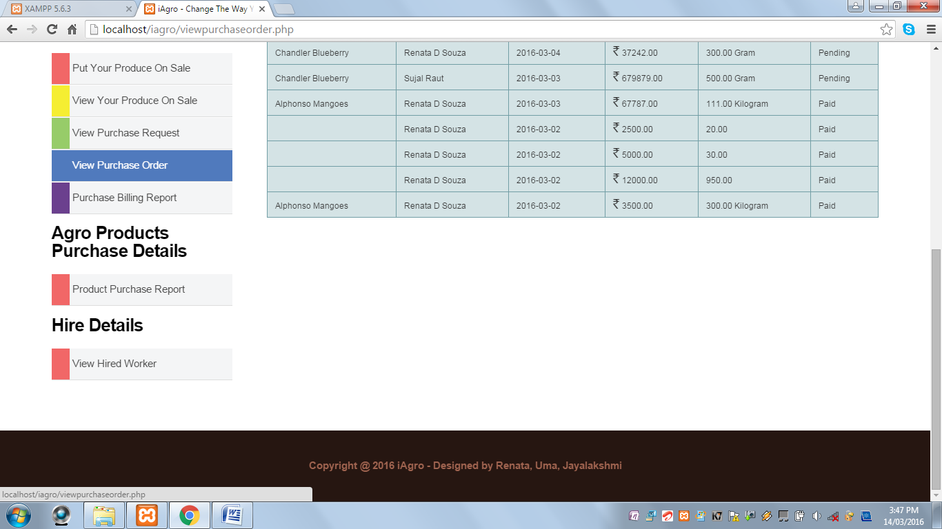

**Purchase Billing Report:** This page displays the billing report of the produces which has been sold by the farmer with Print option to print the corresponding bill.

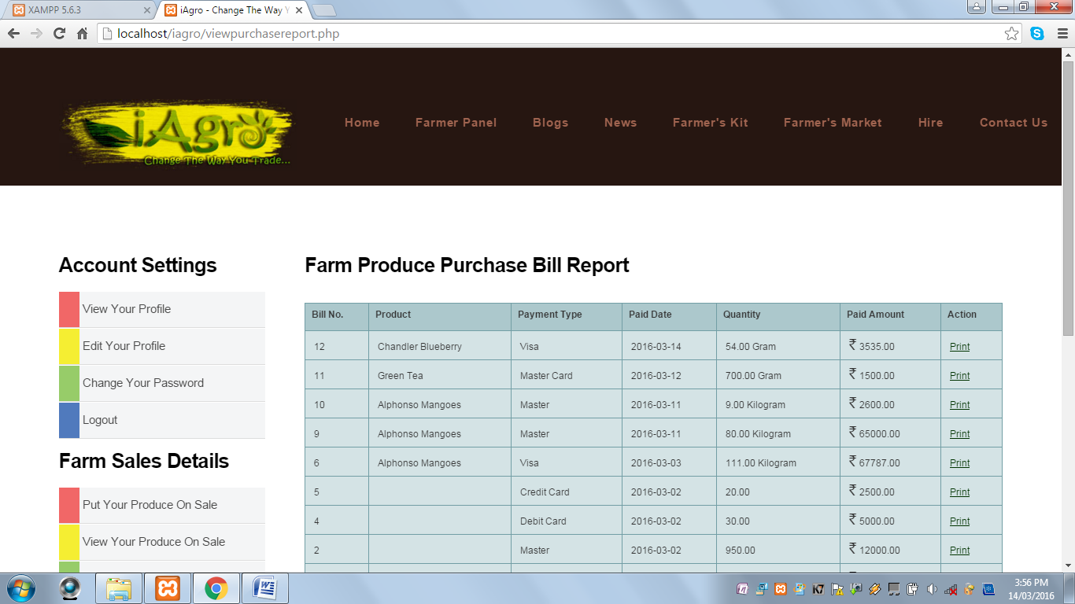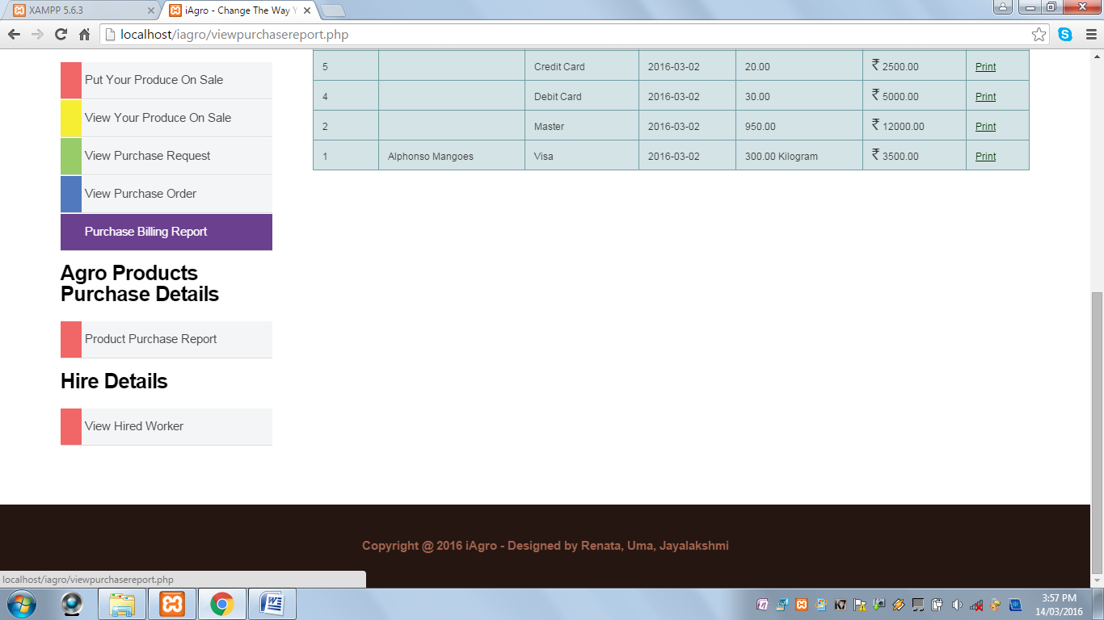

* When Print option is clicked, the Print window opens.

**Product Purchase Details:** This page displays products such as fertilizers, tools and equipments, etc. which are purchased by the farmer online with View Bill option to view the bill and print the bill.

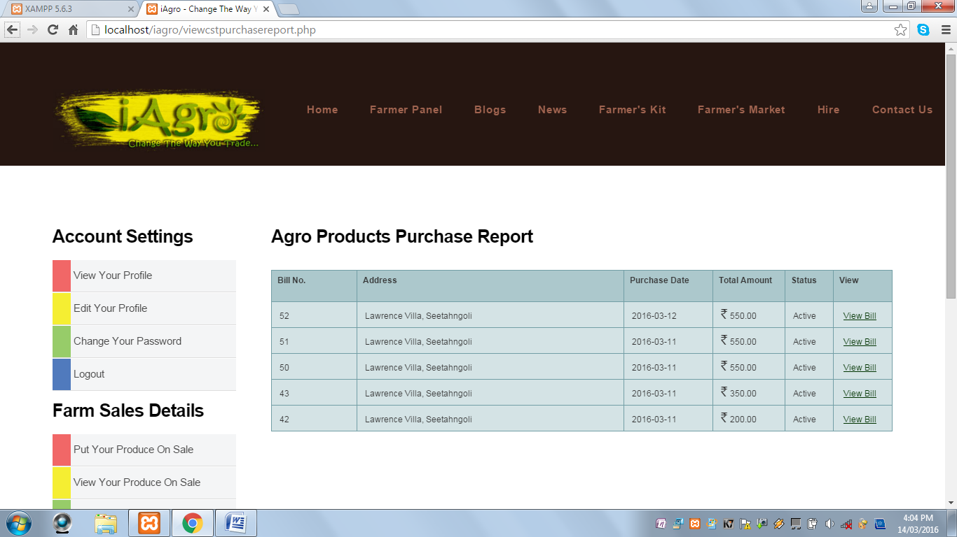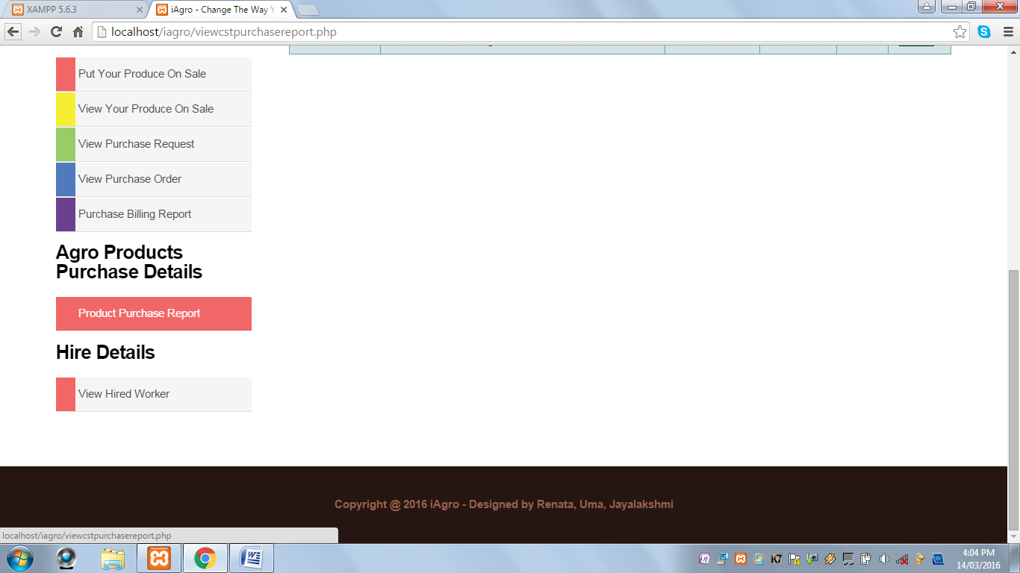

**View Hired Workers:** This page displays the worker to whom the farmer has sent work request. The farmer can Edit the sent request and also view the request.

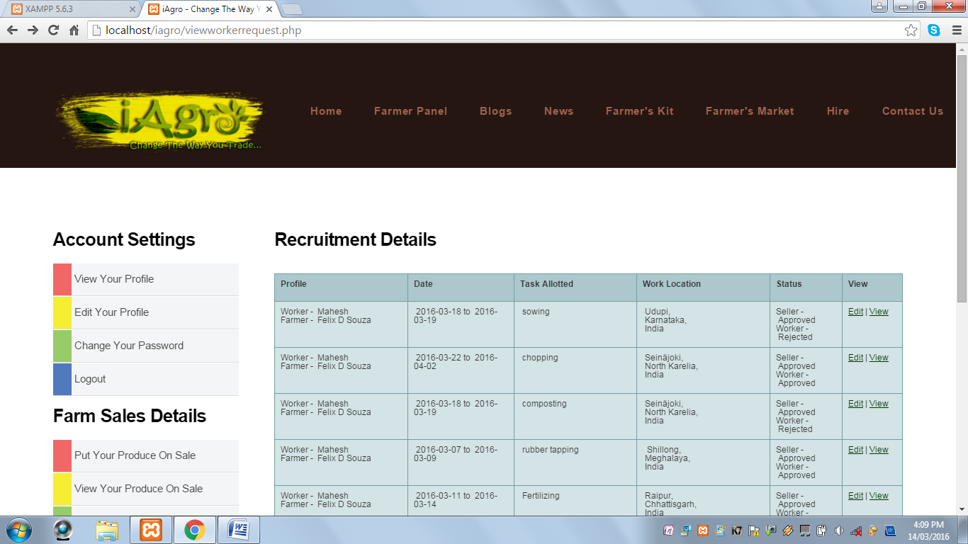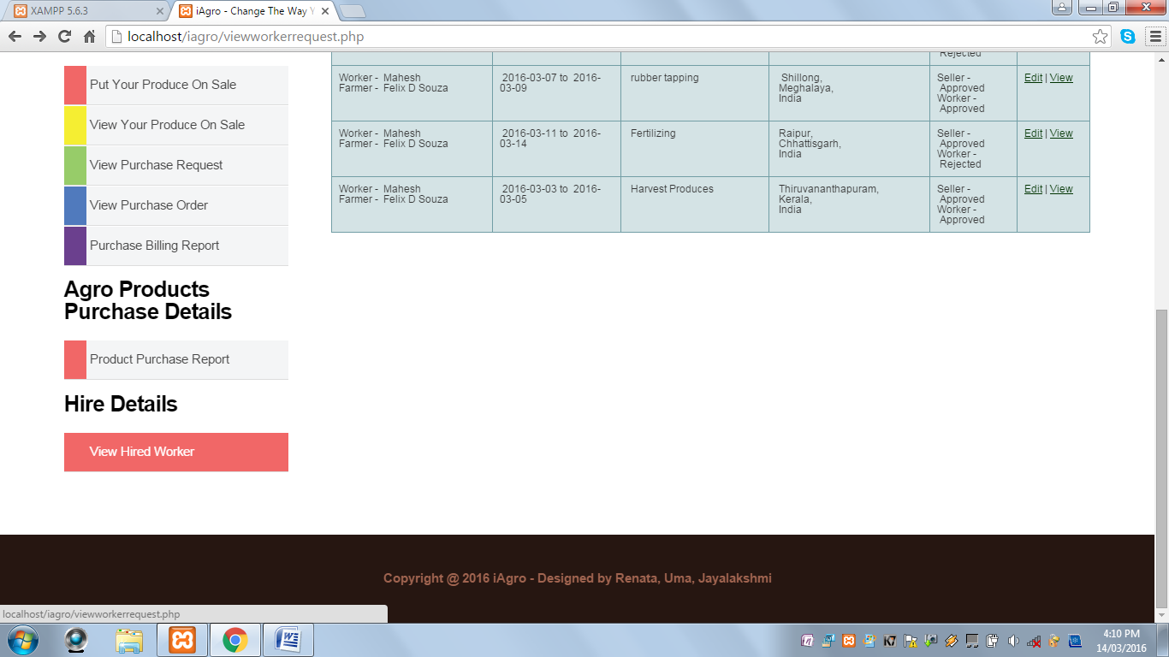

* When Edit option is clicked, the following page is displayed:

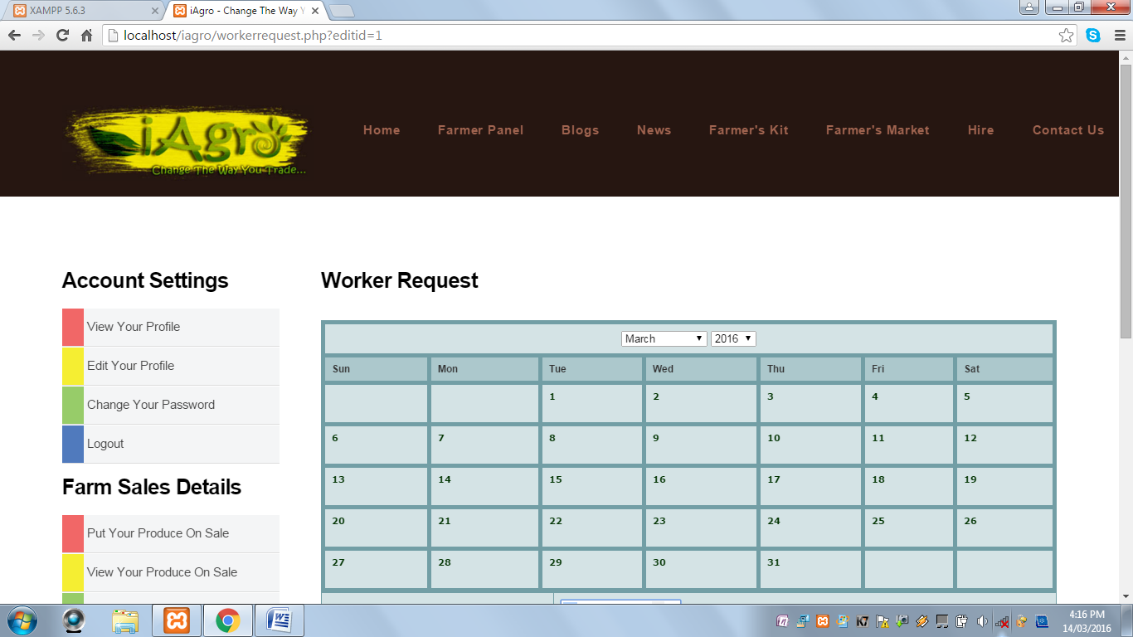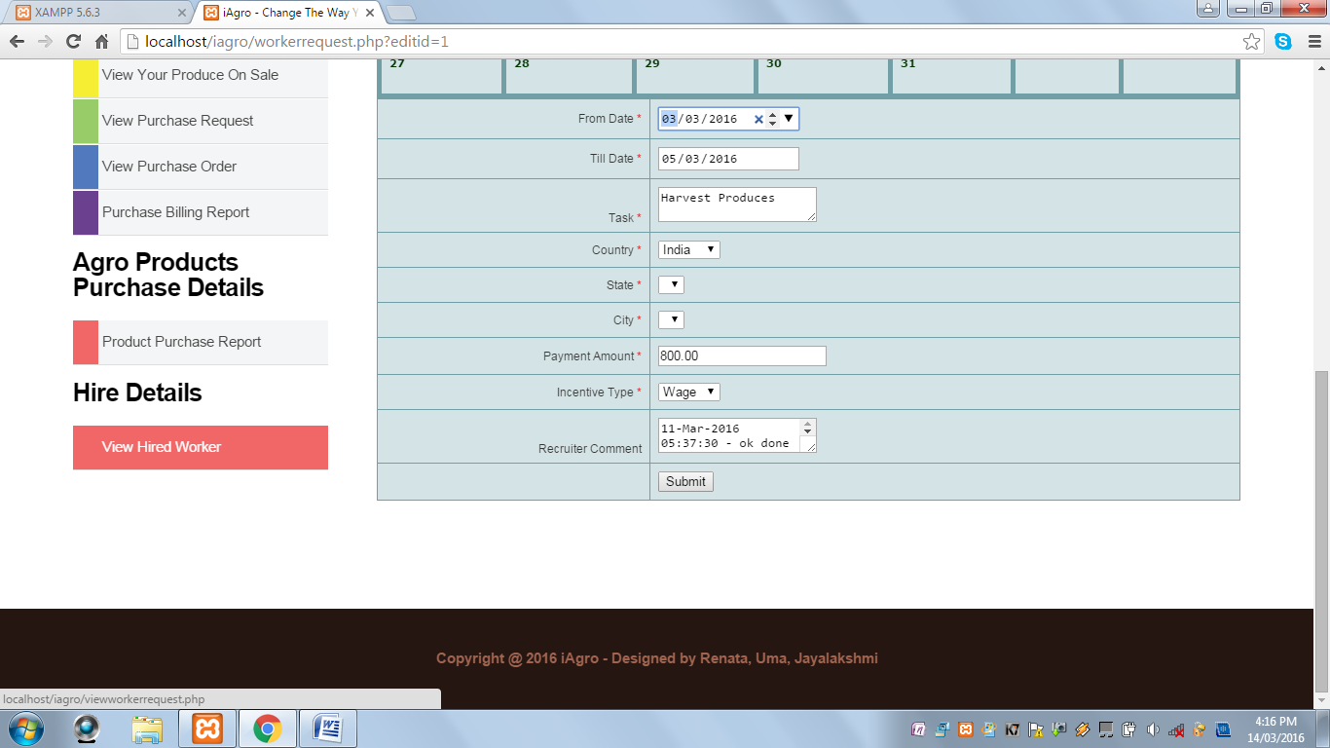

* When View option is clicked, the following page is displayed:

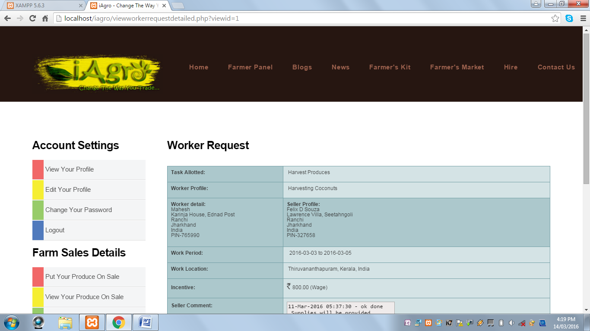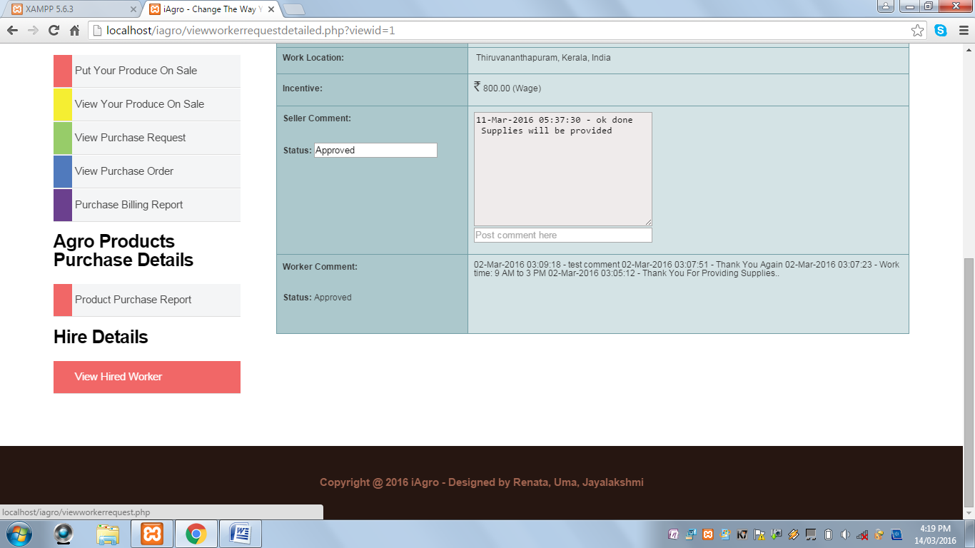

* When the farmer clicks on the Hire tab on the header, the following page is displayed:

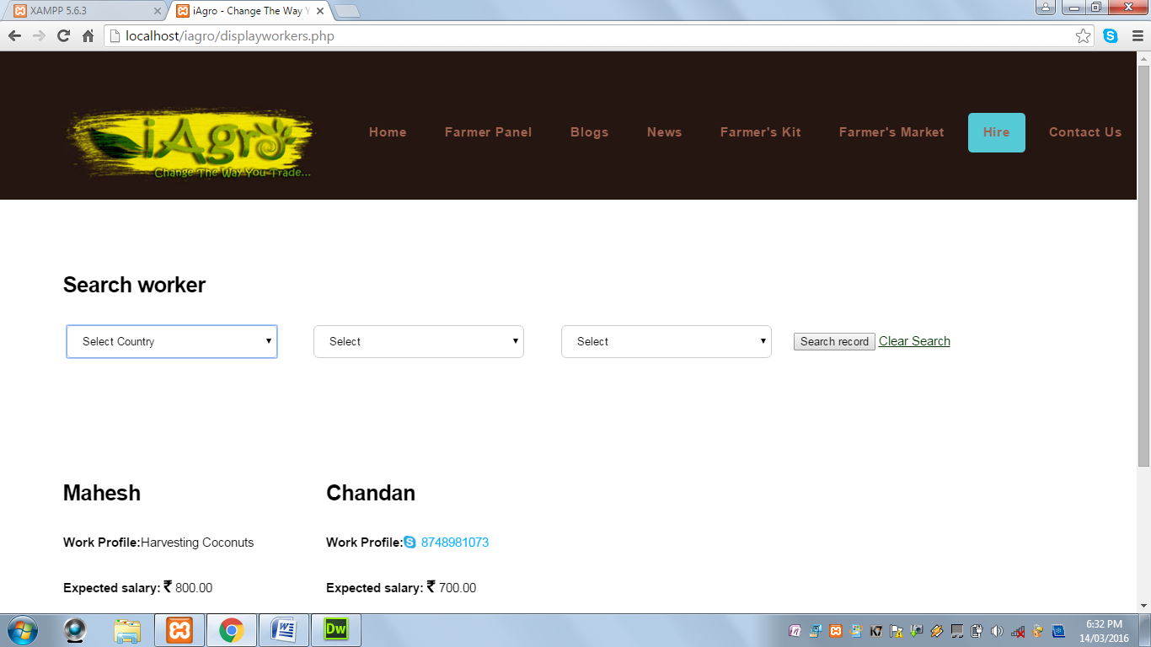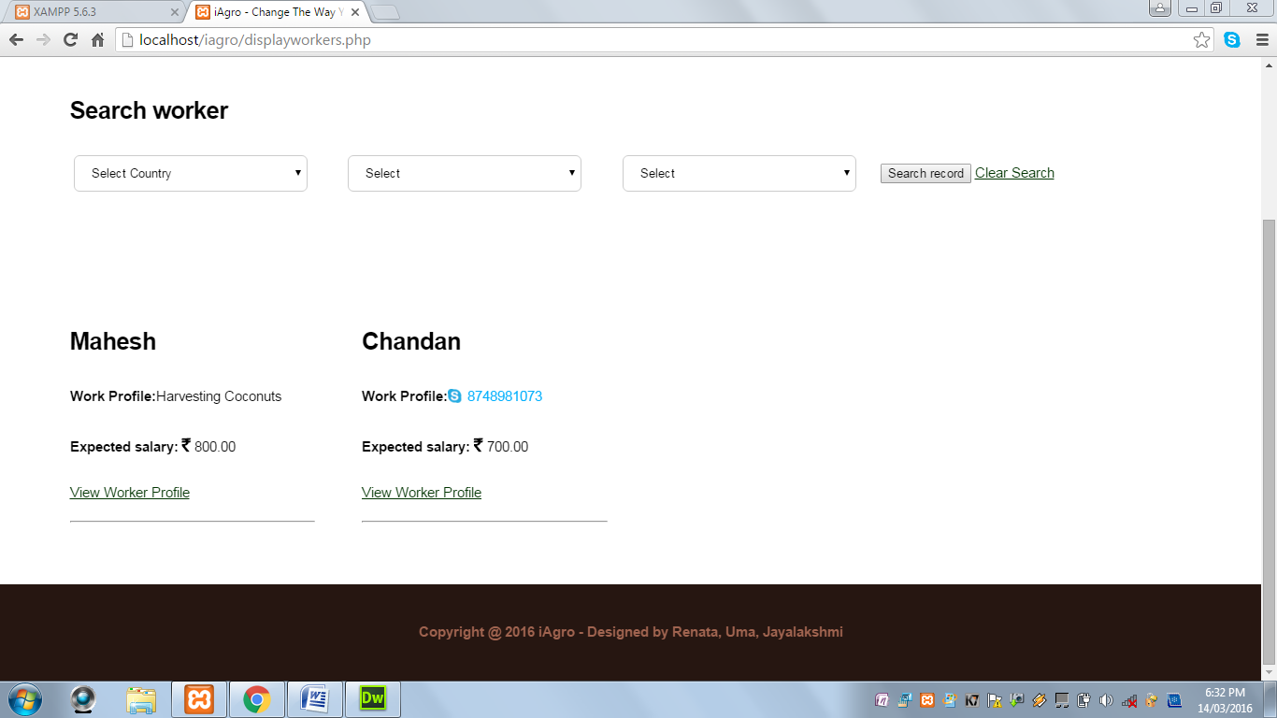

* The farmer can make use of search by location option on the top of the page to search workers from a specified location.
* When the farmer clicks on any one of the worker profiles, the following page is displayed:

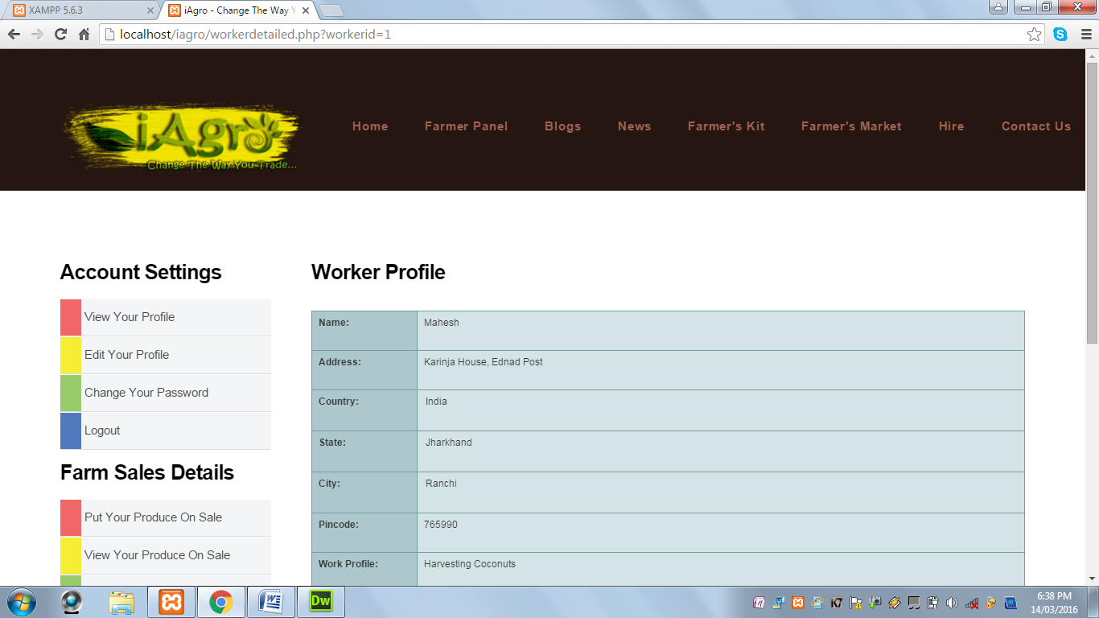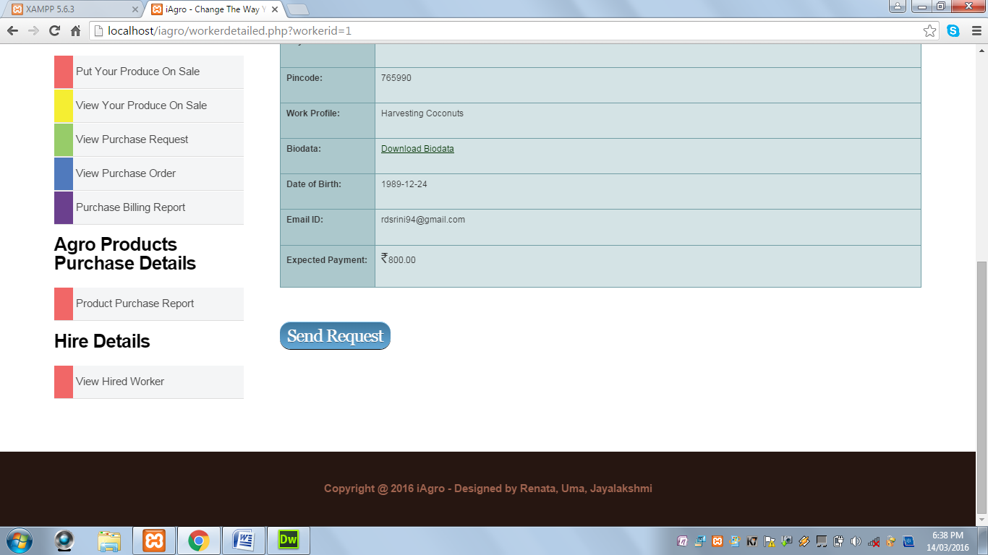

* This page contains worker’s profile with option to download the worker’s bio data and send a work request.
* When Send Request button is clicked, the following page is displayed:

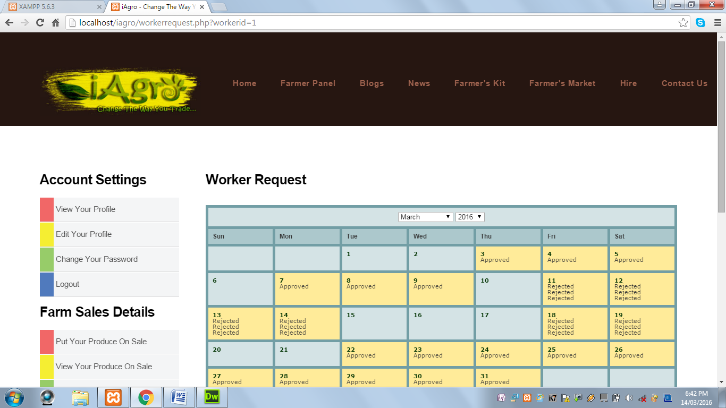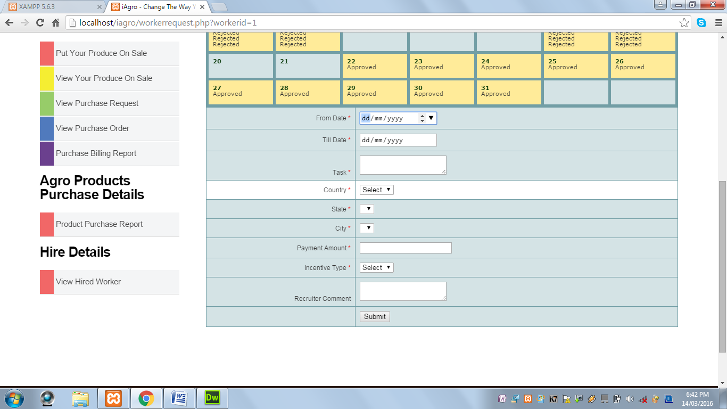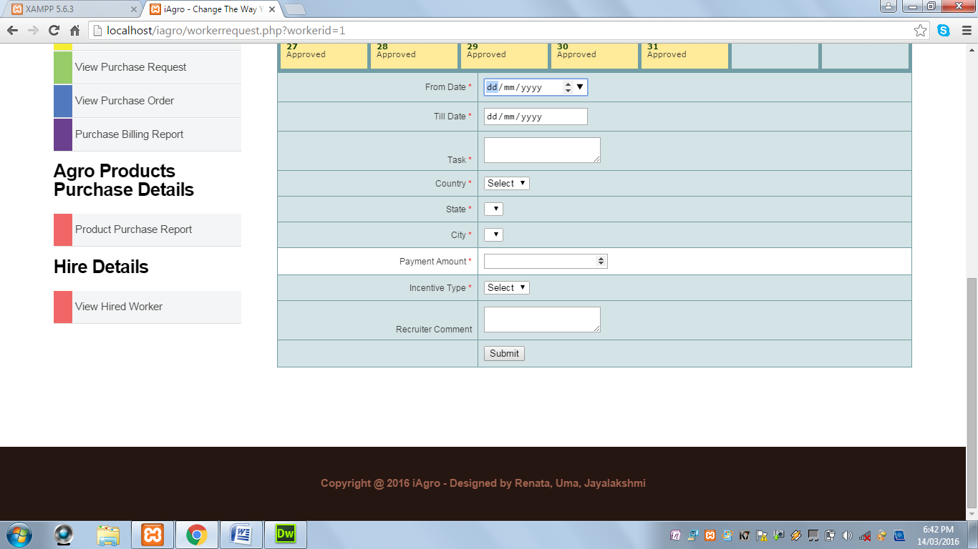

* This page contains a calendar where the farmer can view on which date the worker is available.

When Submit button is clicked and From Date is not selected, the following alert message is displayed:

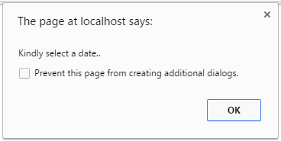

When Submit button is clicked and Till Date field is not selected, the following alert message is displayed:



When Submit button is clicked and Task field is blank, the following alert message is displayed:

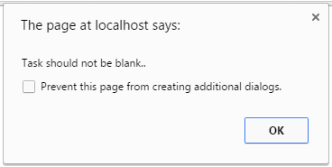

When Submit button is clicked and Country is not selected, the following alert message is displayed:



When Submit button is clicked and State is not selected, the following alert message is displayed:

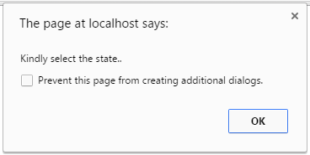

When Submit button is clicked and City is not selected, the following alert message is displayed:



When Submit button is clicked and Salary field is blank, the following alert message is displayed:

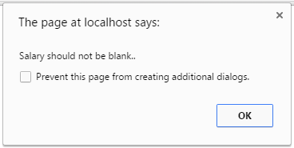

When Submit button is clicked and Salary field contains values other than numeric values, the following alert message is displayed:



When Submit button is clicked and Incentive Type is not selected, the following alert message is displayed:

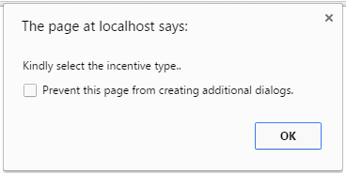

When Submit button is clicked and all the required fields are successfully validated, the following alert message is displayed:

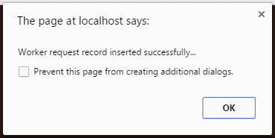

* When the user clicks on the Sign Up link under Worker icon, the following page is displayed:

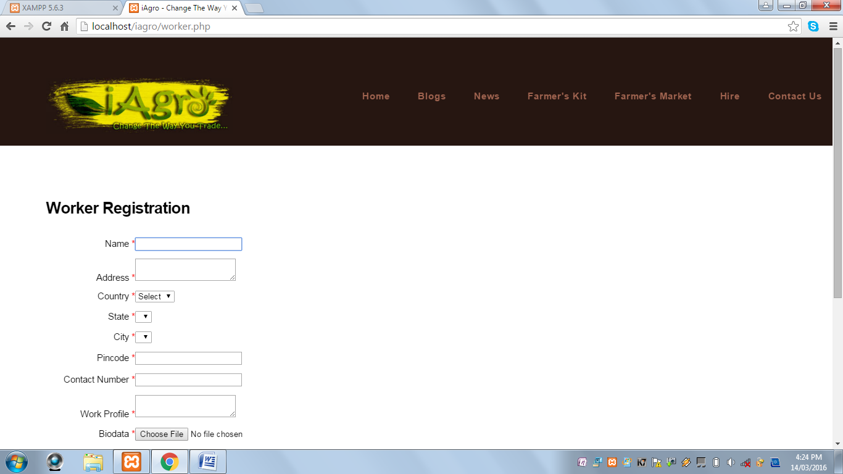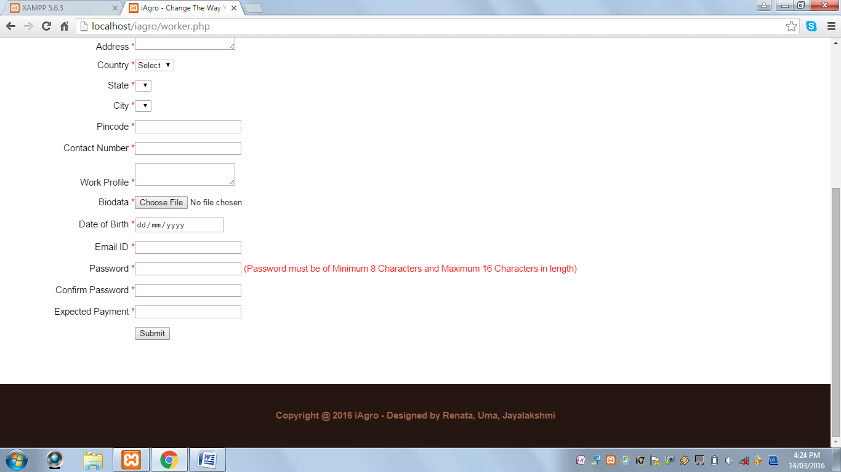

When Submit button is clicked and Name field is blank, the following alert message is displayed:

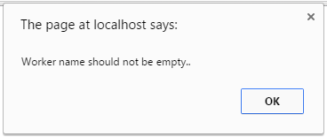

When Submit button is clicked and Name field contains values other than alphabets and spaces, the following alert message is displayed:



When Submit button is clicked and Address field is blank, the following alert message is displayed:



When Submit button is clicked and country field is not selected, the following alert message is displayed:

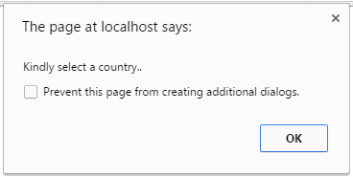

When Submit button is clicked and State field is not selected, the following alert message is displayed:

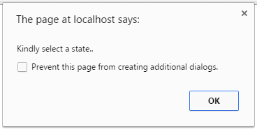

When Submit button is clicked and City field is not selected, the following alert message is displayed:

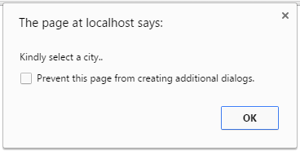

When Submit button is clicked and PIN Code field is blank, the following alert message is displayed:

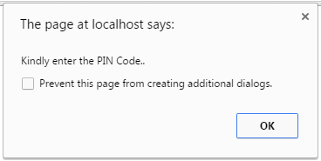

When Submit button is clicked and PIN Code field contains values other than numeric values, the following alert message is displayed:



When Submit button is clicked and Work Profile is blank, the following alert message is displayed:

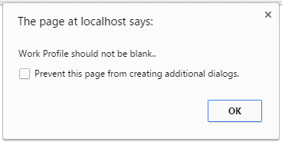

When Submit button is clicked and Bio data field is not selected, the following alert message is displayed:

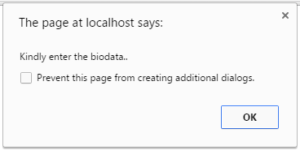

When Submit button is clicked and Date of Birth field is not selected, the following alert message is displayed:

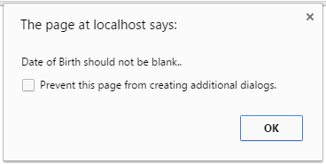

When Submit button is clicked and E-Mail ID field is blank, the following alert message is displayed:



When Submit button is clicked and E-Mail ID field contains an invalid E-Mail ID, the following alert message is displayed:



When Submit button is clicked and Password field is blank, the following alert message is displayed:



When Submit button is clicked and Password length is less than 8 characters, the following alert message is displayed:



When Submit button is clicked and Password length is greater than 16 characters, the following alert message is displayed:



When Submit button is clicked and Password and Confirm Password field does not match, the following alert message is displayed:



When Submit button is clicked and Expected Salary field is blank, the following alert message is displayed:

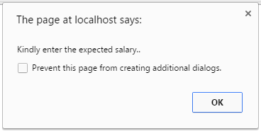

When Submit button is clicked and Expected Salary field contains values other than numeric values, the following alert message is displayed:



When Submit button is clicked and all the fields are successfully validated, the following alert message is displayed and the user is directed to the Worker Login Panel Page:

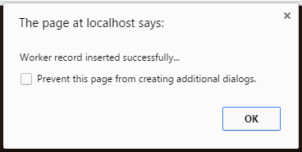

After the user has successfully registered, the Worker Login page is displayed:

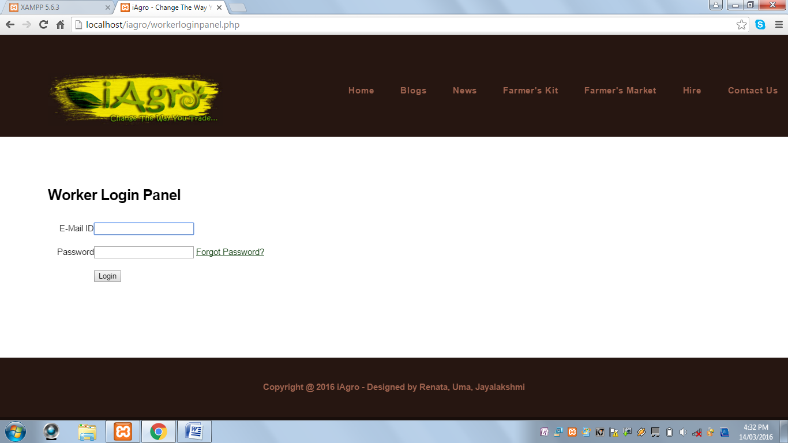

* This page contains a login form and Forgot Password link.
* When the worker has successfully logged in, the Worker Panel page is displayed:

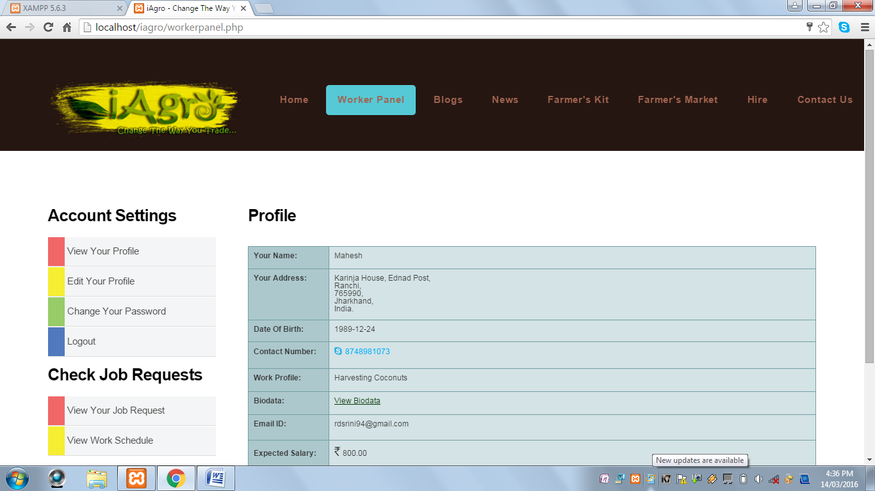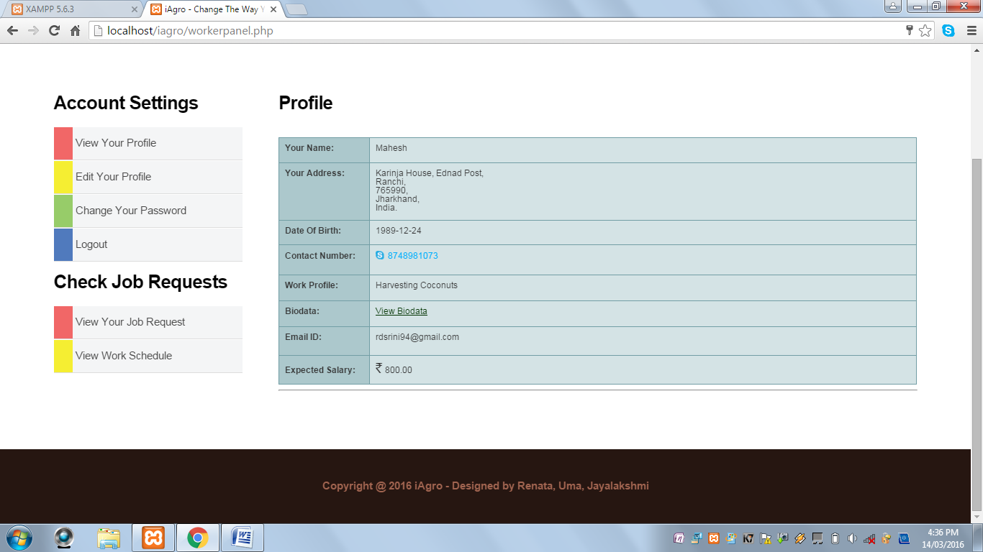

* This page contain a Left Navigation Menu with various options:

**View Your Profile:** This page displays information about the worker such as name, address, contact information, work profile and expected payment, etc.

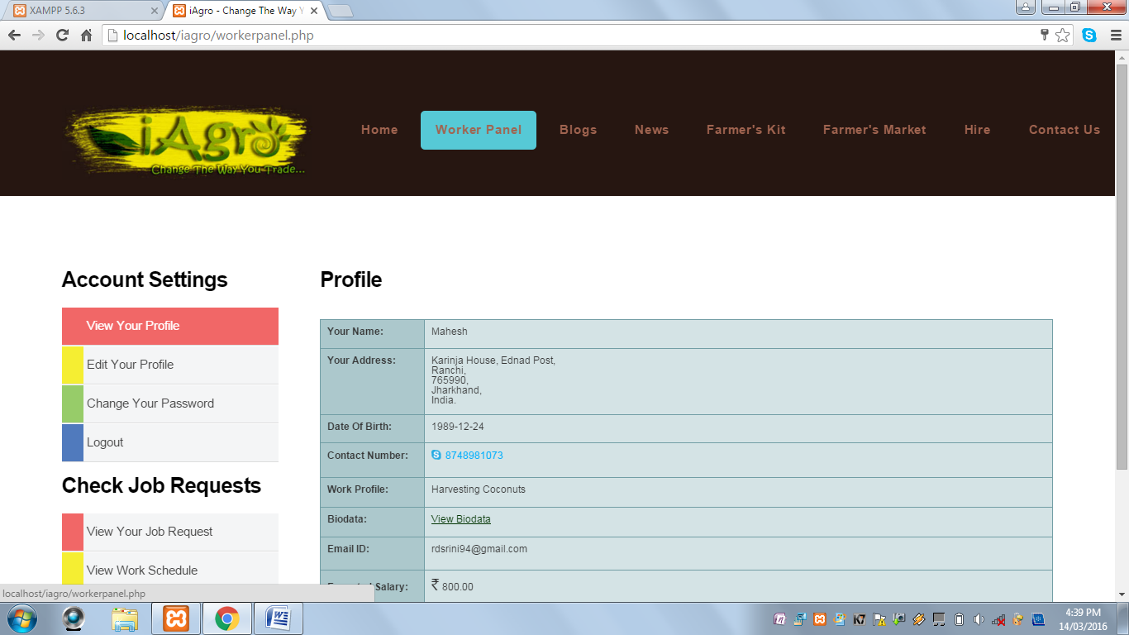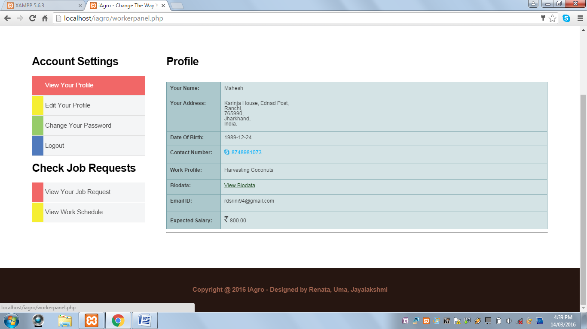

**Edit Your Profile:** This page displays a form to keep the information of the worker updated.

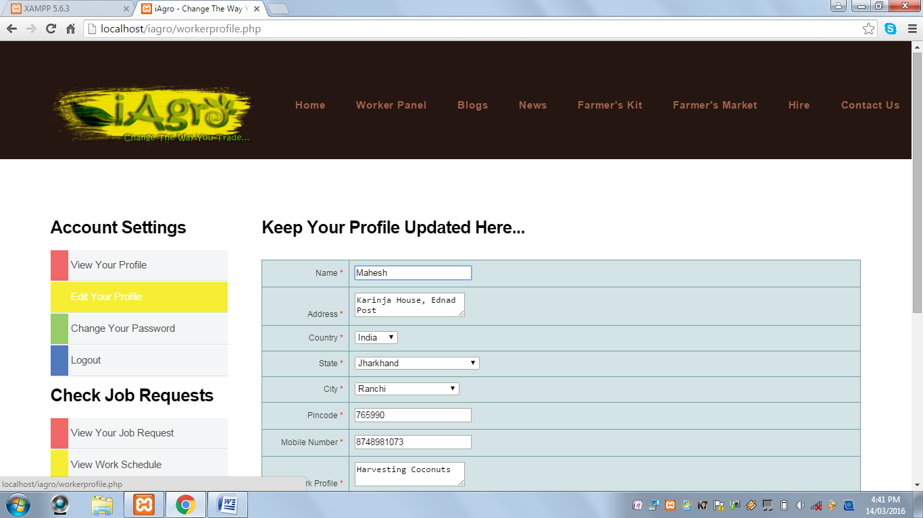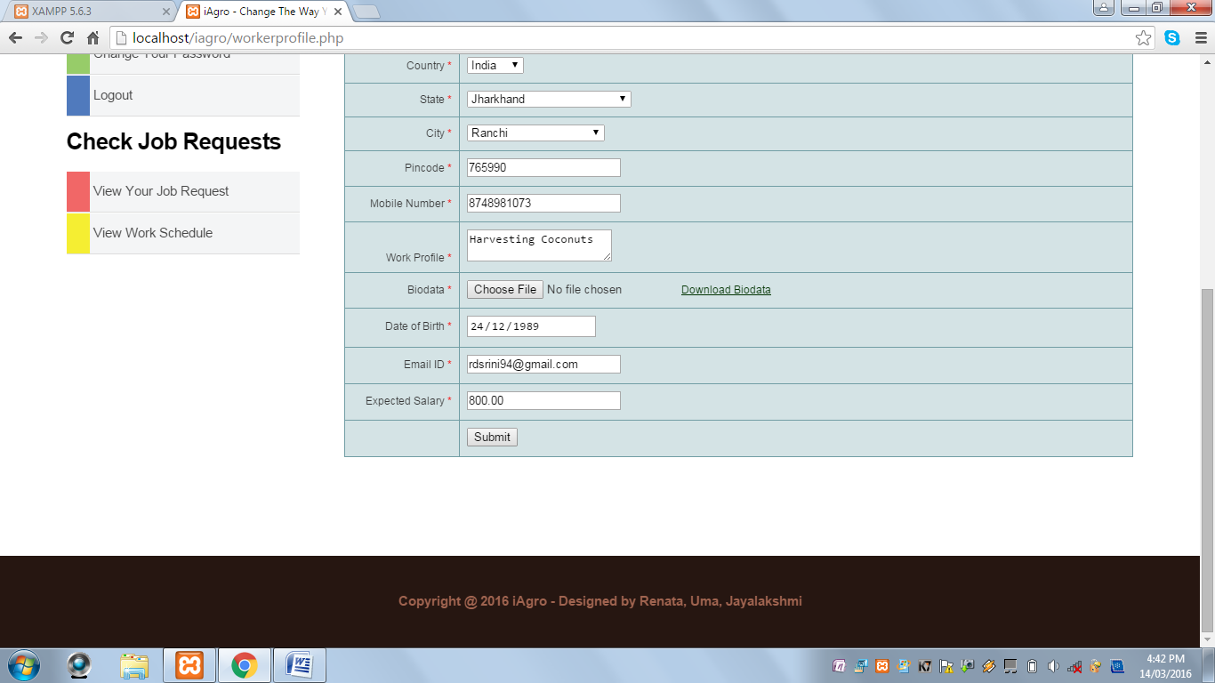

**Change Your Password:** This page displays a form to reset the password.

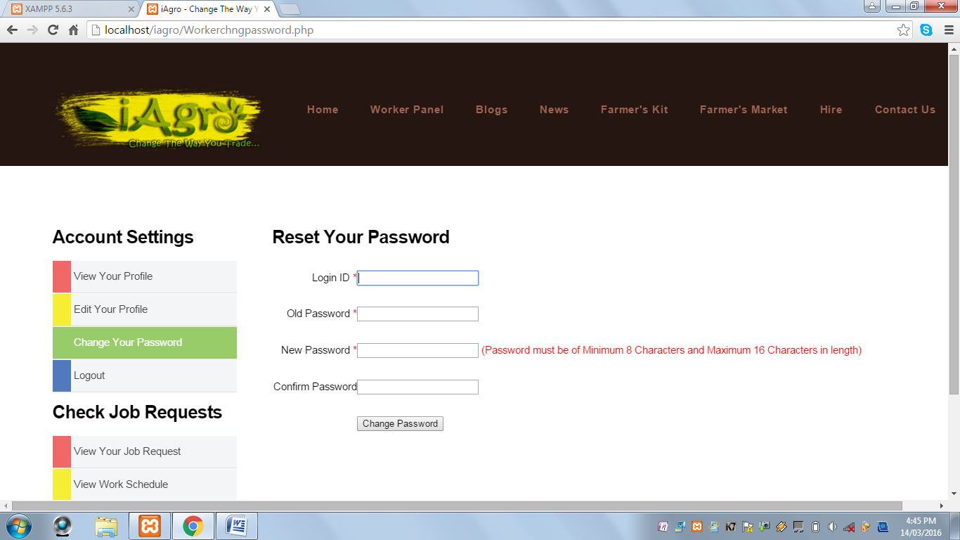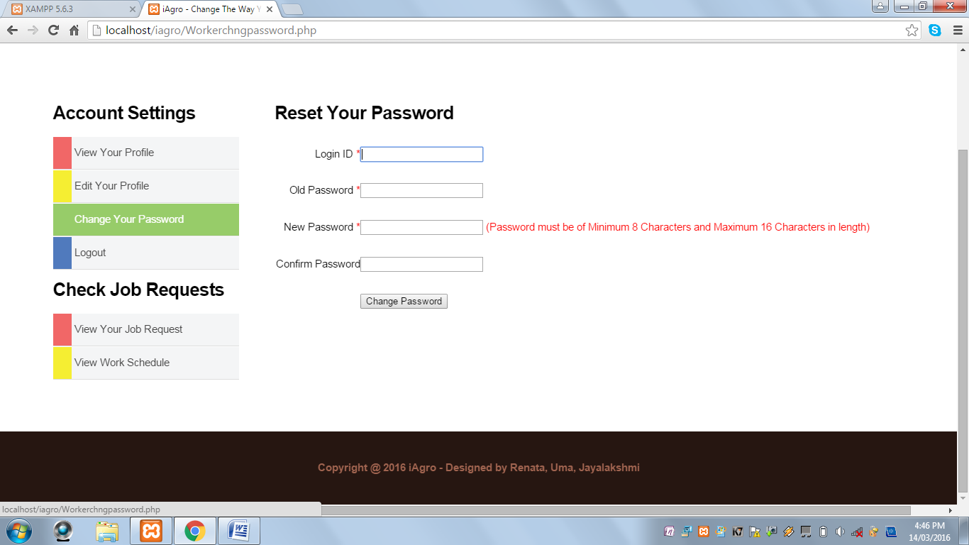

**Logout:** This option helps to log out of the option.

**View Your Job Request:** This page displays the work request received by the worker. It also contains a View option where the worker can Approve/Reject the request.

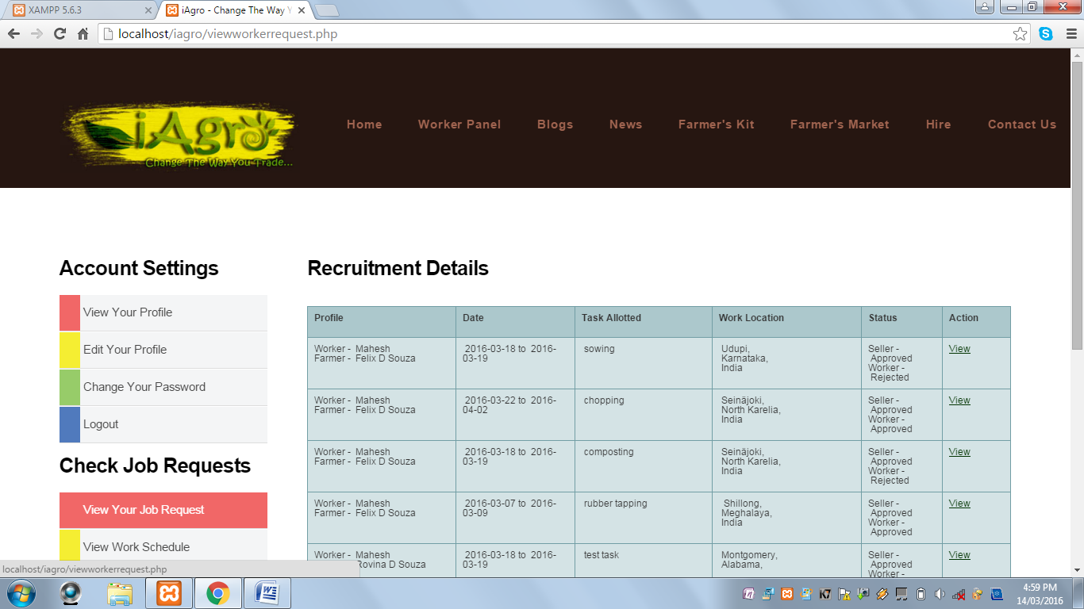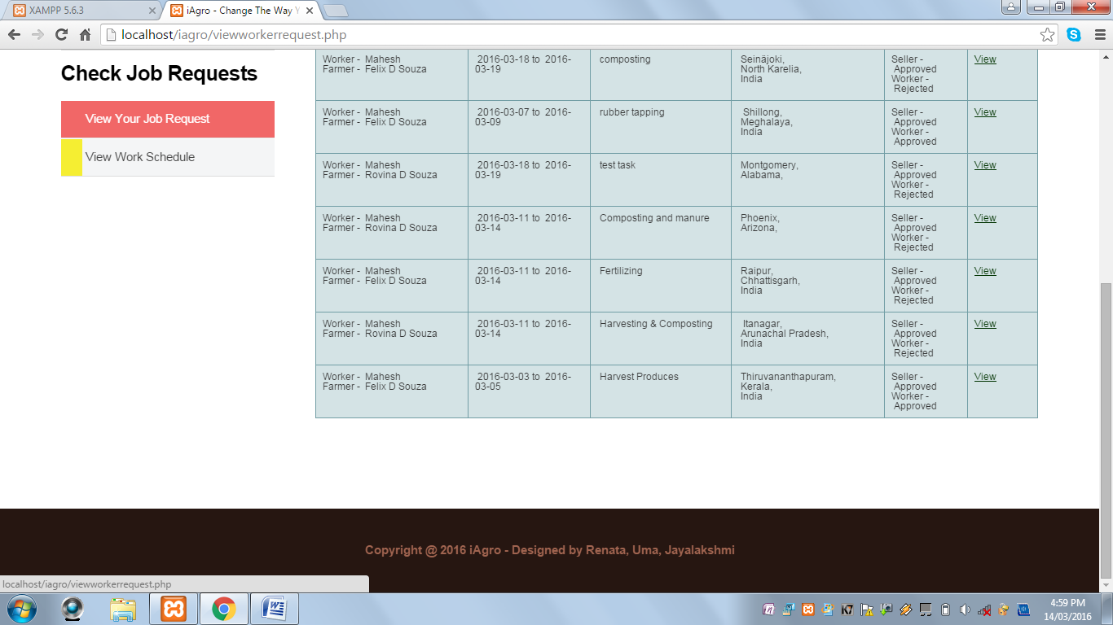

**View Work Schedule:** This page displays a calendar where the dates are highlighted indicating that the worker has work scheduled on that particular date.

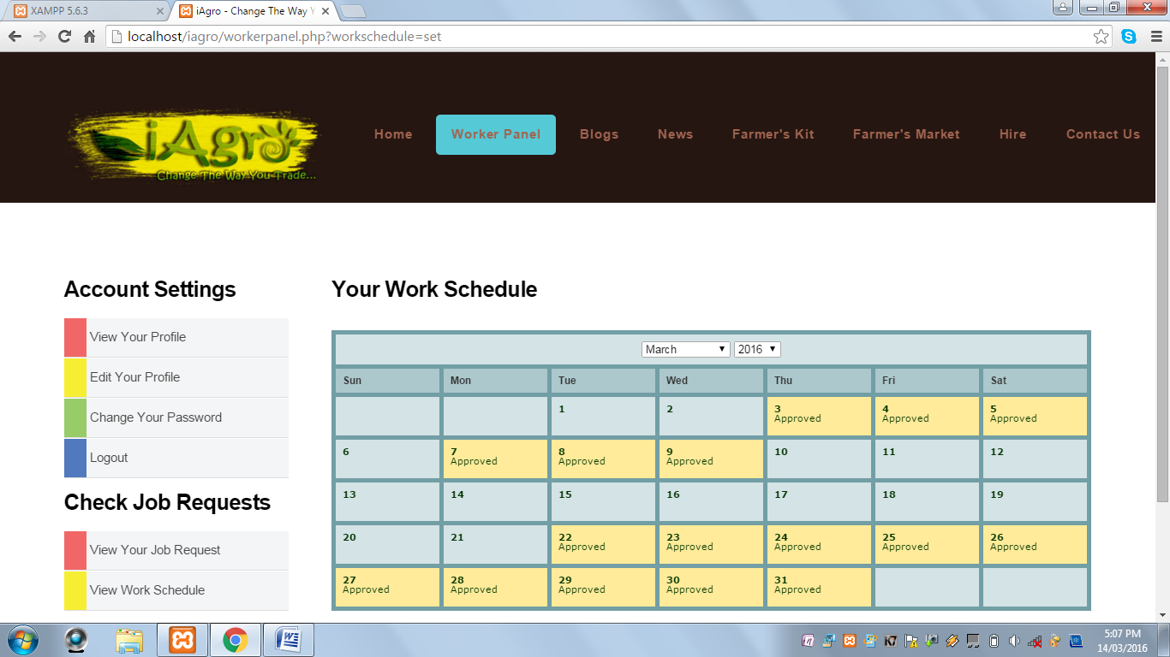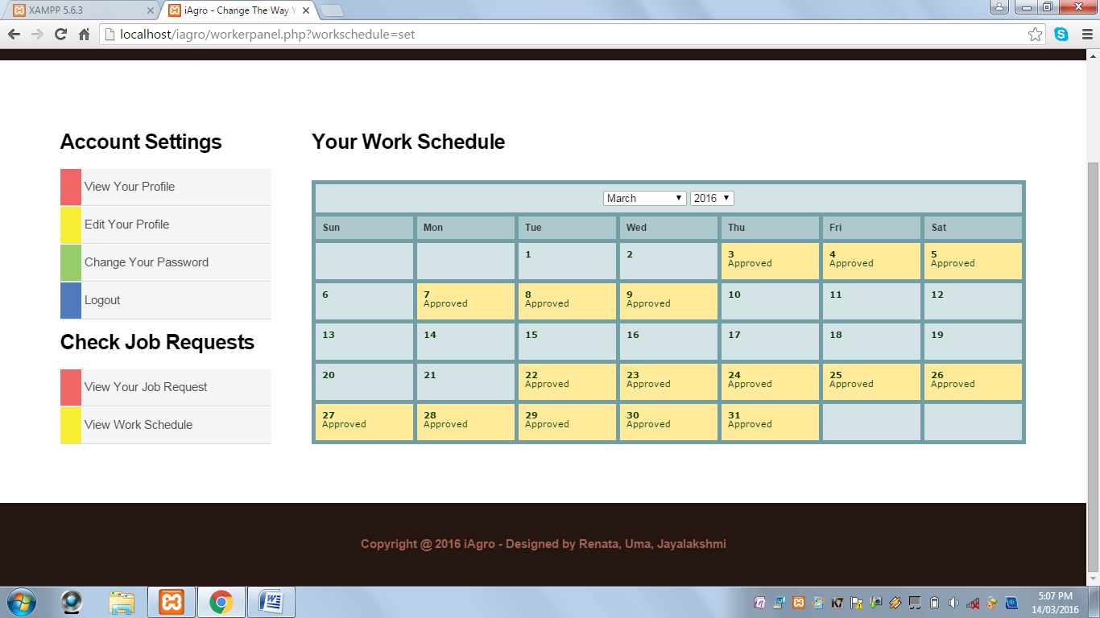

* When the Sign In link under the Admin icon is clicked, the following page is displayed:

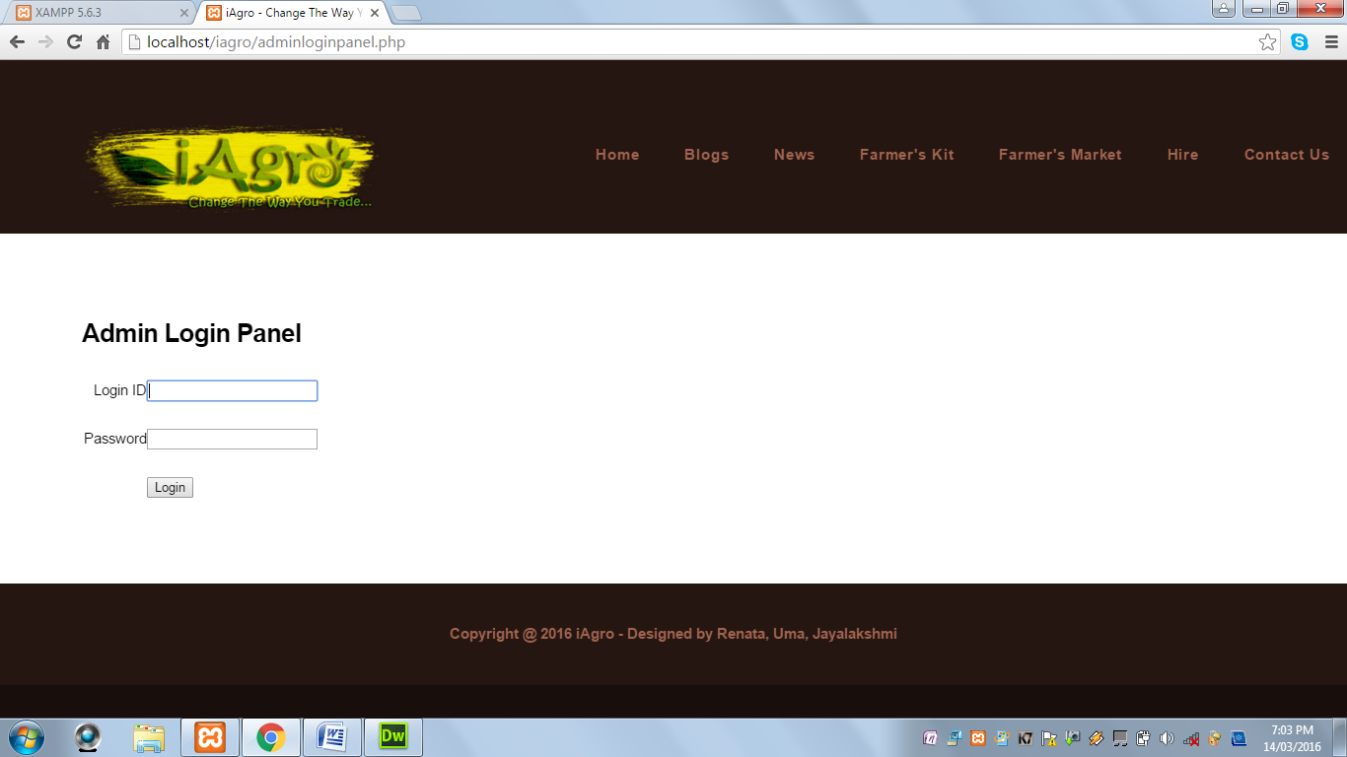

* When Admin successfully logs in, the Admin Panel page is displayed:

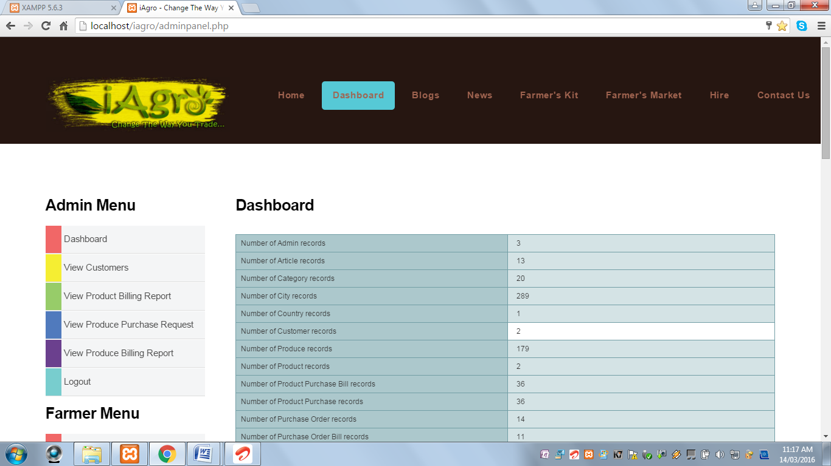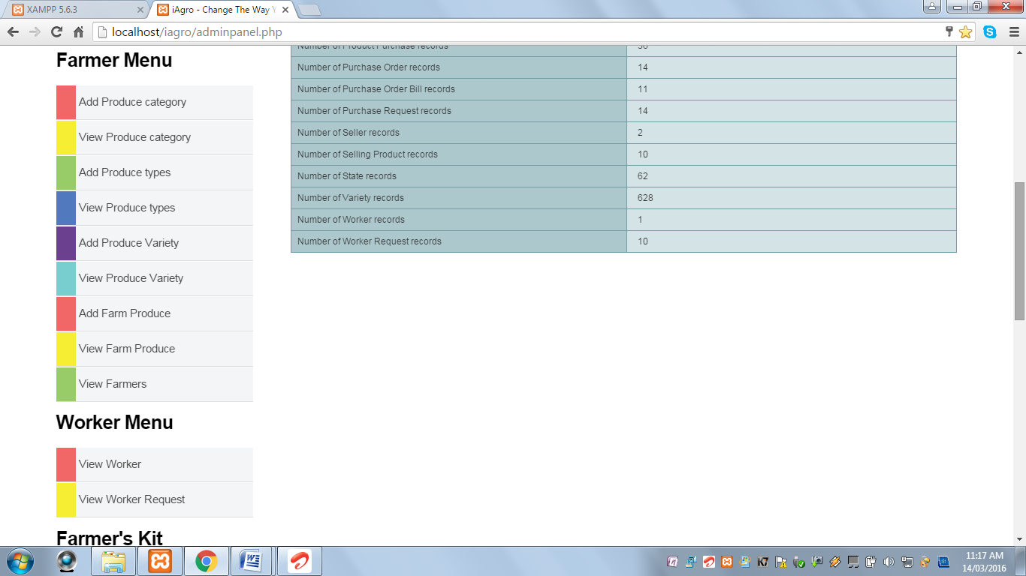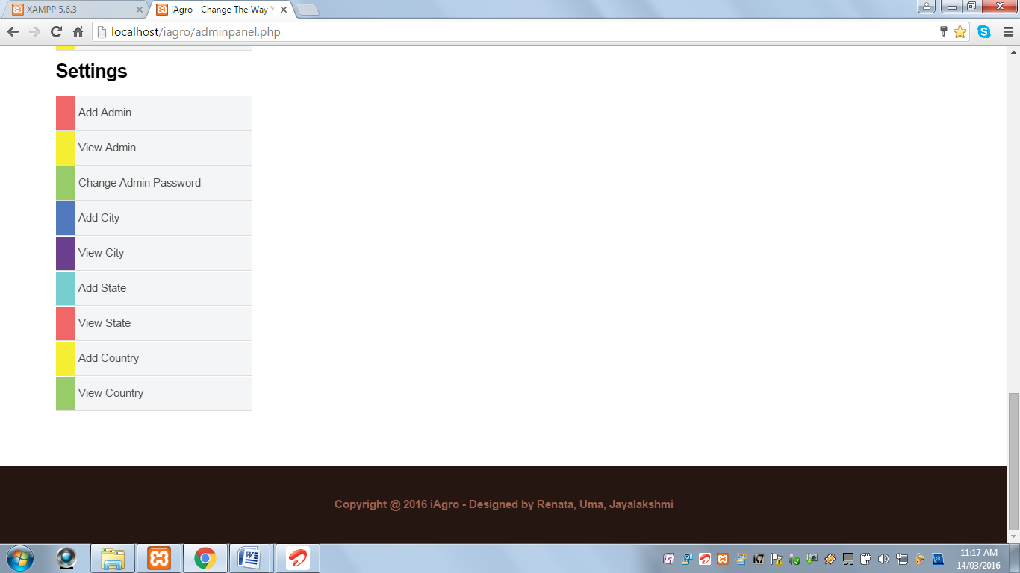

* This page contains Left Navigation Menu with various options:

**Dashboard:** This page displays all the tables in the database with the total number of records.

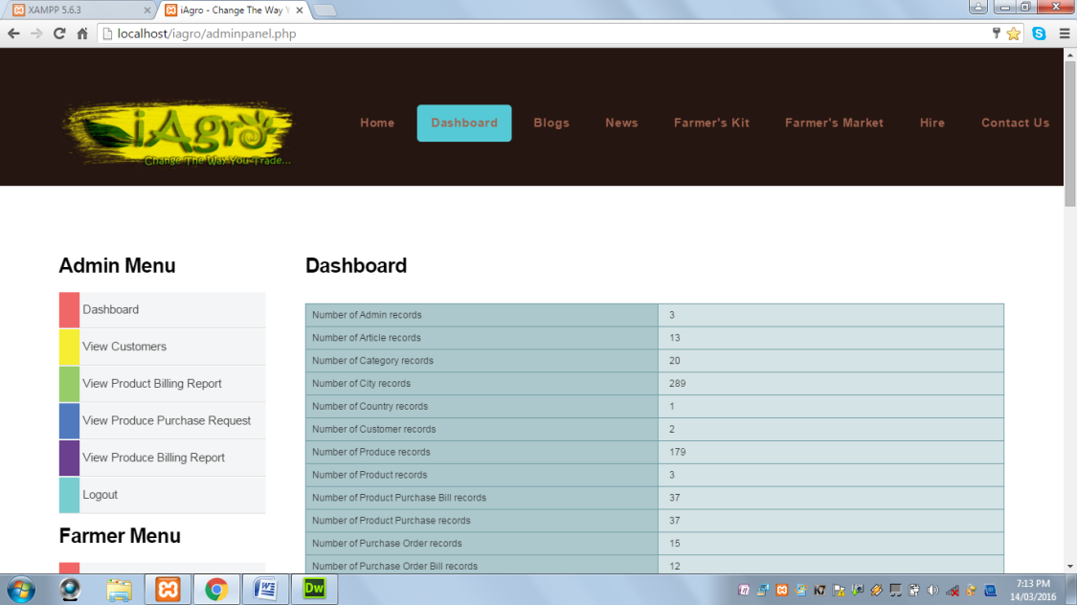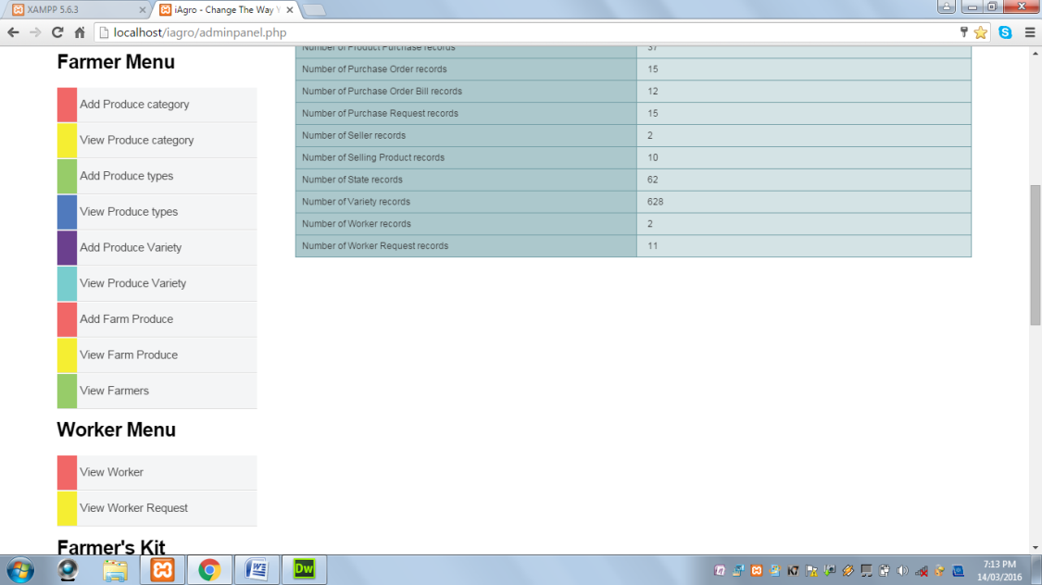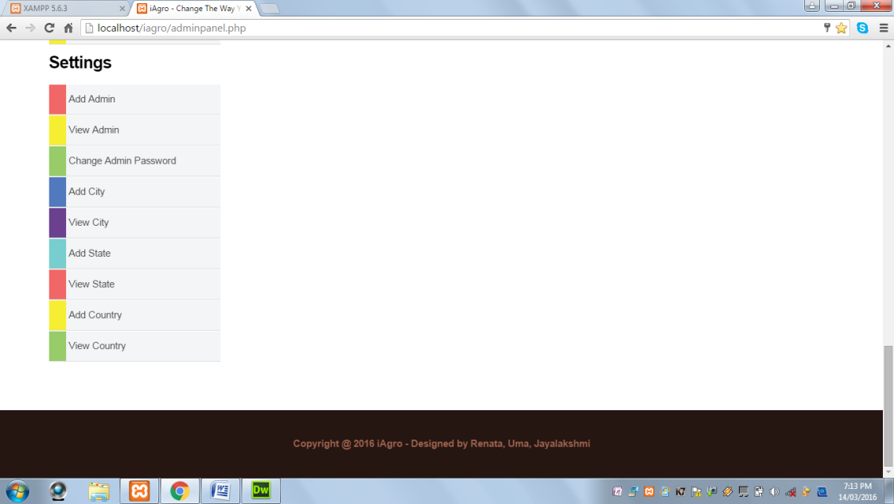

**View Customers:** This page displays all the registered customers.

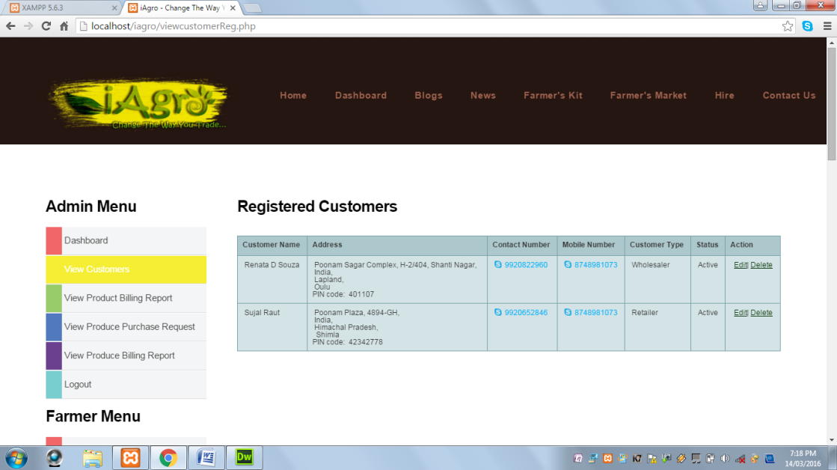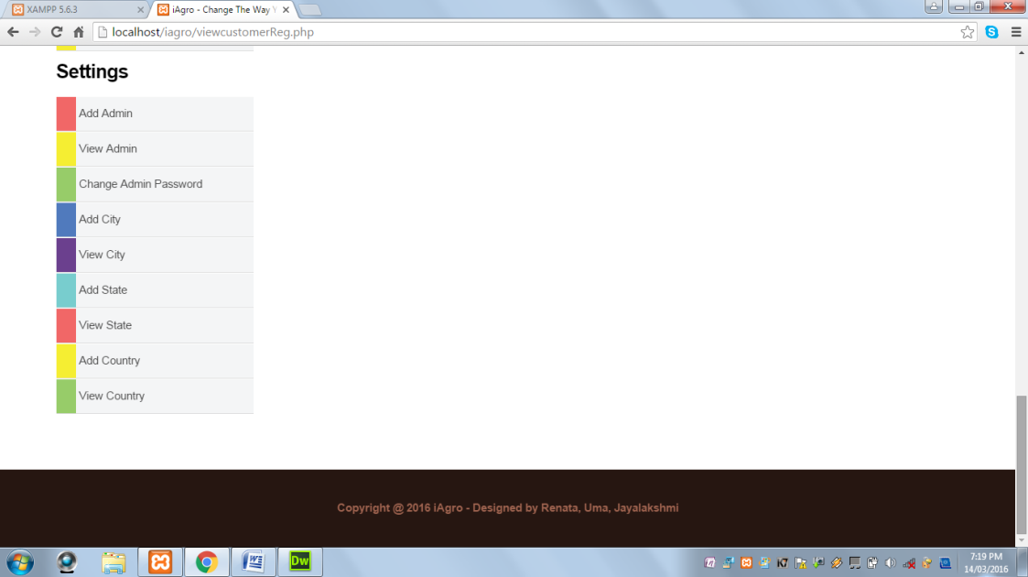

**View Product Billing Report:** This page displays all the Farmer’s Kit products purchase bills.

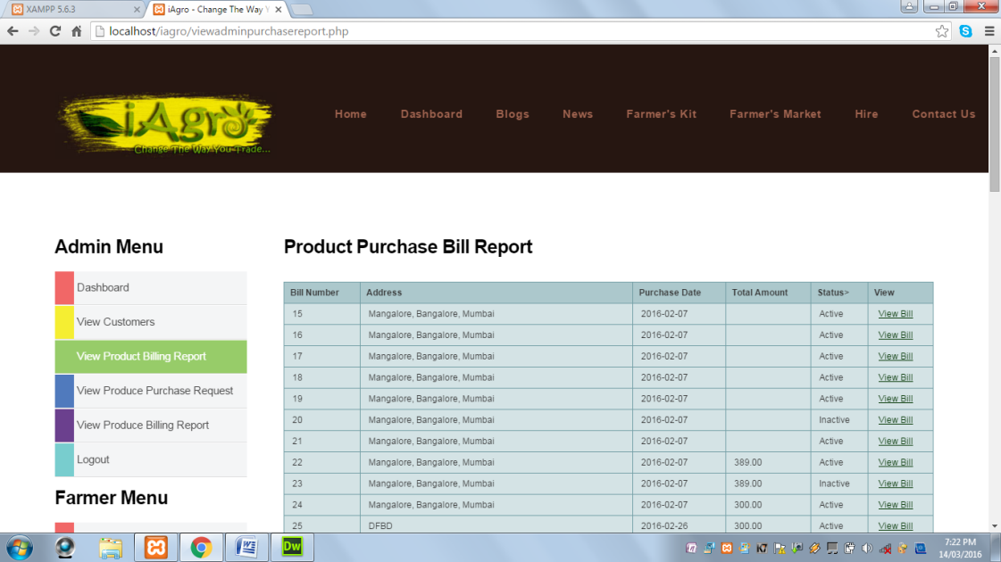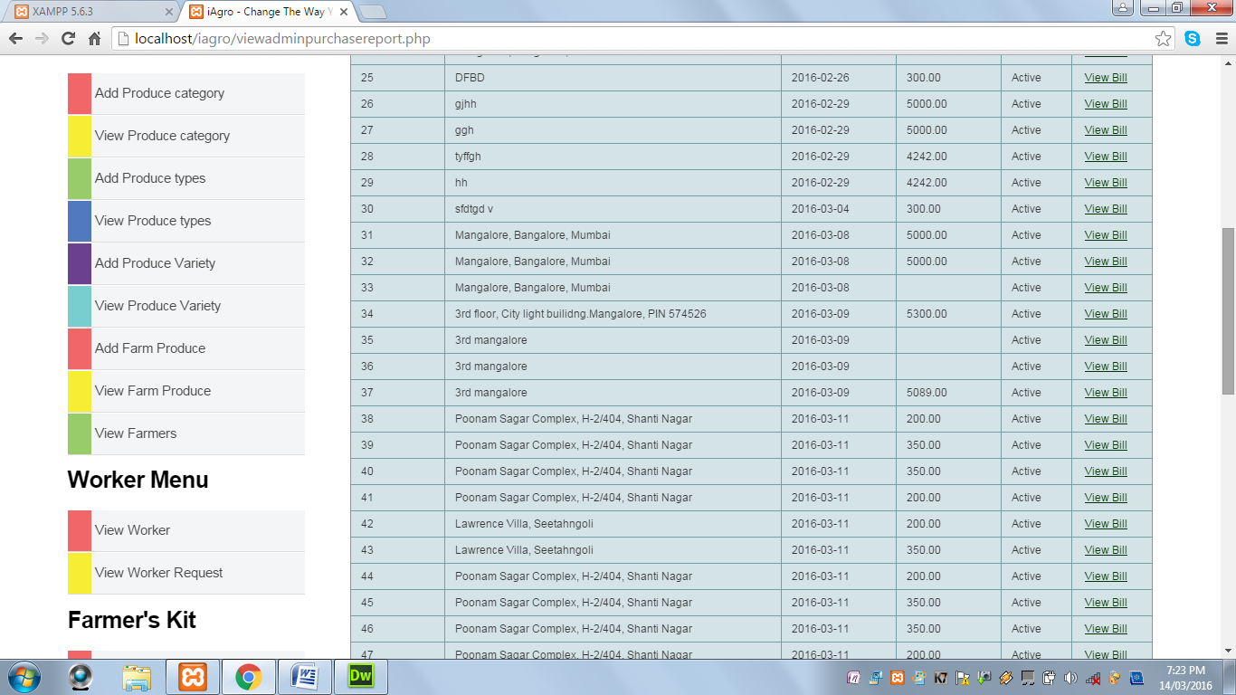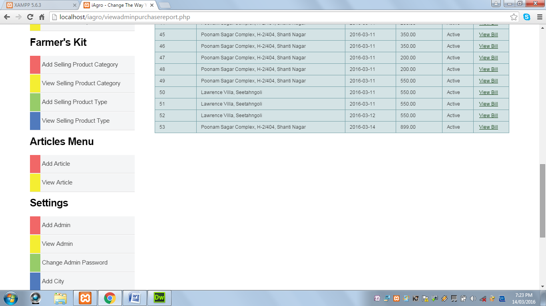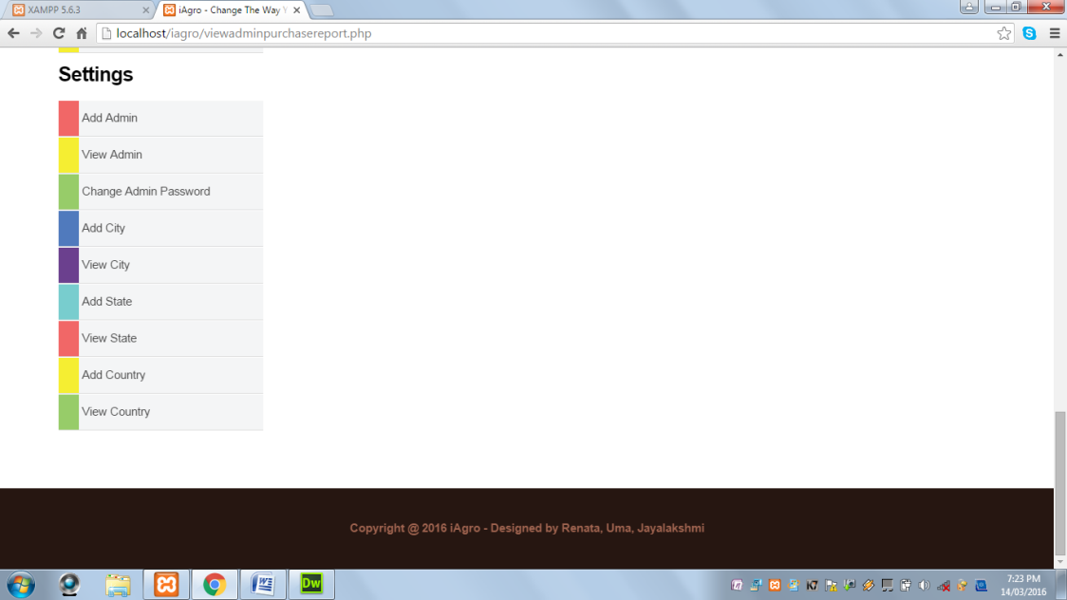

**View Produce Purchase Request:** This page displays the purchase request sent for all the farm produces by the farmers.

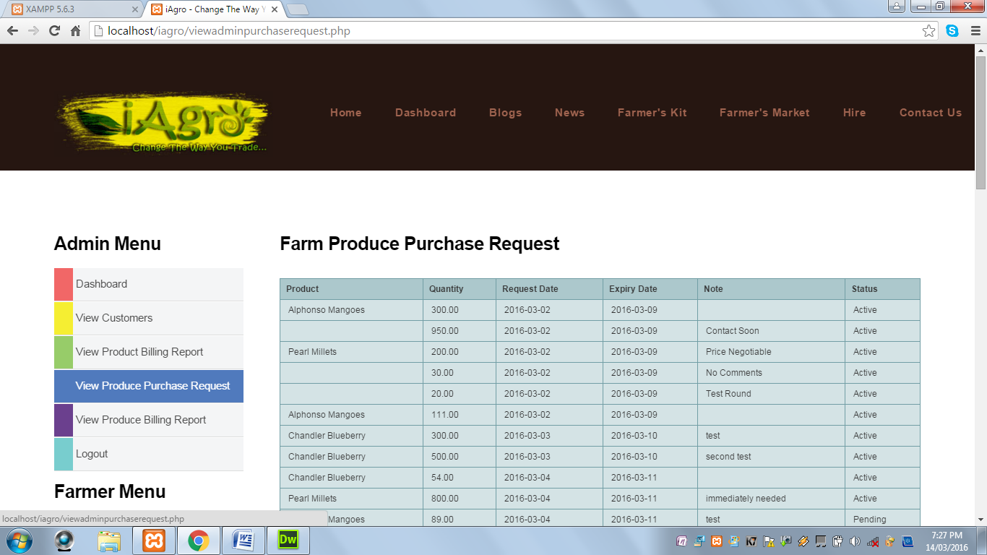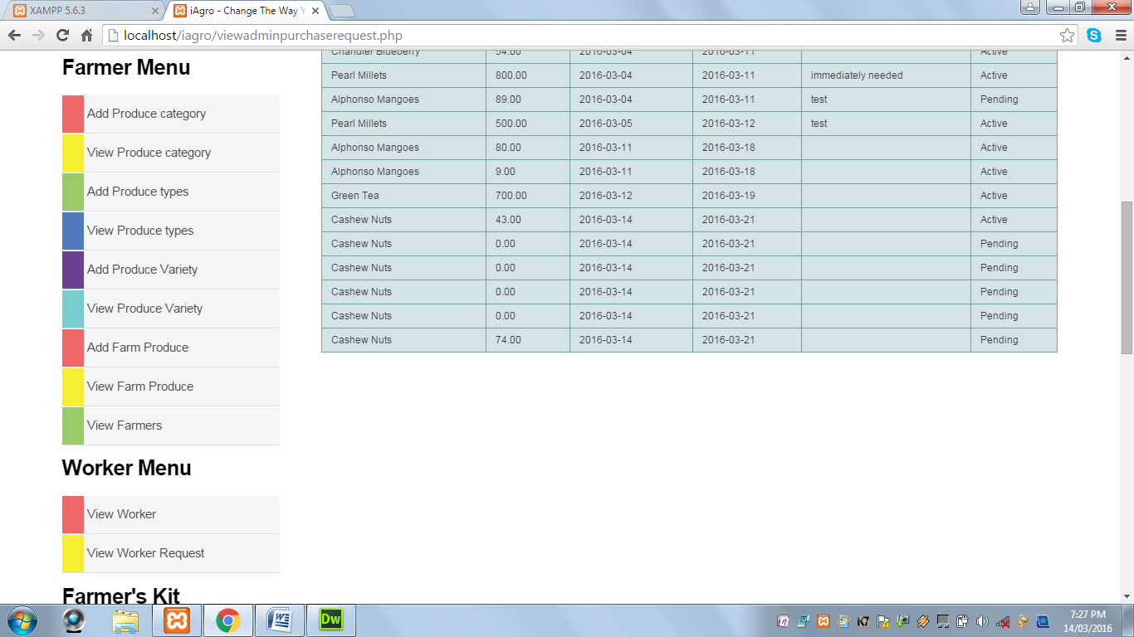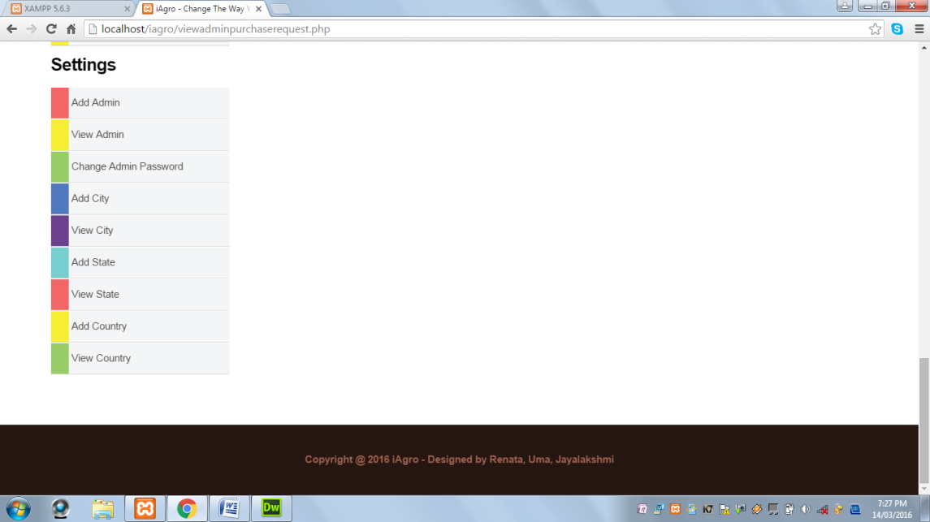

**View Produce Billing Report:** This page displays the billing report for the farm produces purchased.

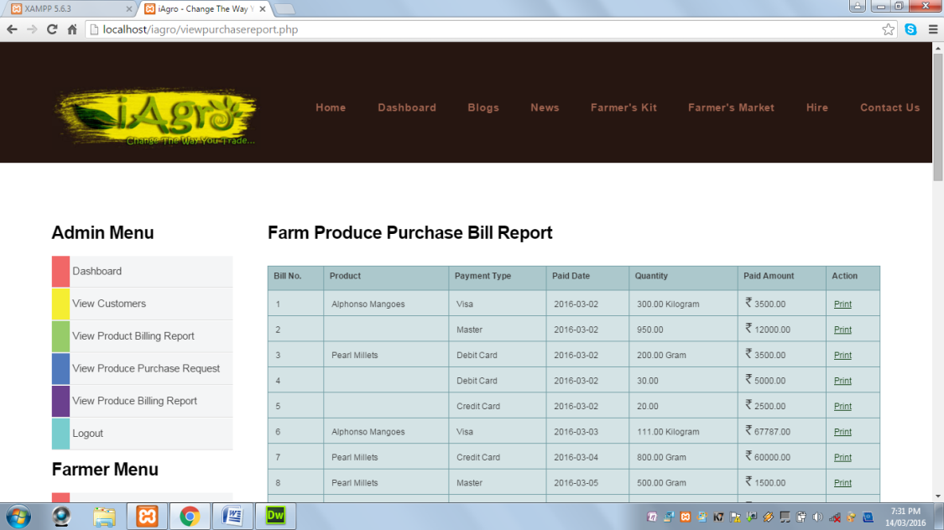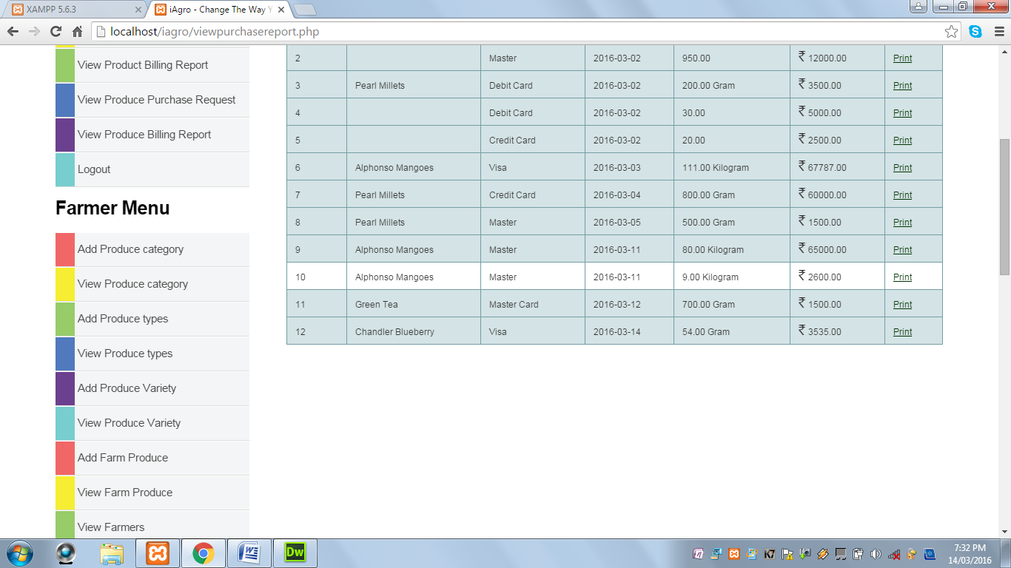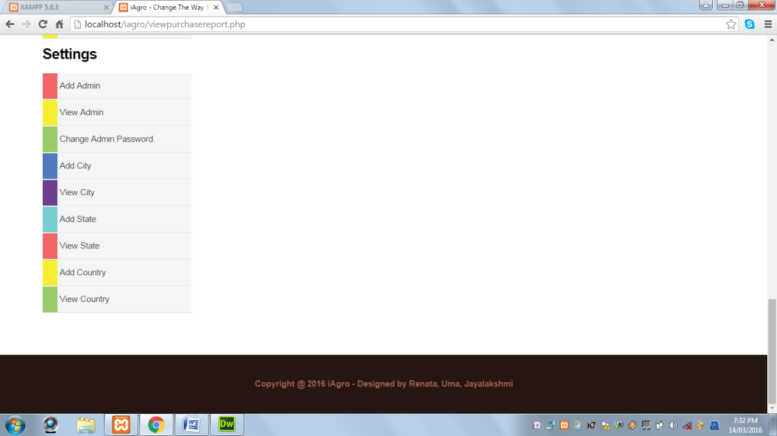

**Add Produce Category:** This page displays a form to add produce category.

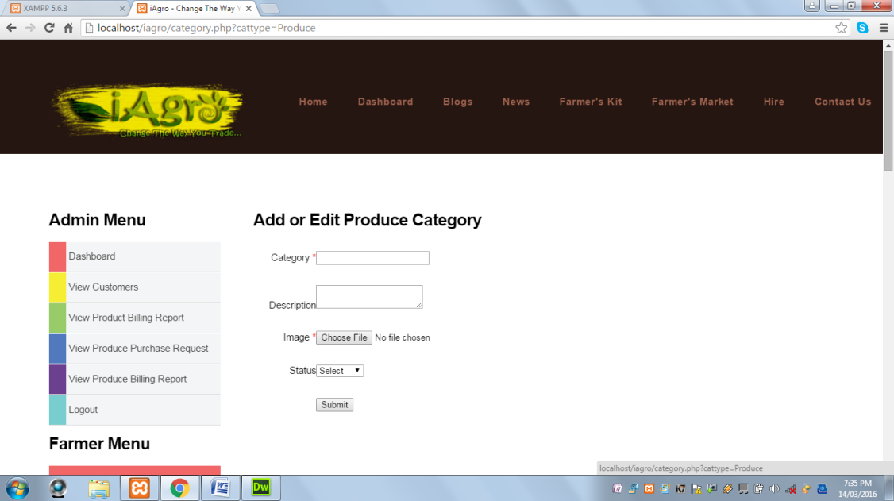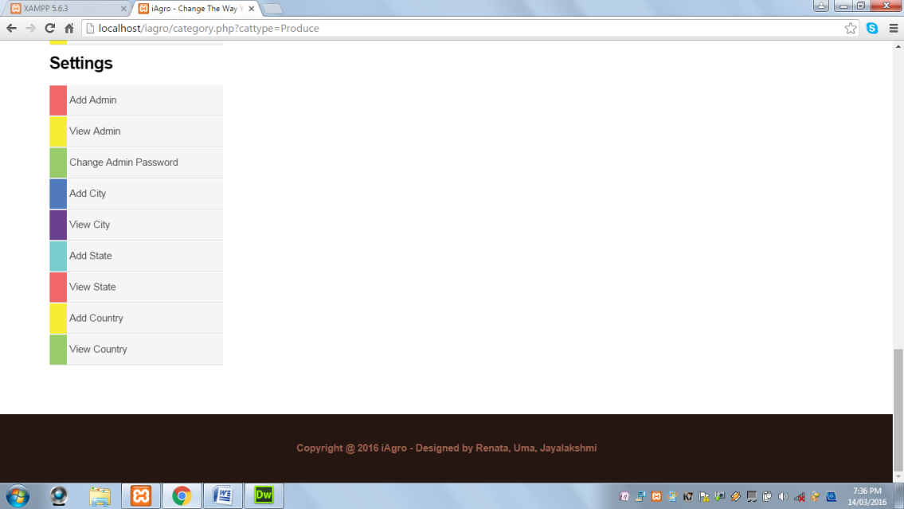

**View Produce Category:** This page displays all the categories of the farm produce.

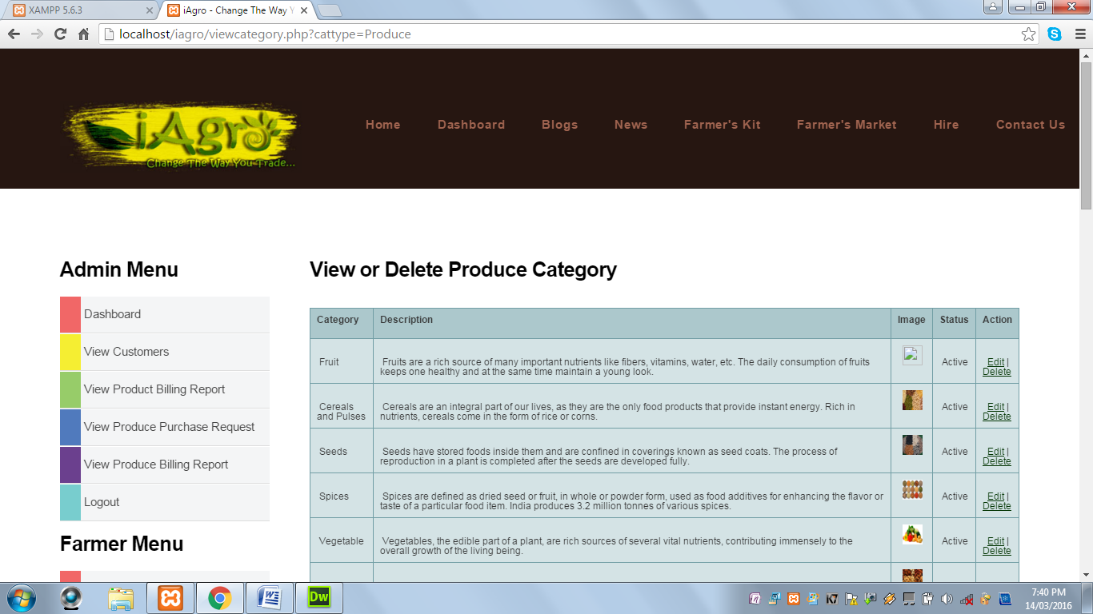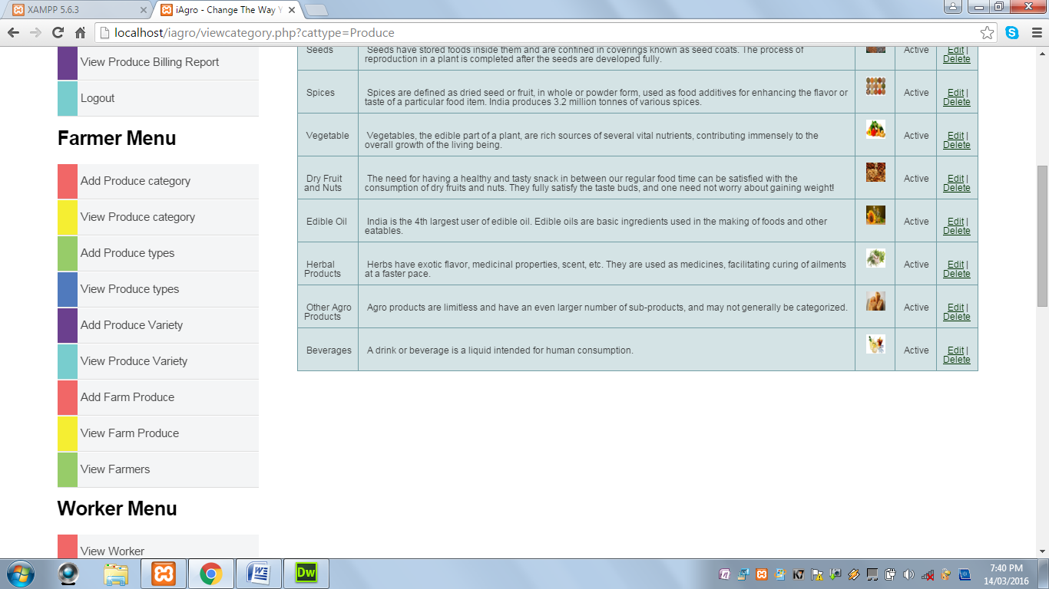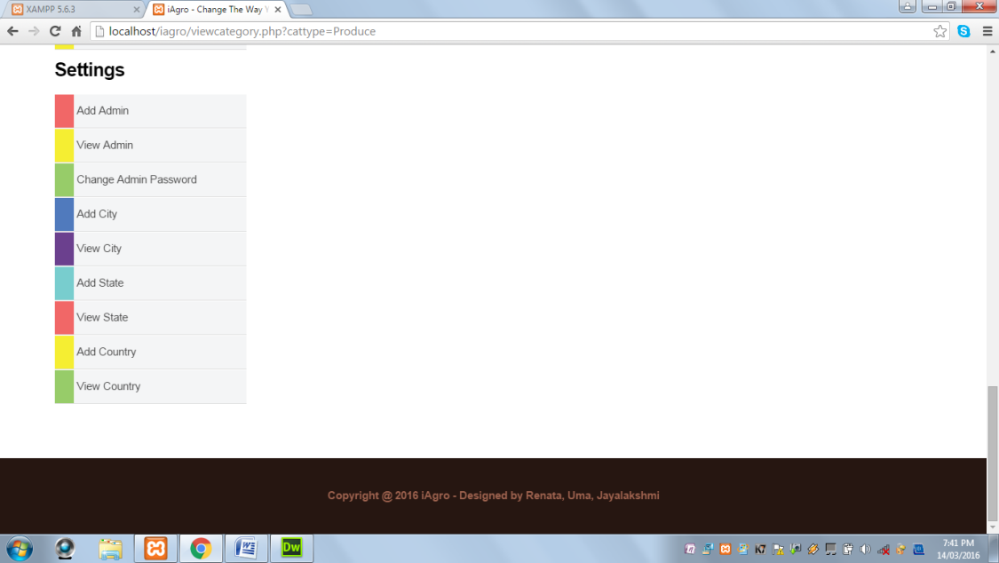

**Add Produce Type:** This page displays a form to add produce types.

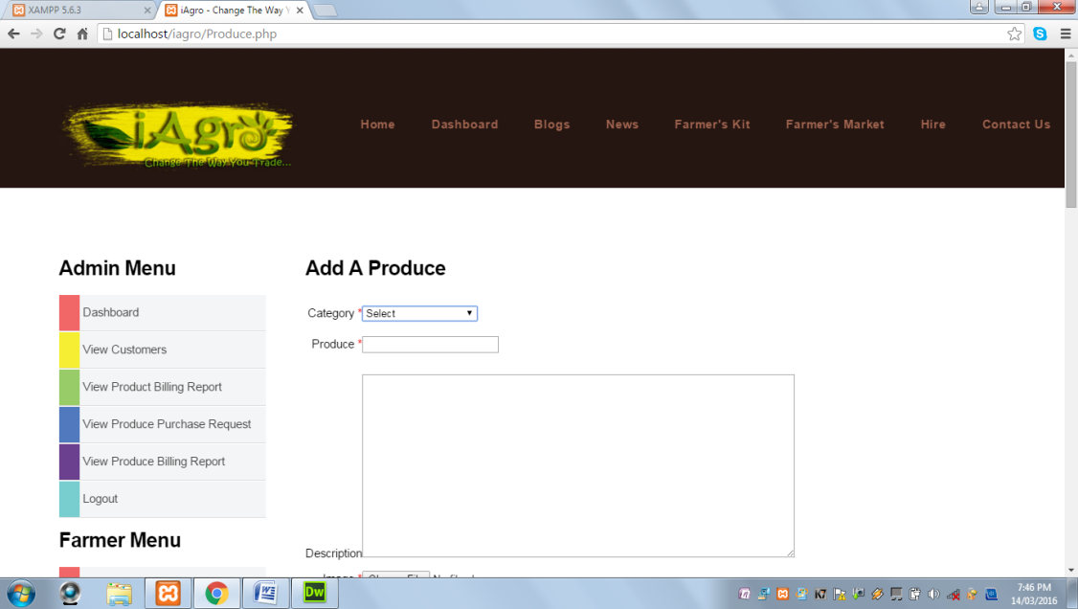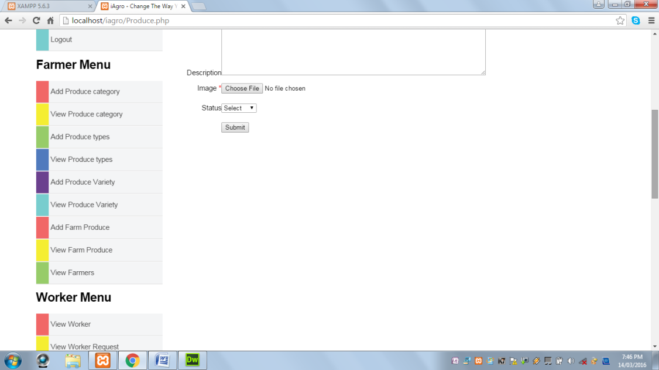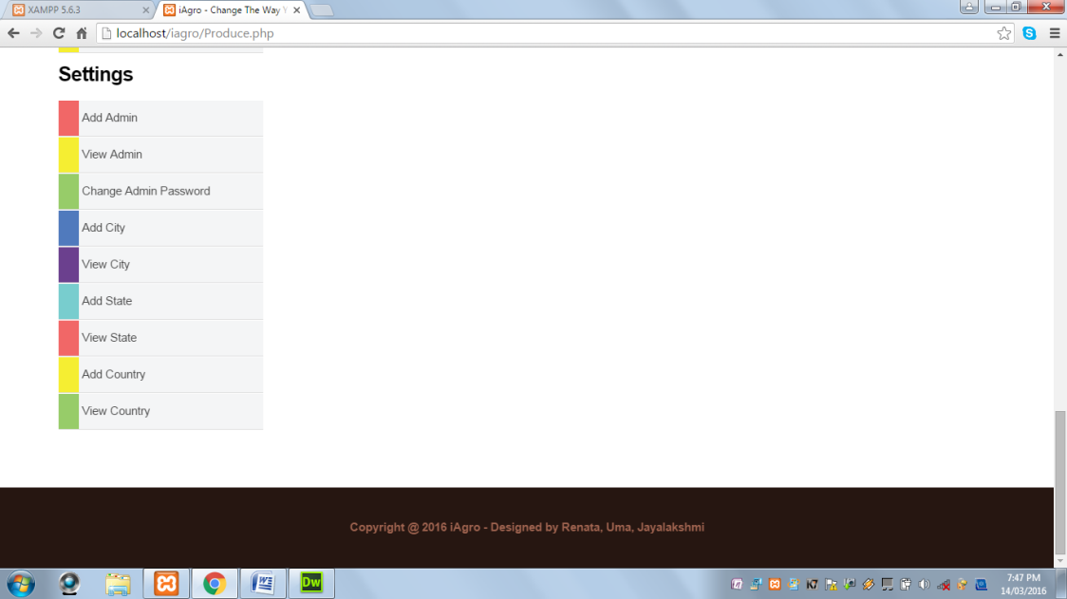

When Submit button is clicked and Category field is not selected, the following alert message is displayed:

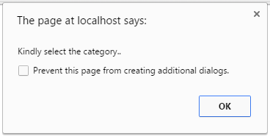

When Submit button is clicked and Produce field is blank, the following alert message is displayed:

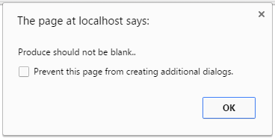

When Submit button is clicked and Produce field contains values other than alphabets and spaces, the following alert message is displayed:

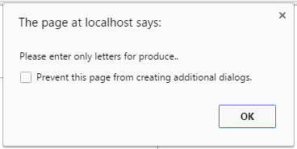

When Submit button is clicked and Image field does not contain an uploaded image, the following alert message is displayed:

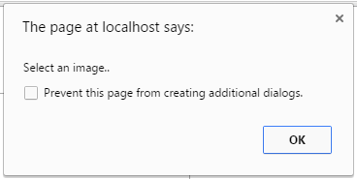

When Submit button is clicked and all the required fields are successfully validated, the following alert message is displayed:

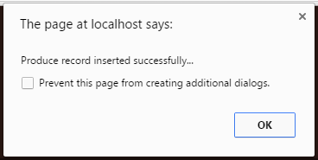

**View Produce Type:** This page displays all the produce types.

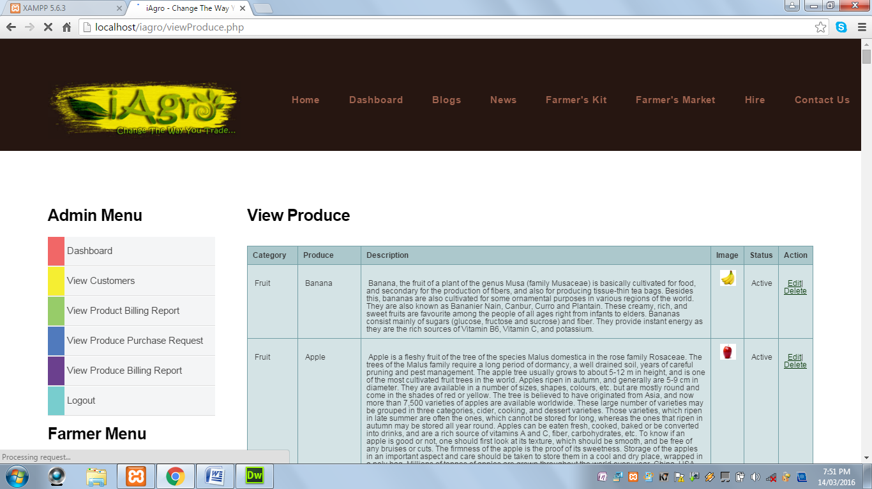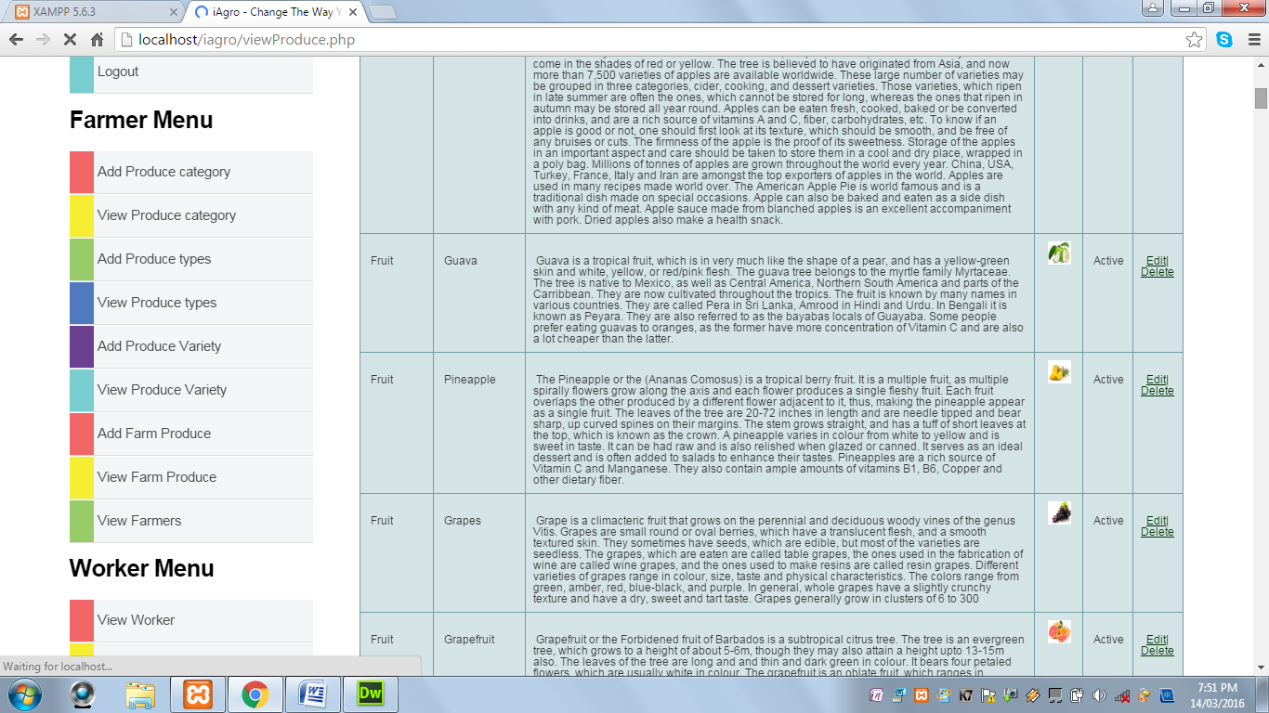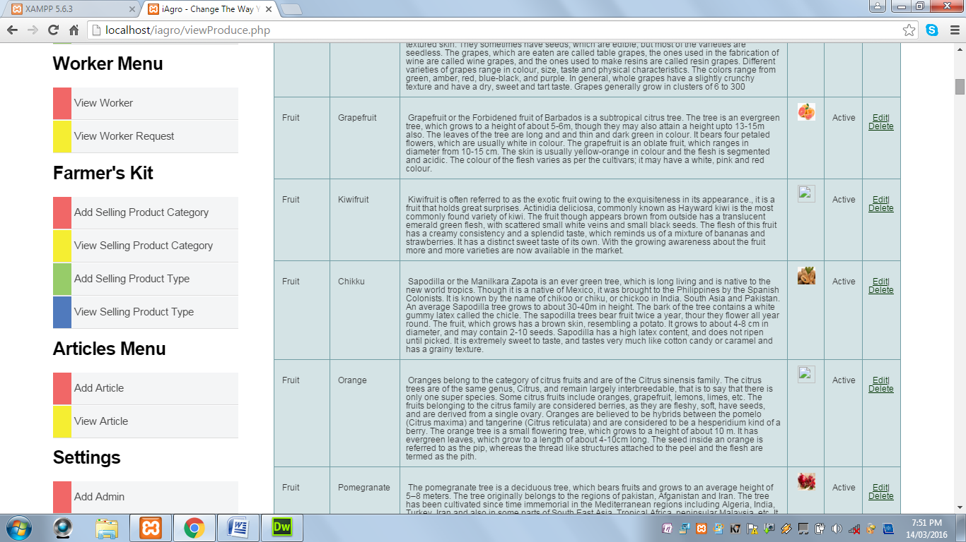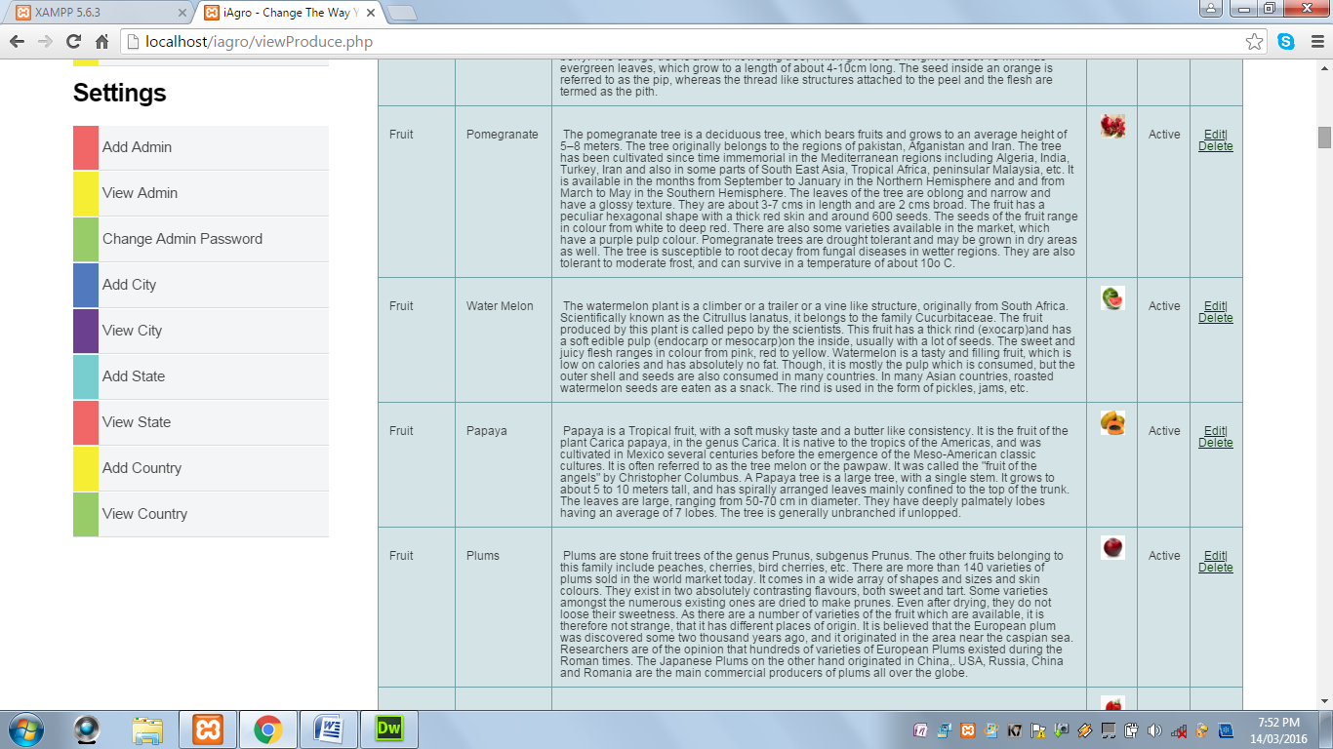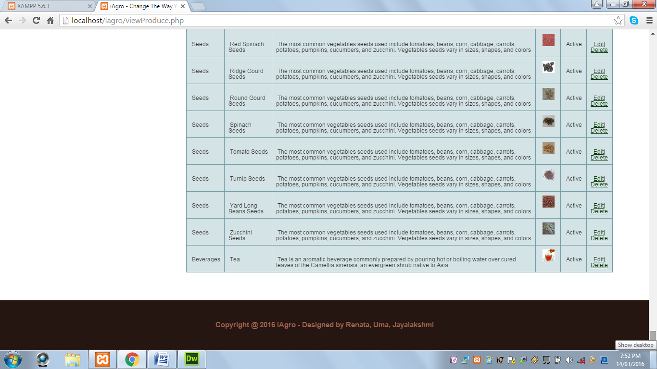

**Add A Variety:** This page displays a form to add produce variety.

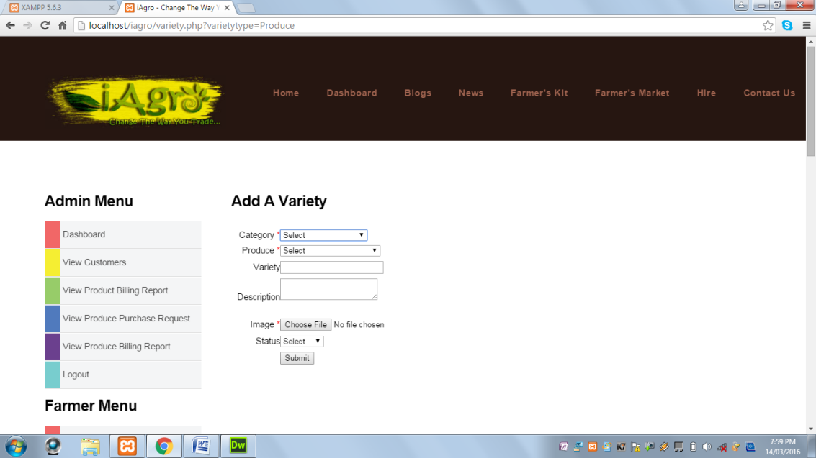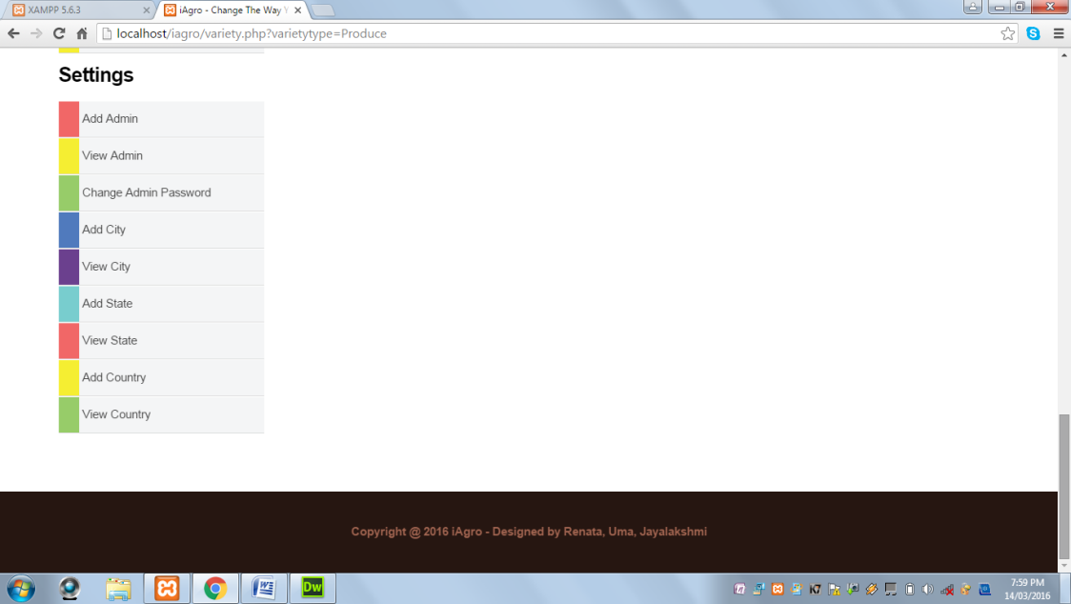

When Submit button is clicked and Category is not selected, the following alert message is displayed:

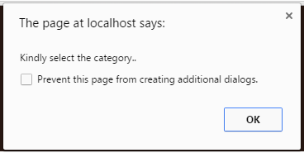

When Submit button is clicked and Produce is not selected, the following alert message is displayed:

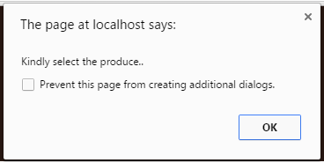

When Submit button is clicked and Variety field is blank, the following alert message is displayed:

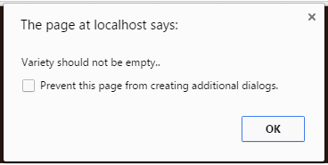

When Submit button is clicked and Variety field contains values other than alphabets and spaces, the following alert message is displayed:

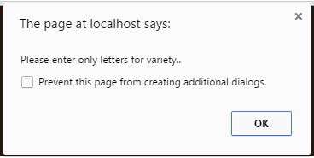

When Submit button is clicked and Image field does not contain any uploaded image, the following alert message is displayed:

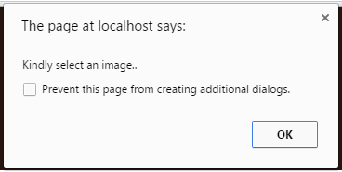

When Submit button is clicked and all the required fields are successfully validated, the following alert message is displayed:

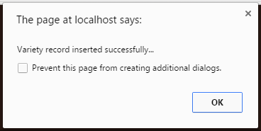

**View Produce Variety:** This page displays all the varieties of the produce.

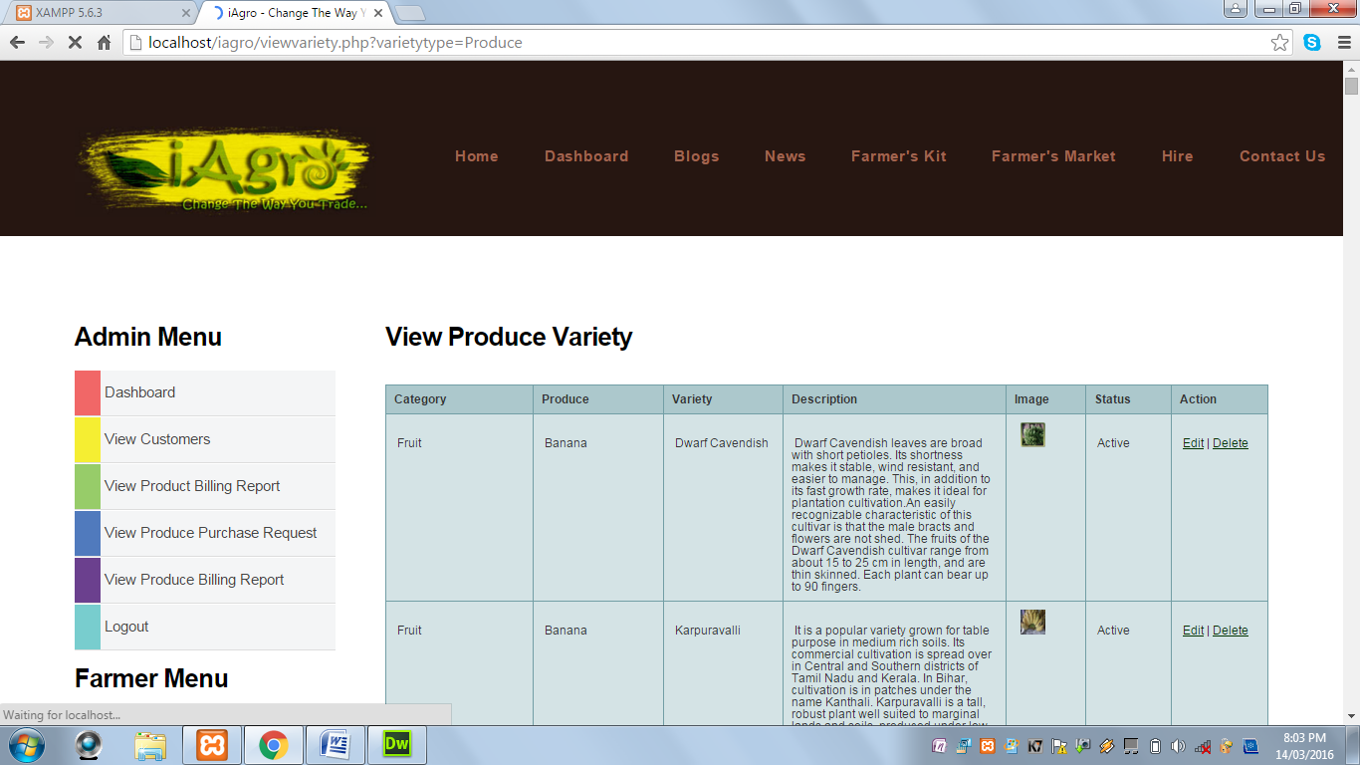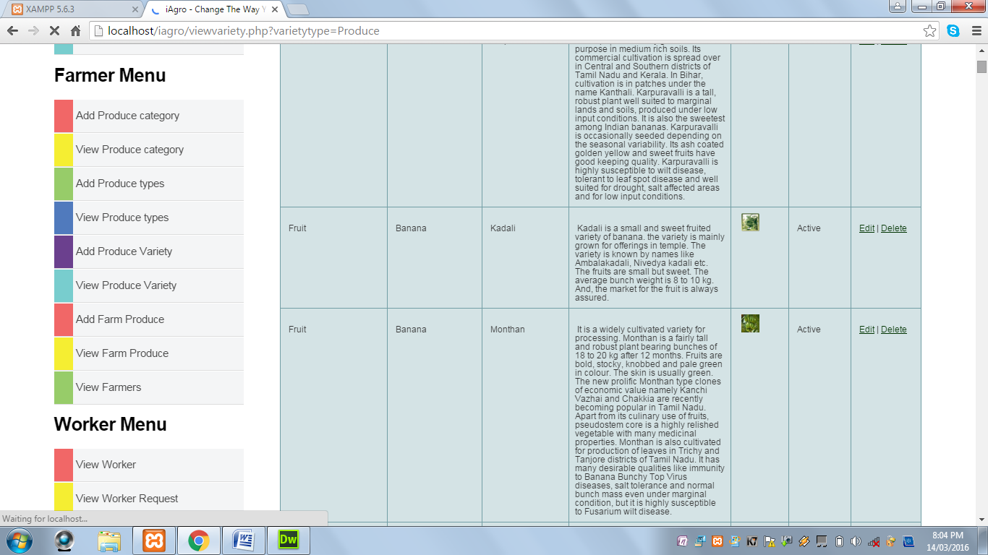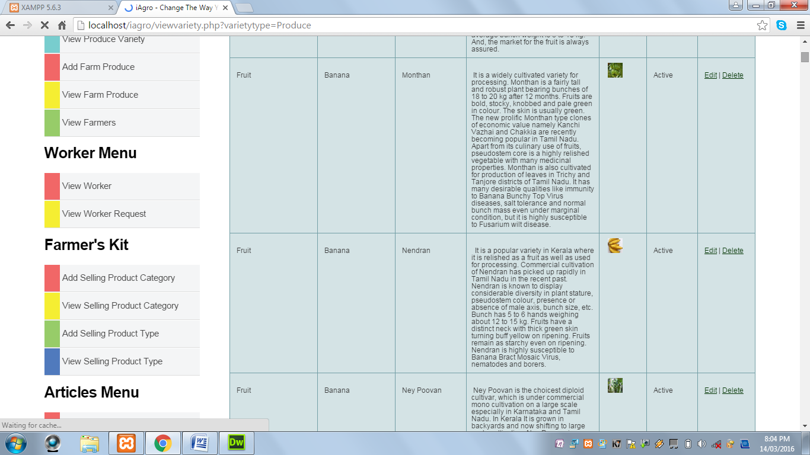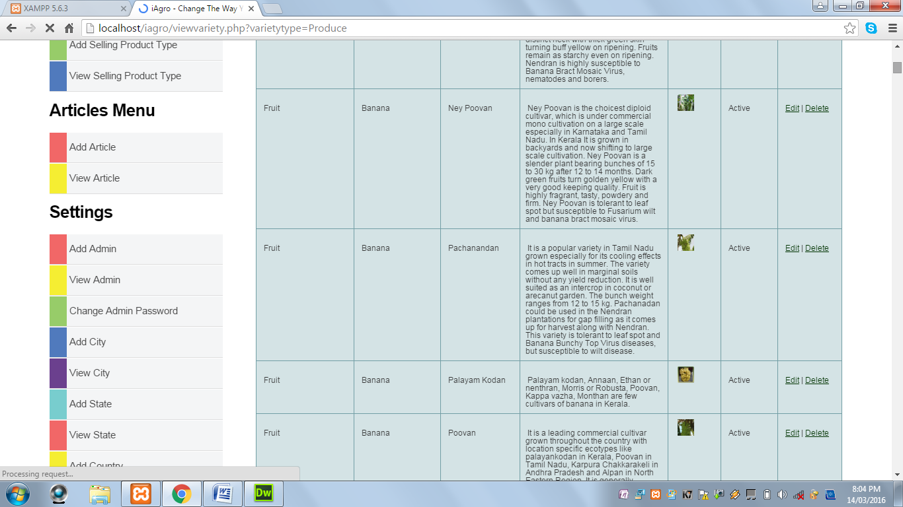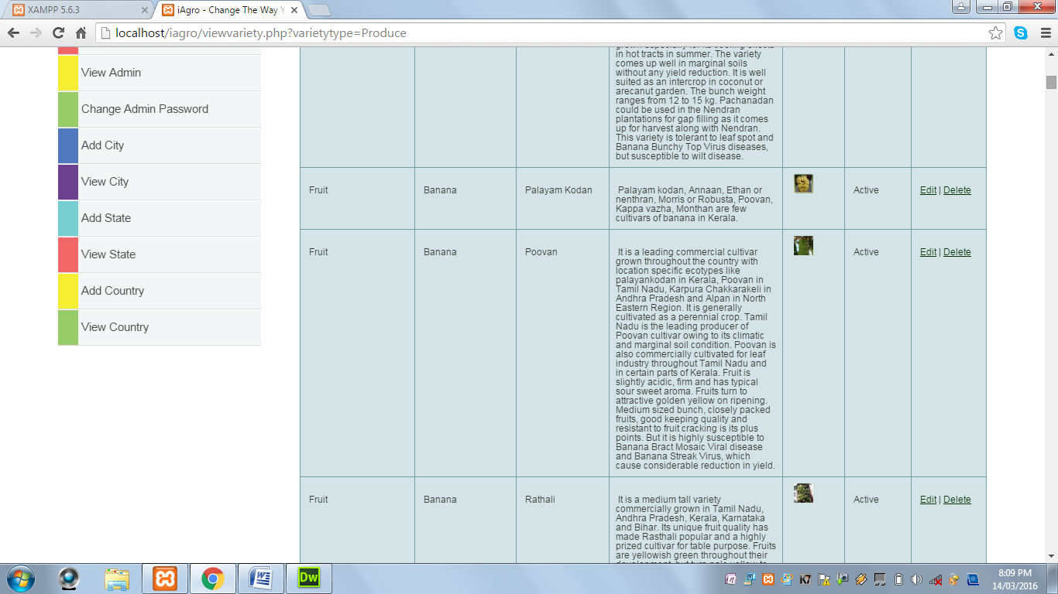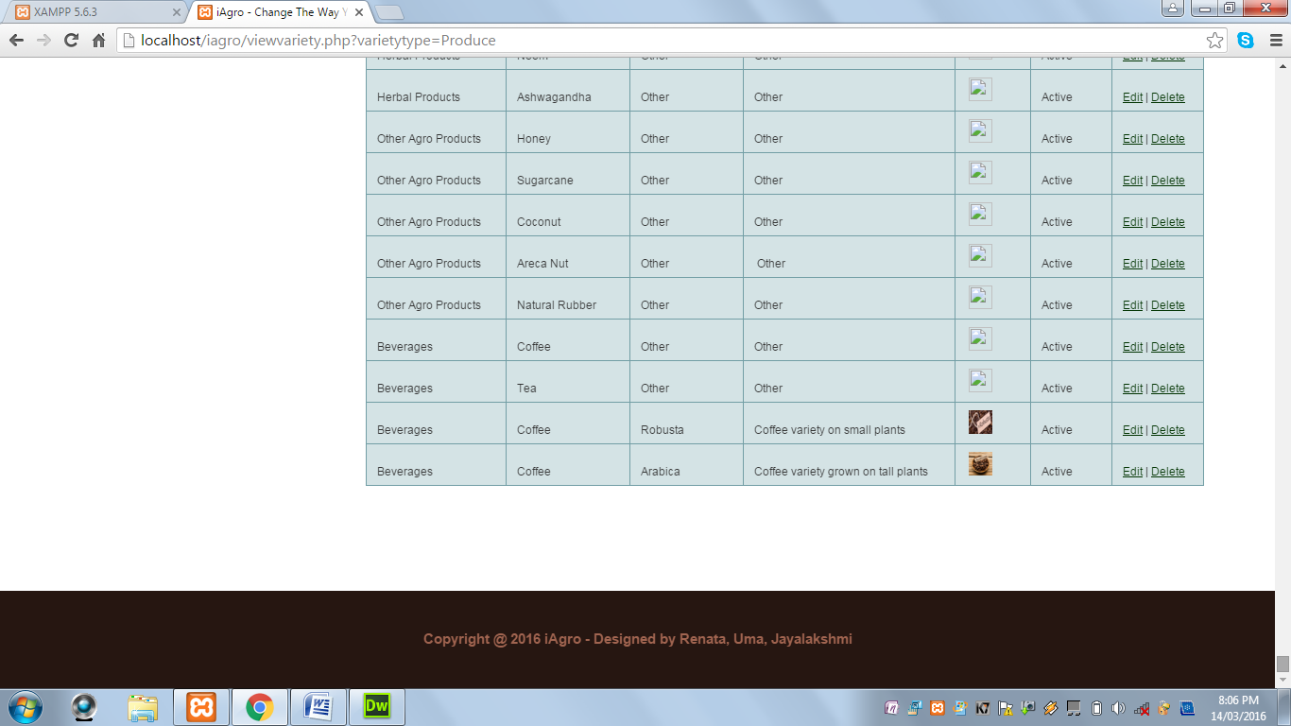

**Add A Farm Produce:** This page displays a form to add farm produce by the admin.

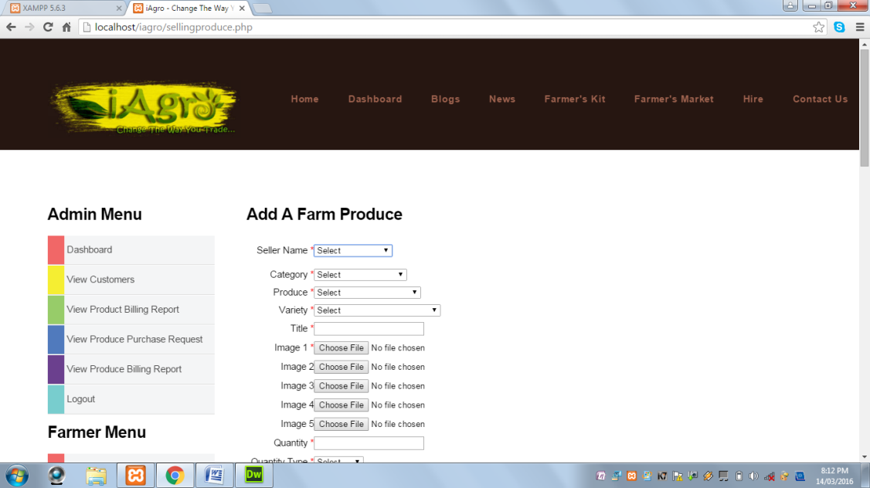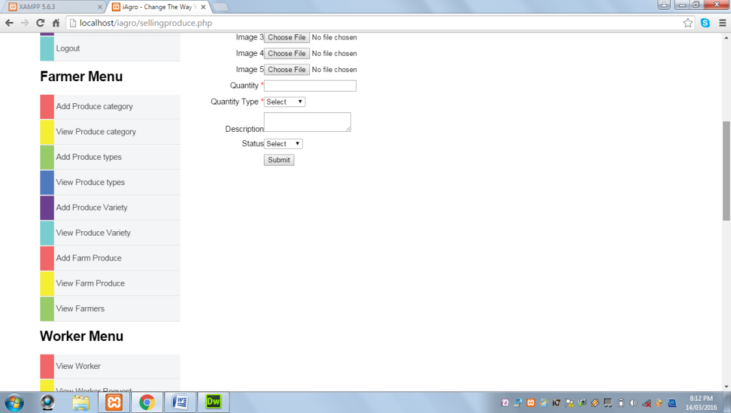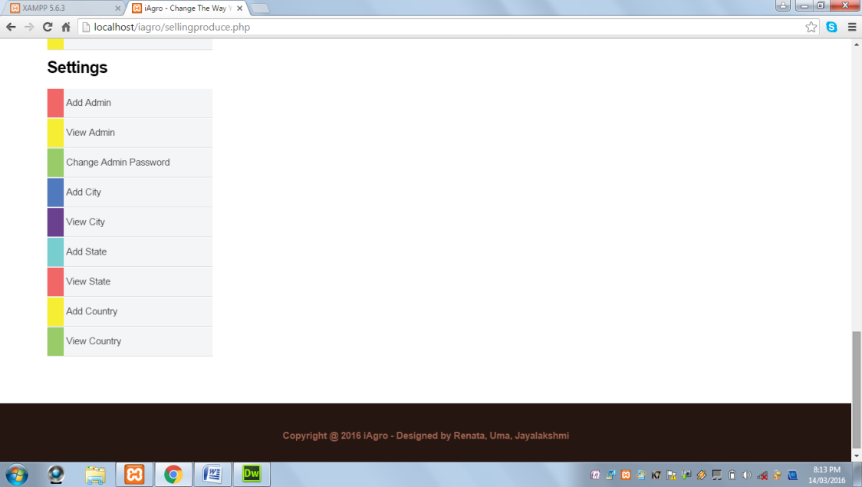

**View Farmers:** This page displays all the registered farmers.

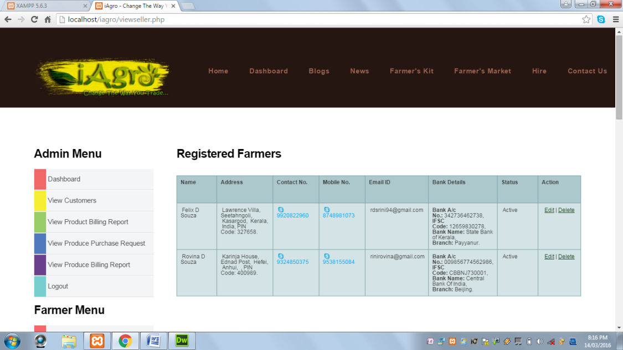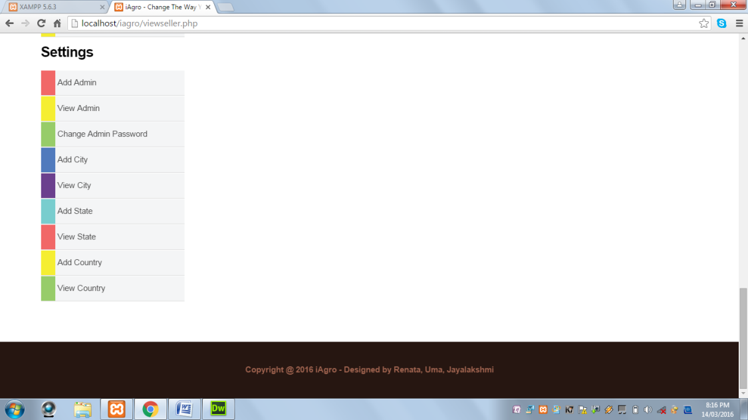

**View Worker:** This page displays all the registered workers.

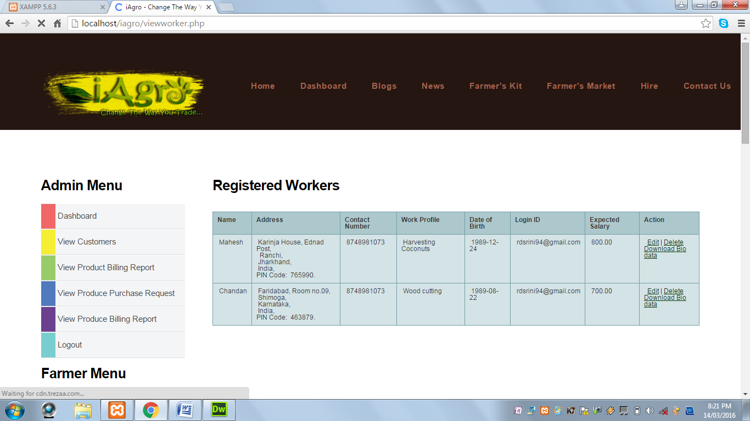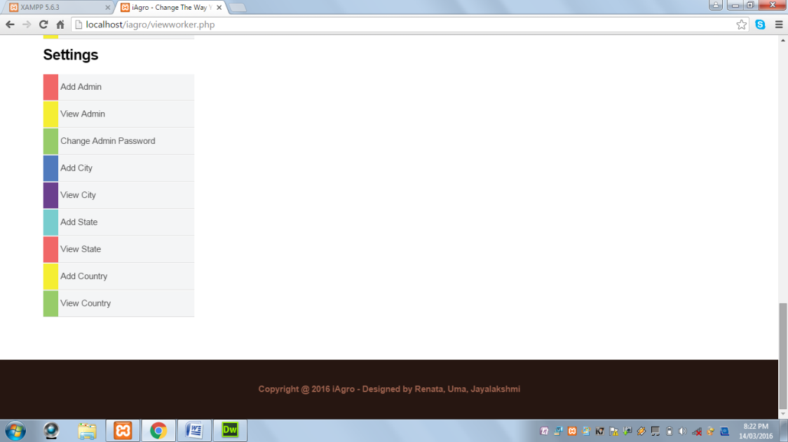

**View Worker Request:** This page displays all the worker requests sent by the farmers.

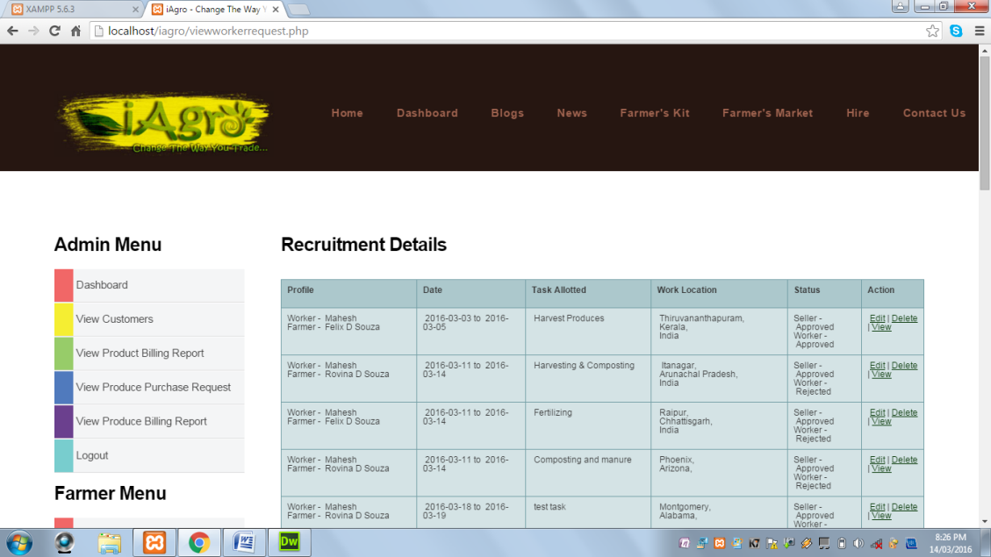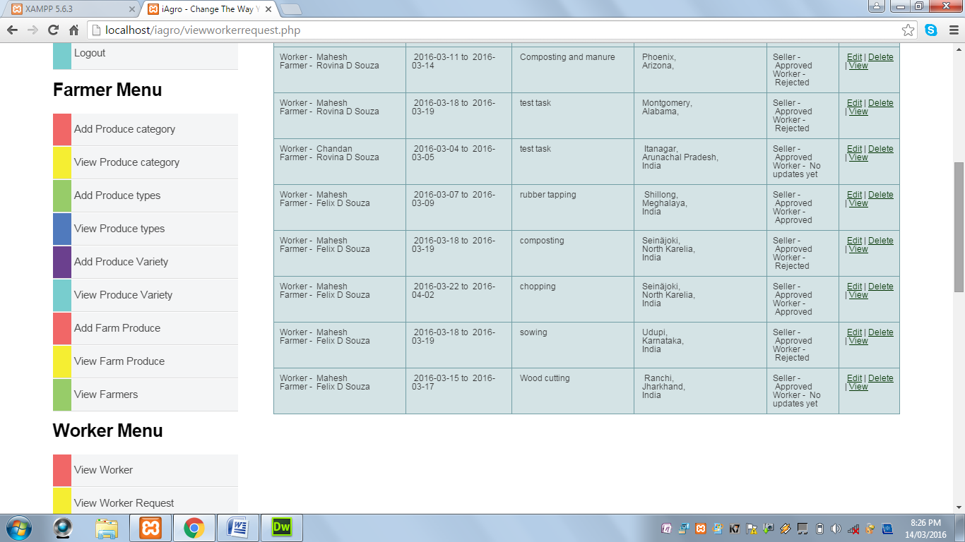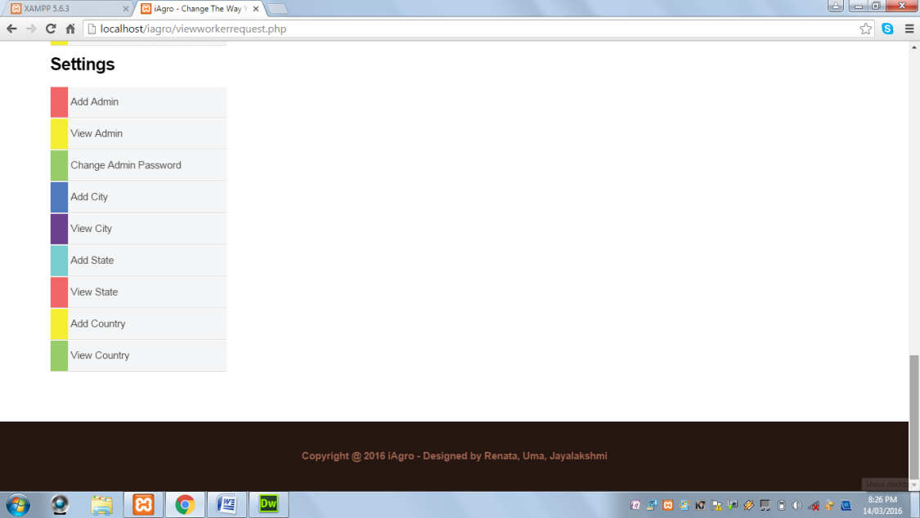

**Add Selling Product Category:** This paged displays a form to add agro product category.

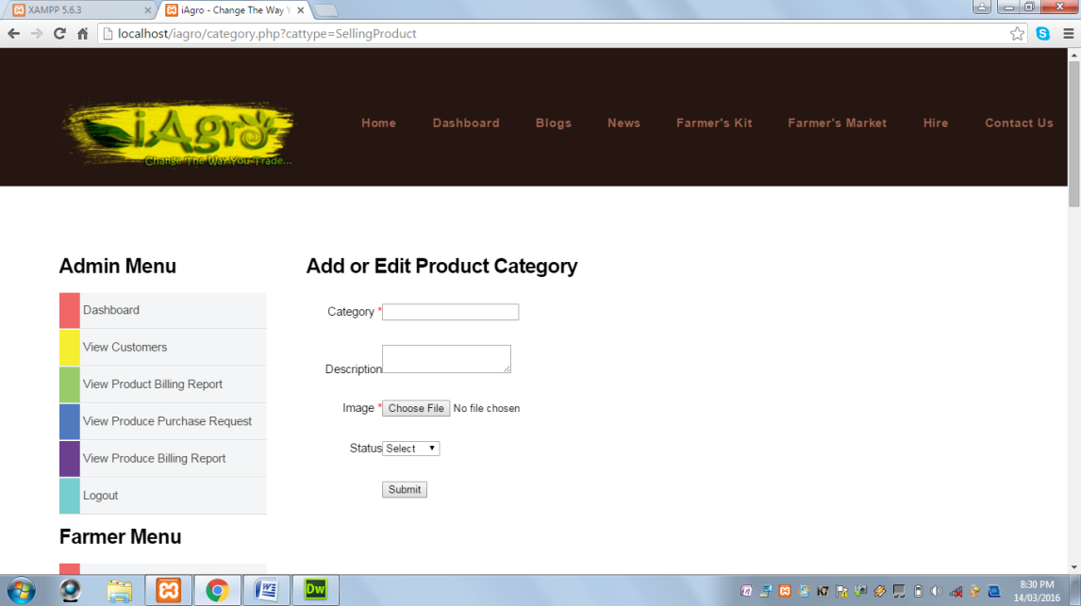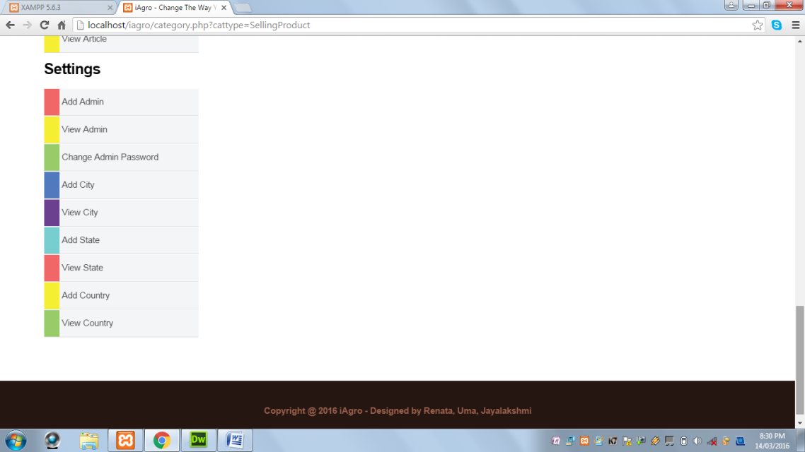

When Submit button is clicked and Category field is blank, the following alert message is displayed:

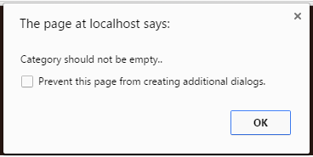

When Submit button is clicked and Category field contains values other alphabets and spaces, the following alert message is displayed:

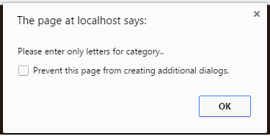

When Submit button is clicked and image field does not contain an image, the following alert message is displayed:



When Submit button is clicked and all the required fields are successfully validated, the following alert message is displayed:

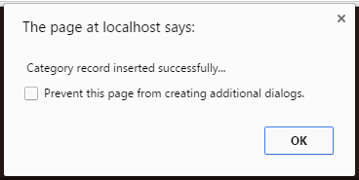

**View Selling Product Category:** This page displays all agro products category.

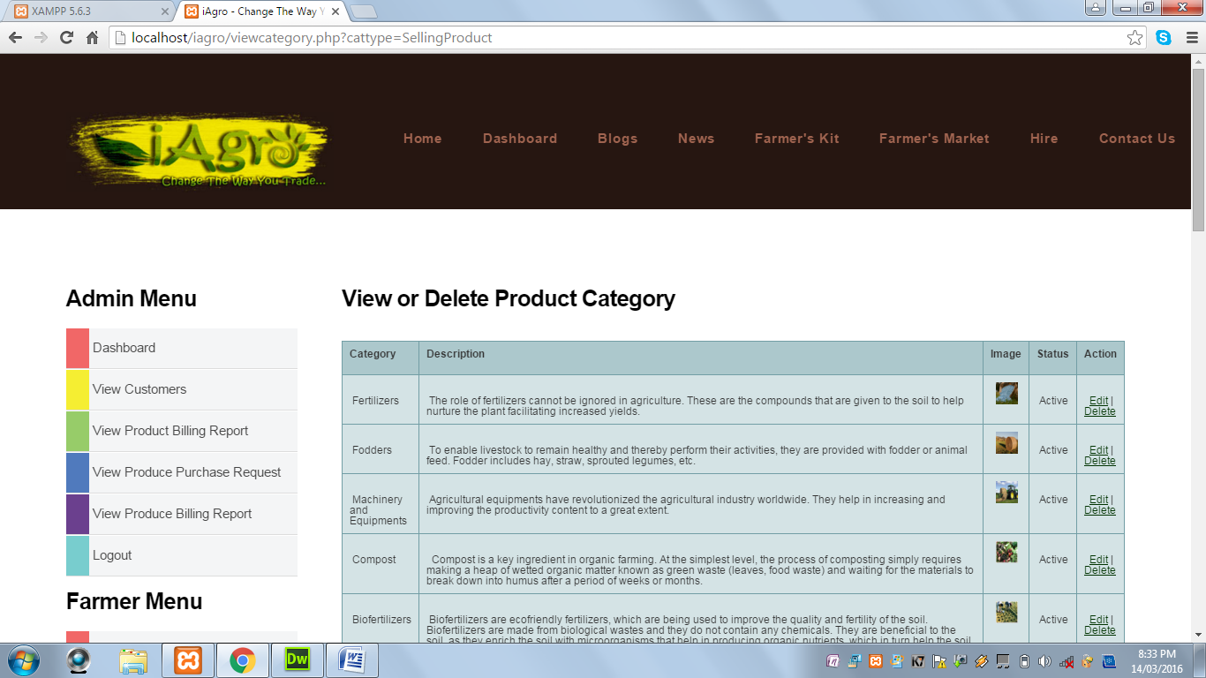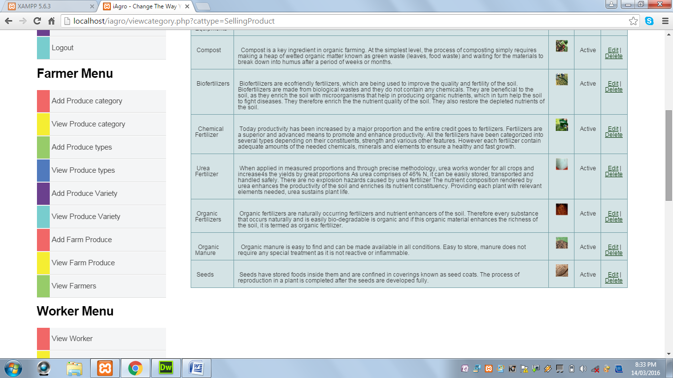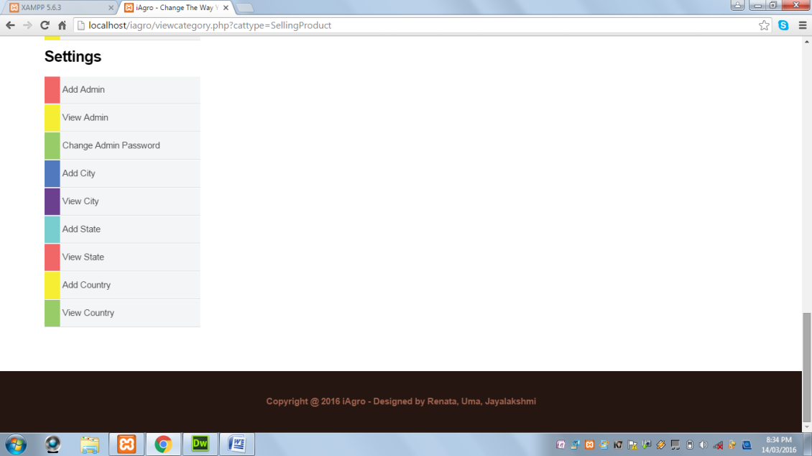

**Add A Selling Product Type:** This page displays a form to add an agro product type.

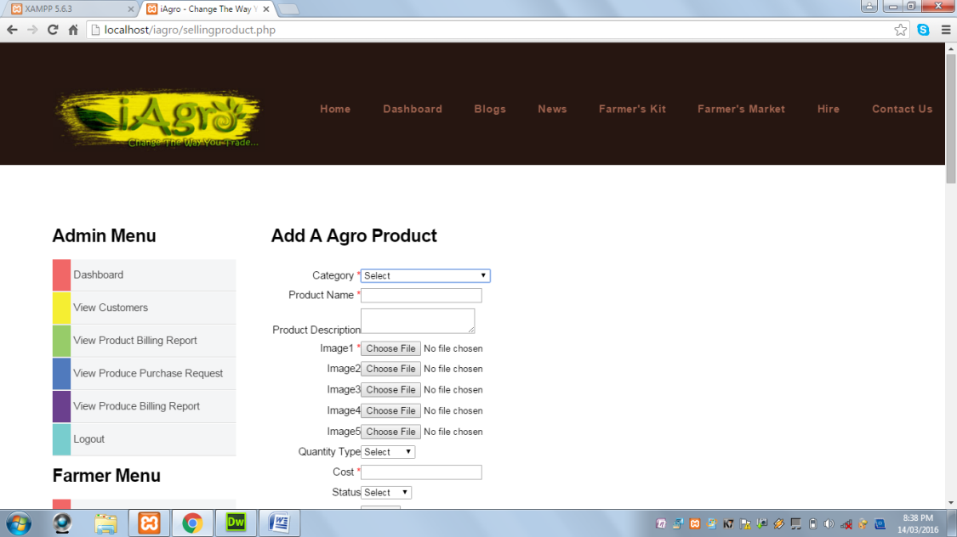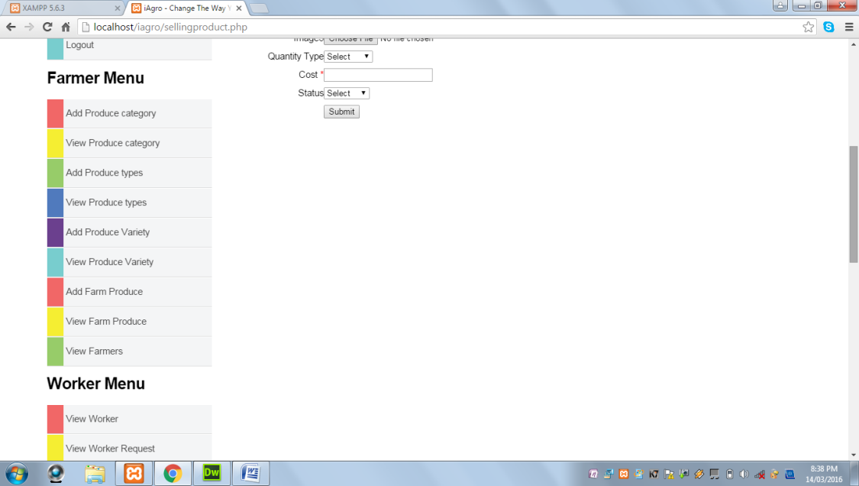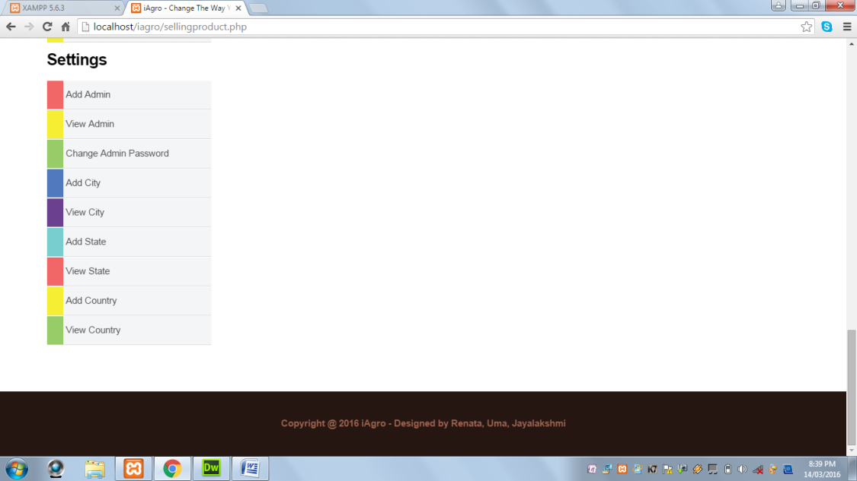

When Submit button is clicked and Category field is not selected, the following alert message is displayed:



When Submit button is clicked and Product field is blank, the following alert message is displayed:

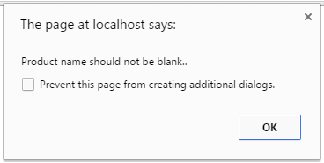

When Submit button is clicked and Product field contains value other than alphabets and spaces, the following alert message is displayed:

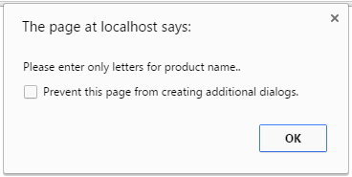

When Submit button is clicked and Image field does not contain any uploaded image, the following alert message is displayed:

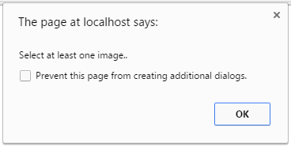

When Submit button is clicked and Cost field is blank, the following alert message is displayed:

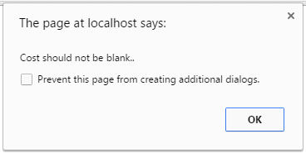

When Submit button is clicked and Cost field contains value other than numeric values, the following alert message is displayed:



When Submit button is clicked and all the required fields are successfully validated, the following alert message is displayed:

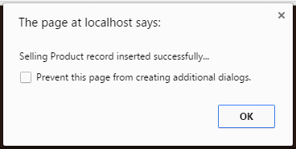

**View Selling Product Type:** This page displays all the agro products types.

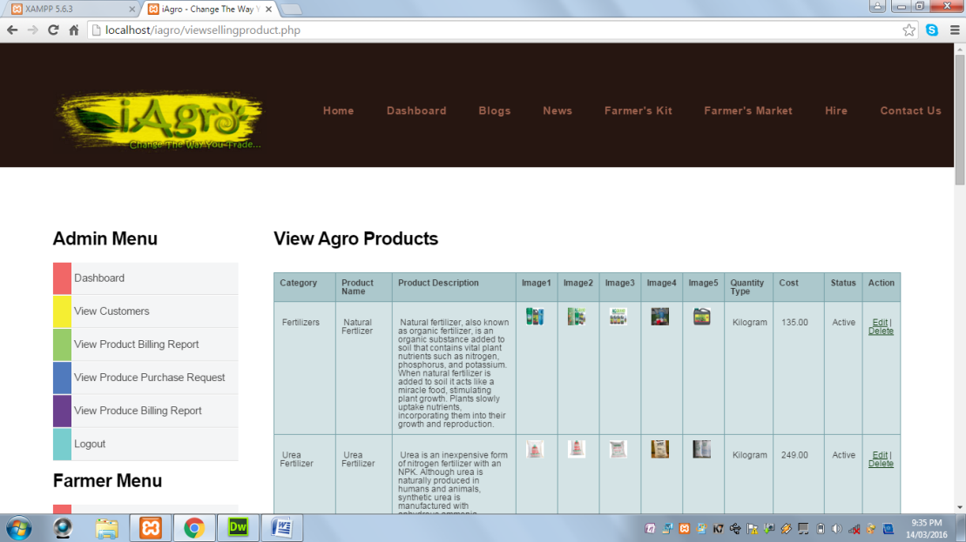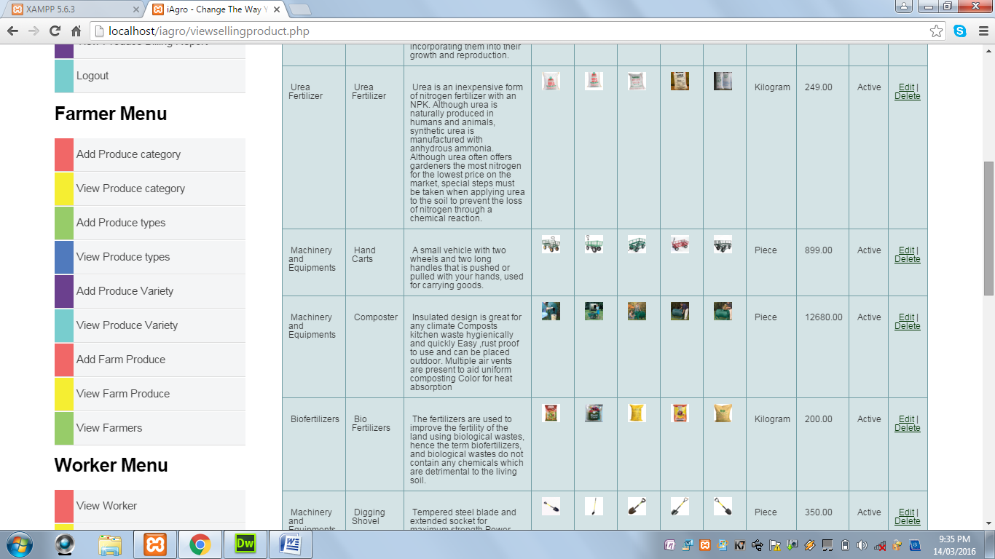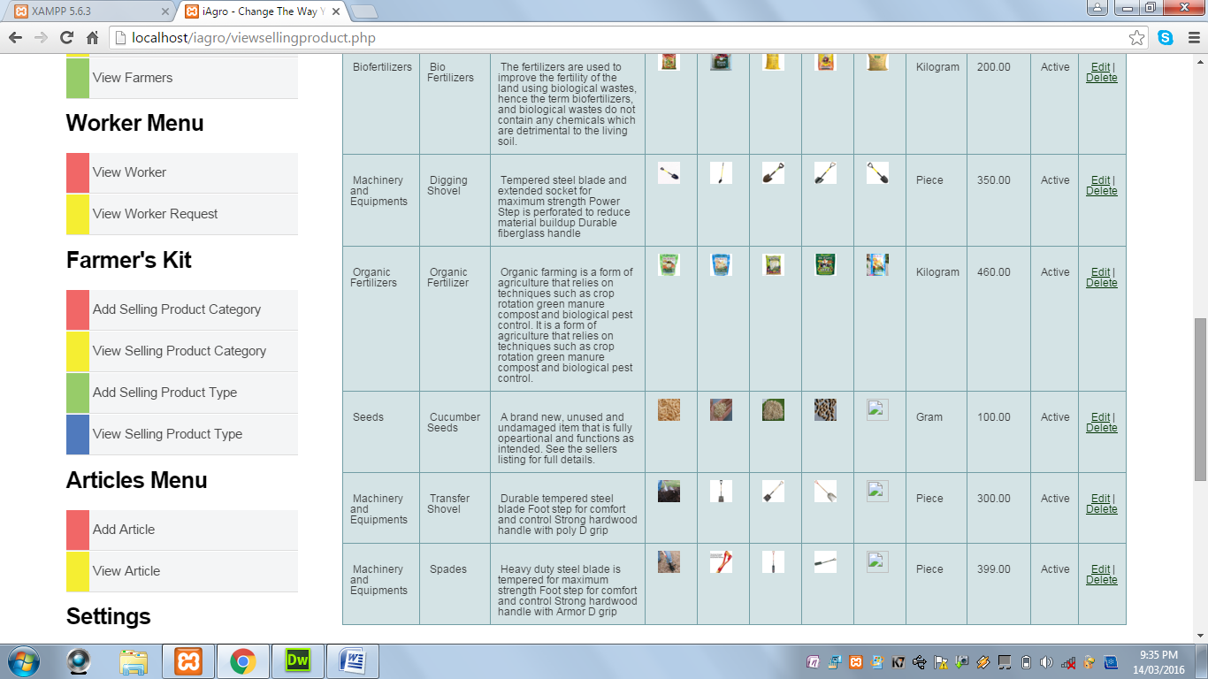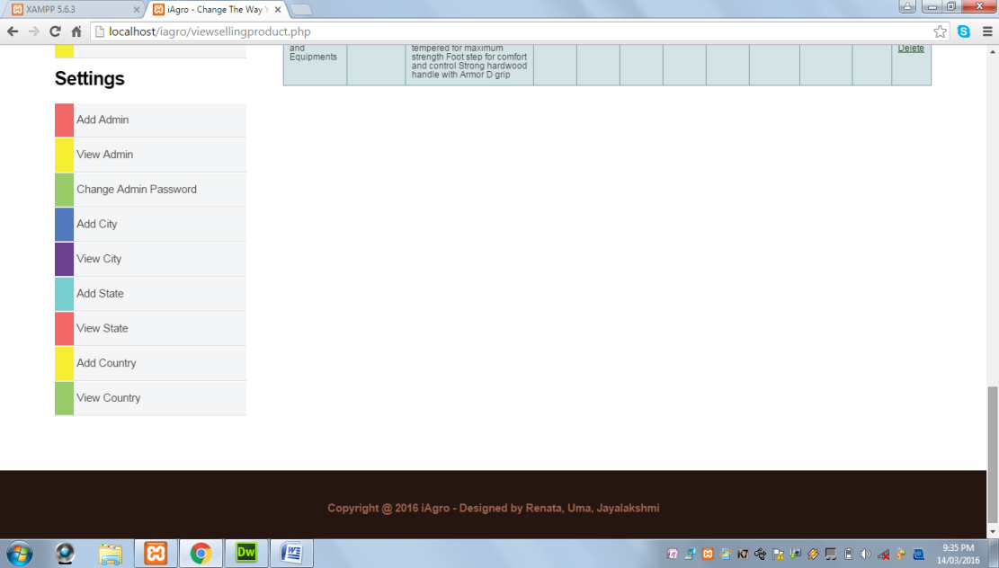

**Add Article:** This page displays a form to add an article.

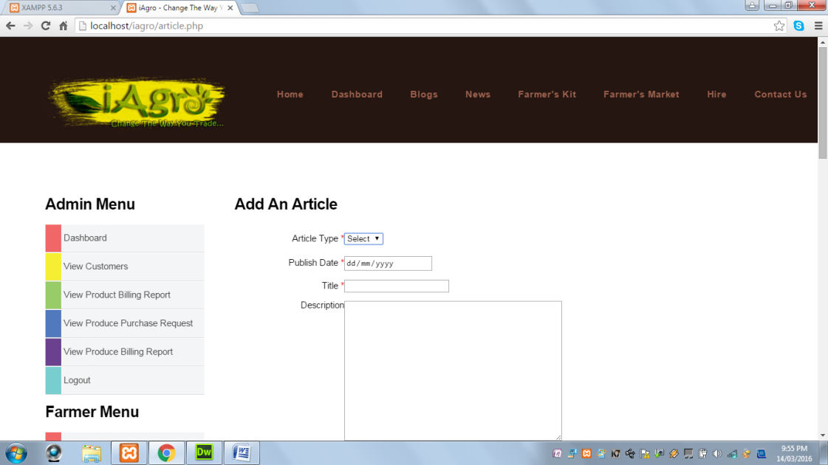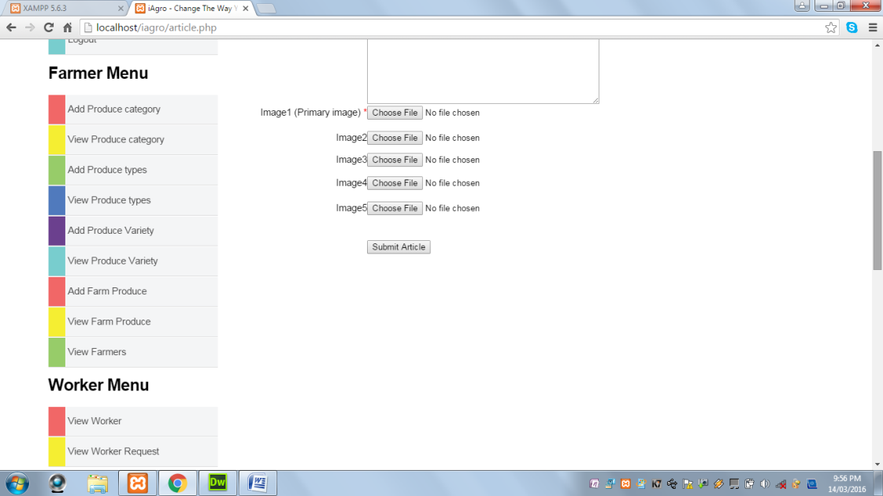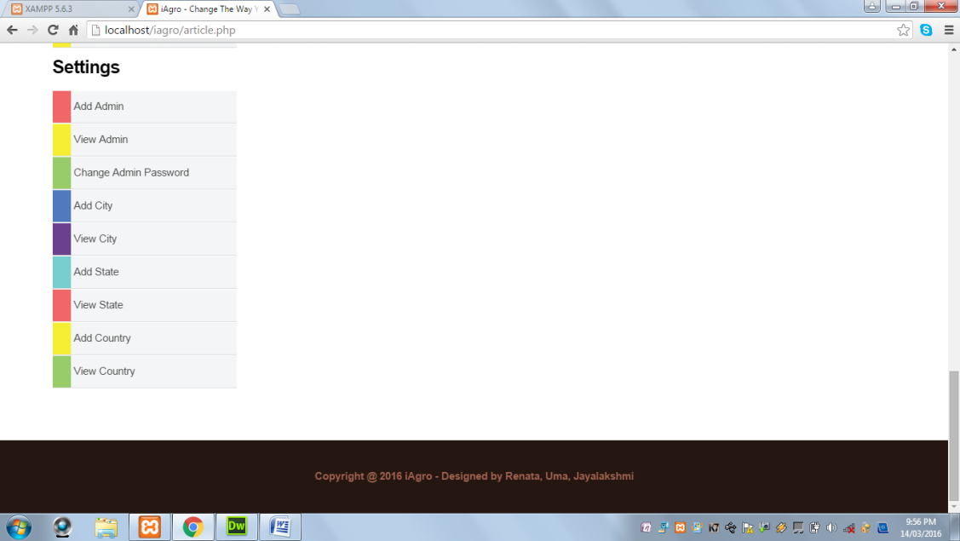

When Submit button is clicked and Article type is not selected, the following alert message is displayed:

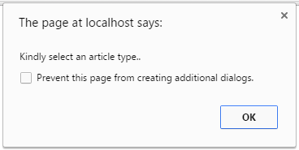

When Submit button is clicked and Publish Date is not selected, the following alert message is displayed:



When Submit button is clicked and Title field is blank, the following alert message is displayed:

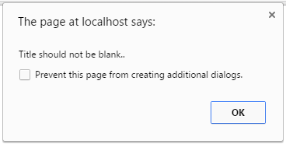

When Submit button is clicked and at least one image is not uploaded, the following alert message is displayed:

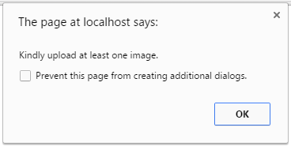

When Submit button is clicked and all the fields are successfully validated, the following alert message is displayed:

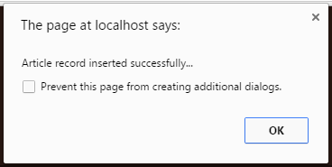

**View Article:** This page displays all the articles.

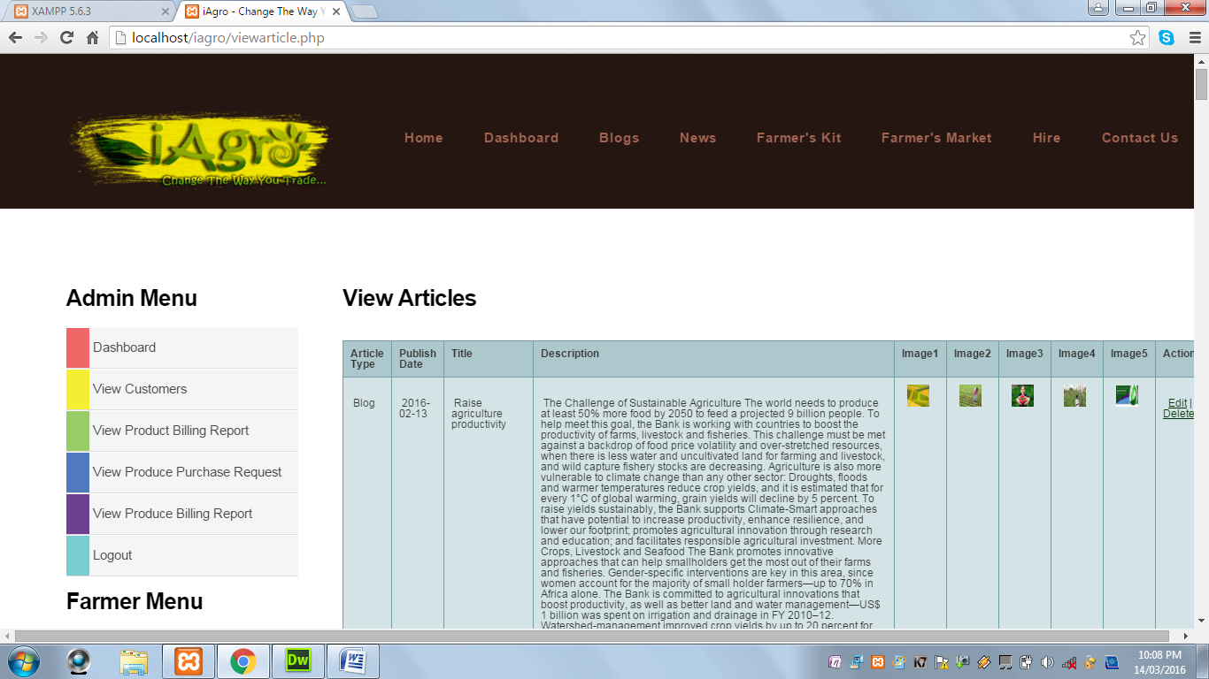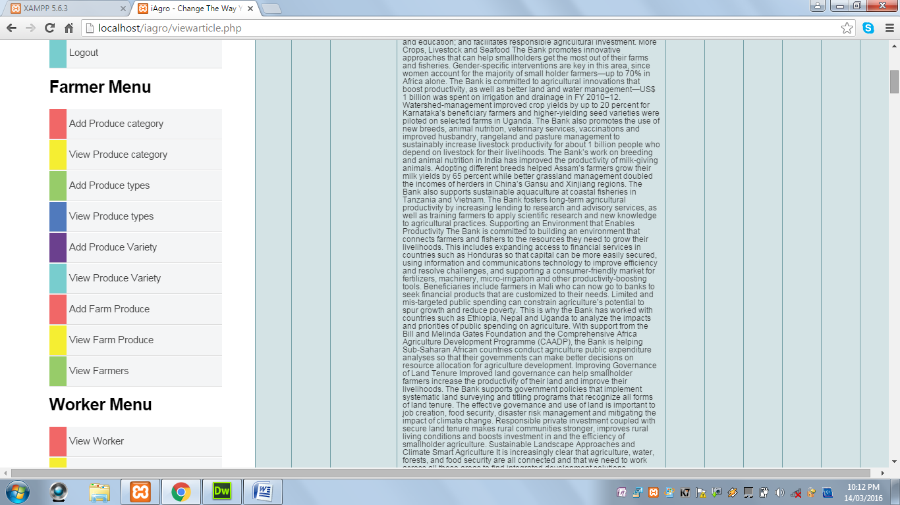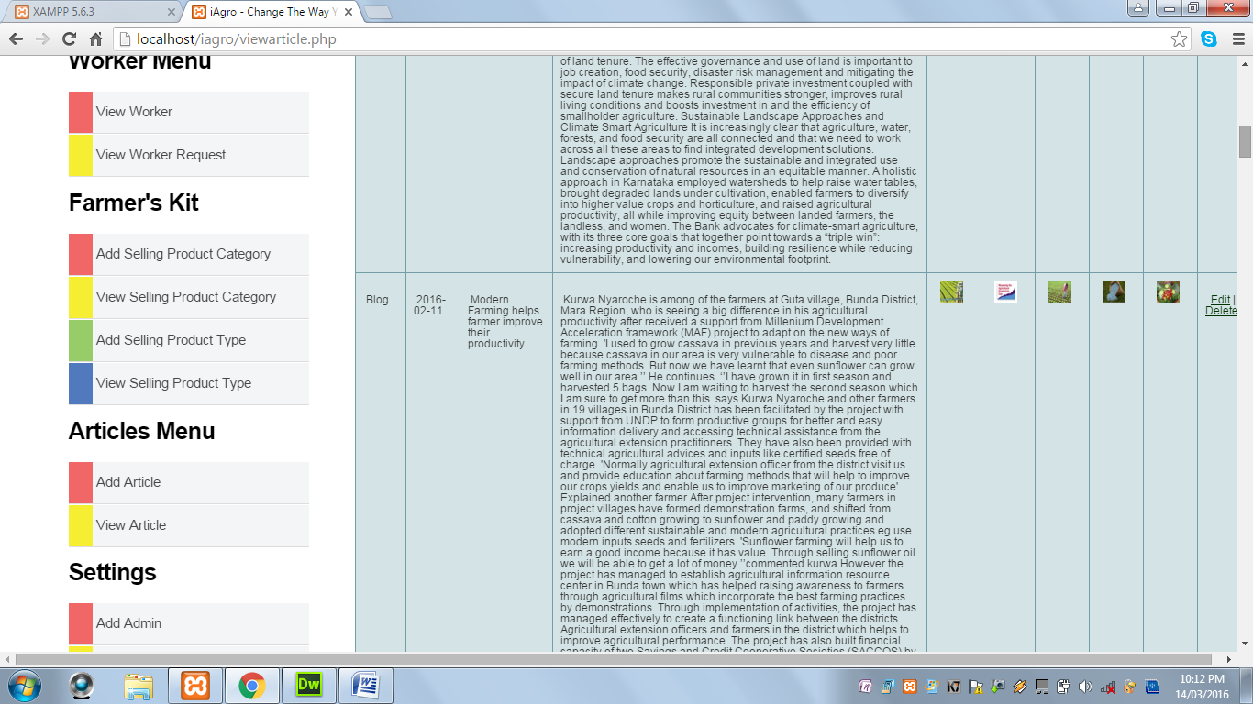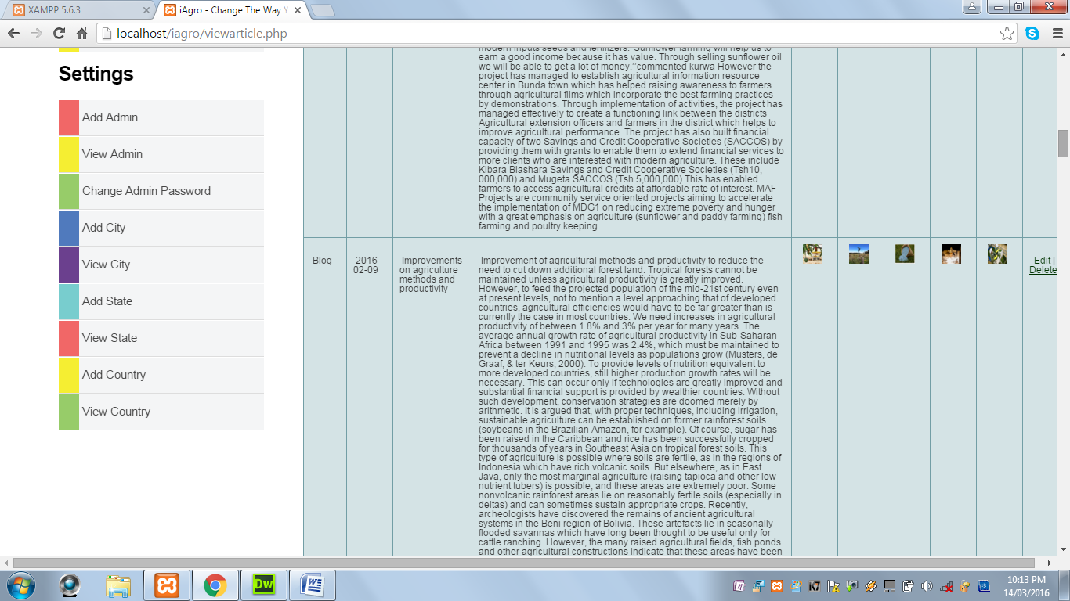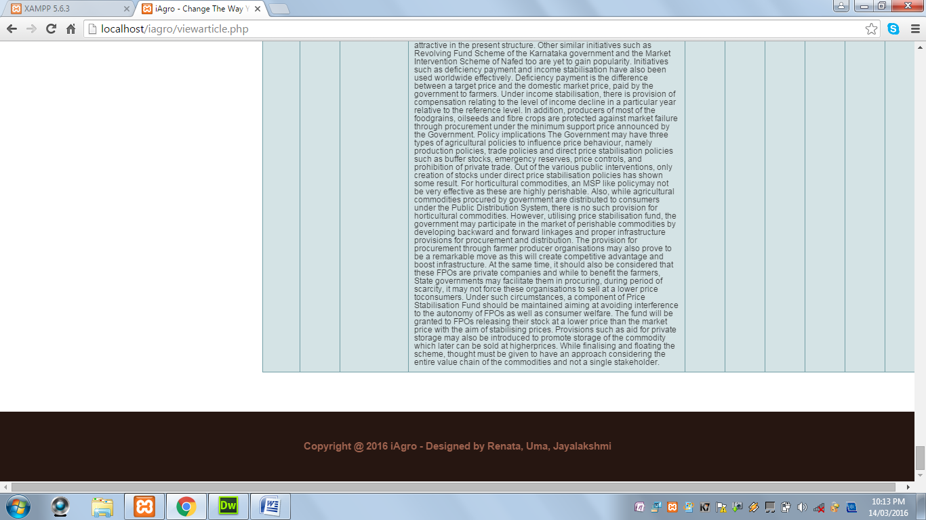

**Add Admin:** This page displays a form to add a new admin by the existing admin.

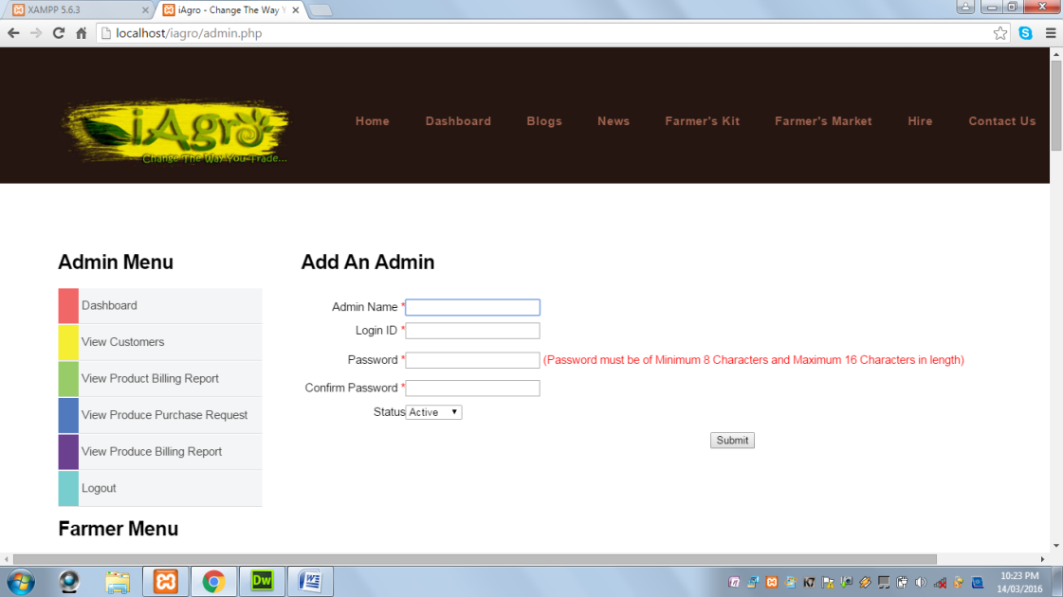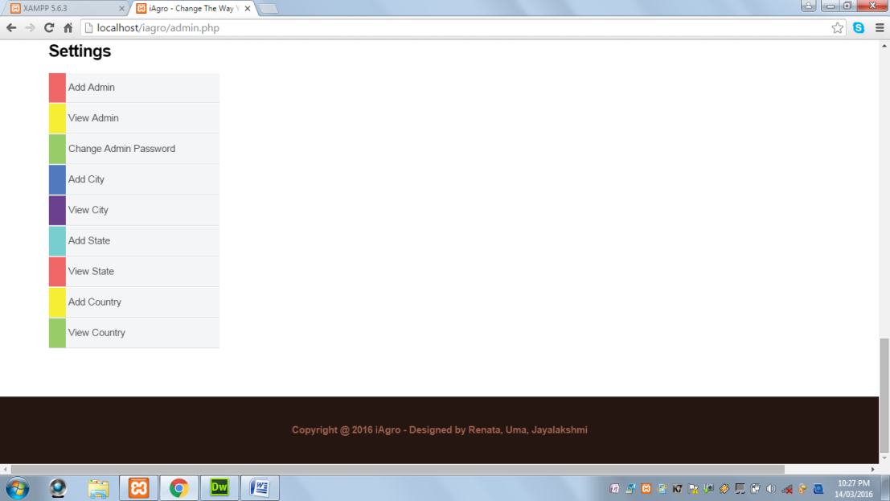

**View Admin:** This page displays all the admin.

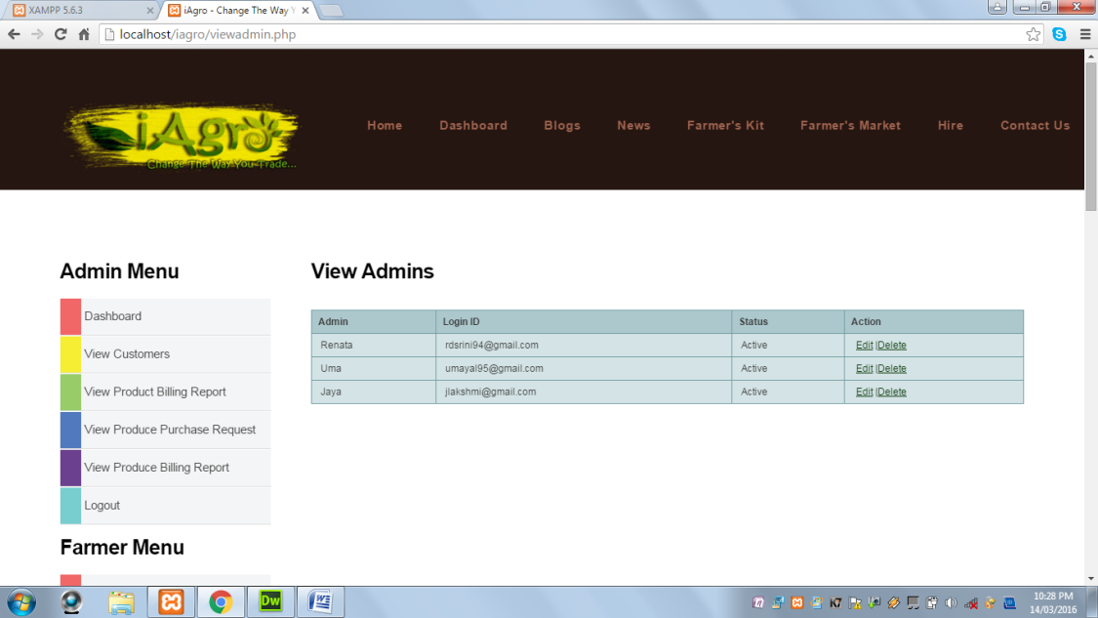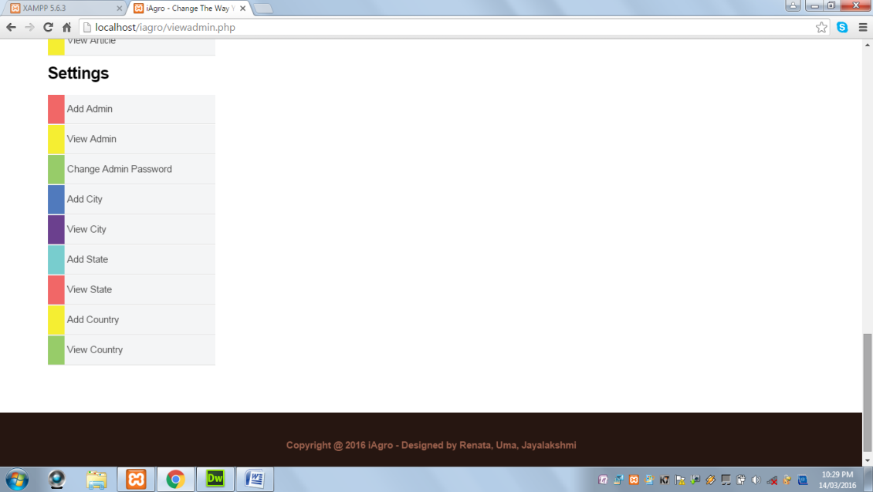

When Submit button is clicked and Admin Name field is blank, the following alert message is displayed:

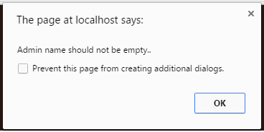

When Submit button is clicked and Admin Name contains values other than alphabets and spaces, the following alert message is displayed:

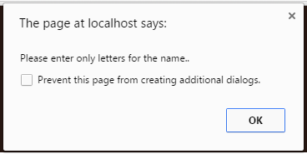

When Submit button is clicked and Login ID field is blank, the following alert message is displayed:

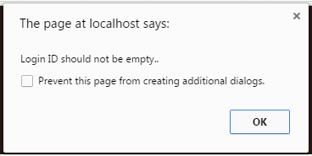

When Submit button is clicked and Login ID contains an invalid Login ID, the following alert message is displayed:

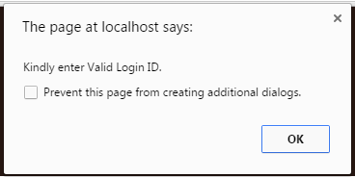

When Submit button is clicked and Password field is blank, the following alert message is displayed:



When Submit button is clicked and Password length is less than 8 characters, the following alert message is displayed:



When Submit button is clicked and Password length is greater than 16 characters, the following alert message is displayed:



When Submit button is clicked and Password and Confirm Password field does not match, the following alert message is displayed:



When Submit button is clicked and all the required fields are successfully validated, the following alert message is displayed:

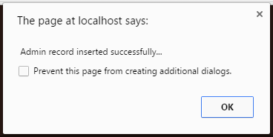

**Change Admin Password:** This page displays a form to reset the password.

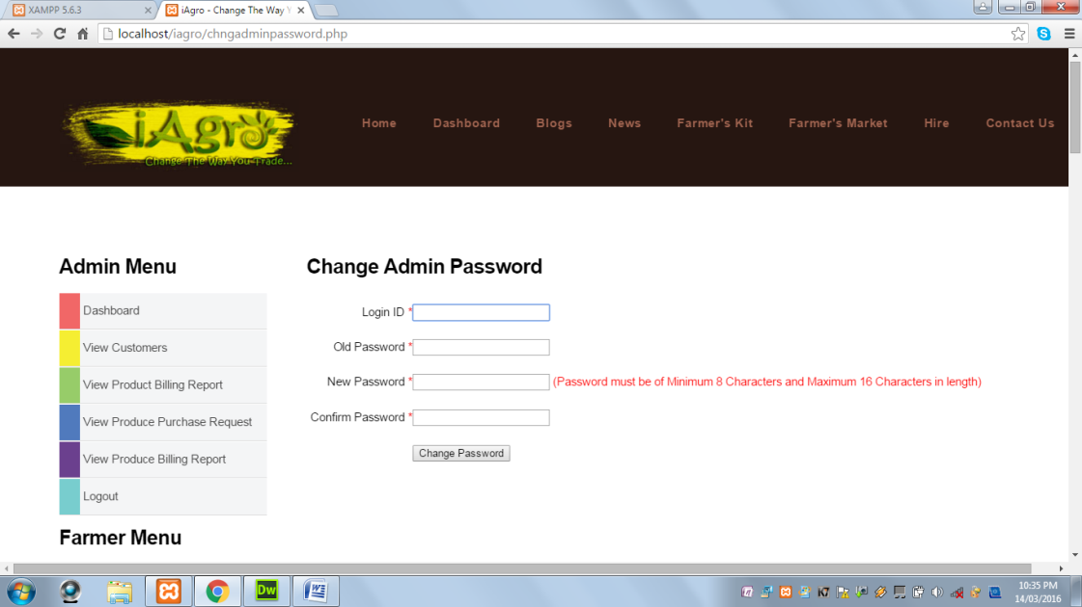 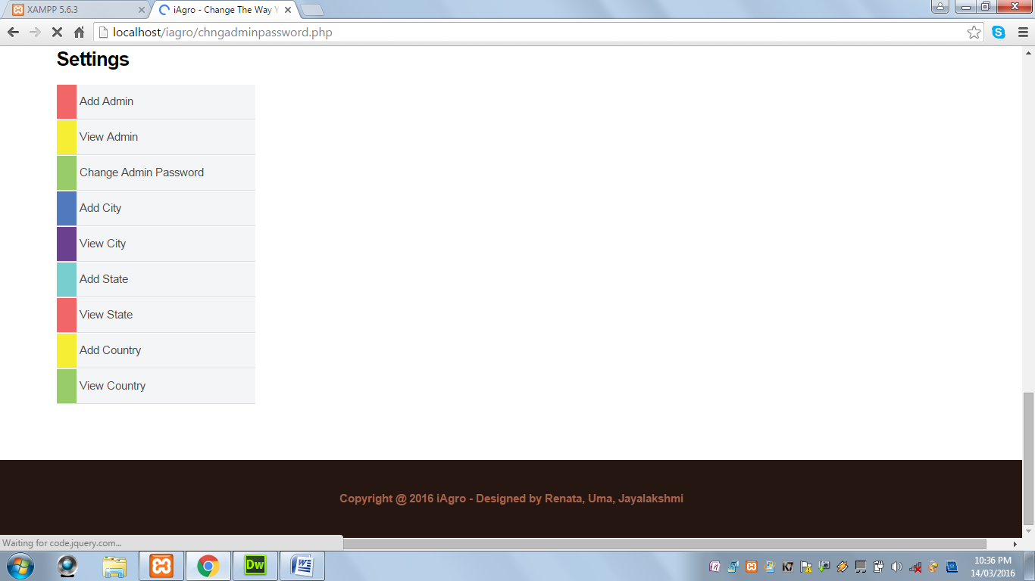

**Add City:** This page displays a form to add city.

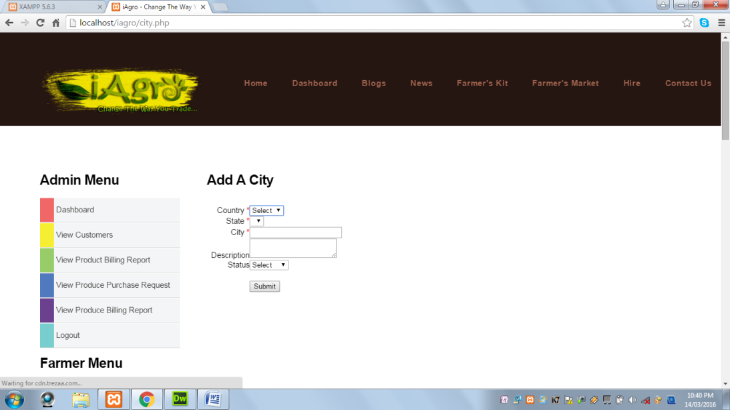 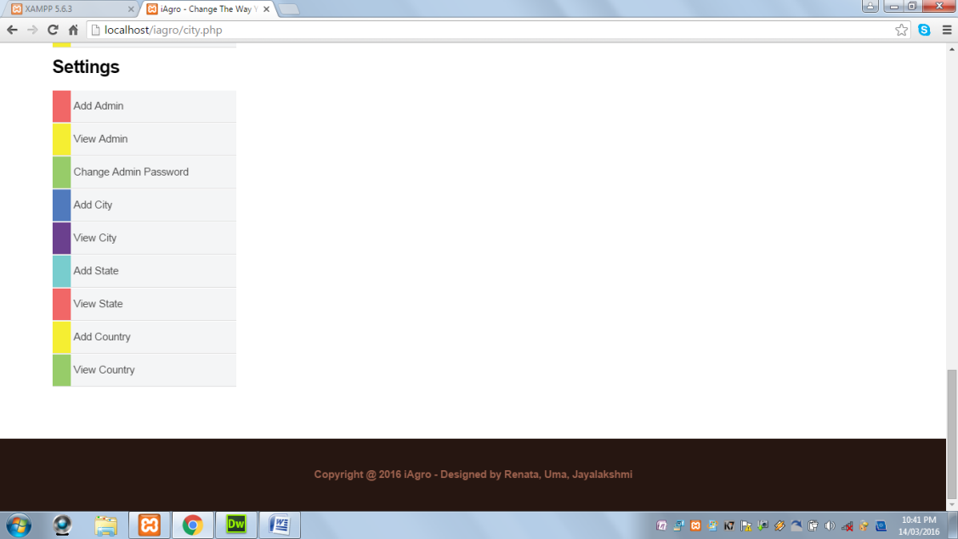

When Submit button is clicked and Country field is not selected, the following alert message is displayed:

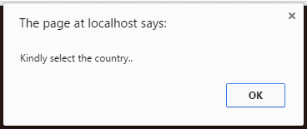

When Submit button is clicked and State field is not selected, the following alert message is displayed:

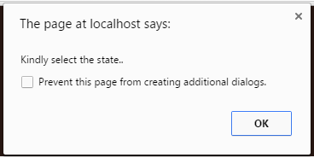

When Submit button is clicked and City field is blank, the following alert message is displayed:

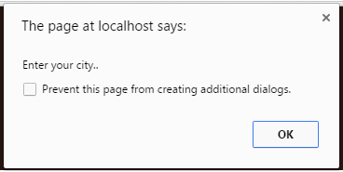

When Submit button is clicked and City field contains values other than alphabets and spaces, the following alert message is displayed:

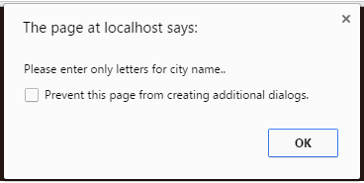

When Submit button is clicked and all the required fields are successfully validated, the following alert message is displayed:

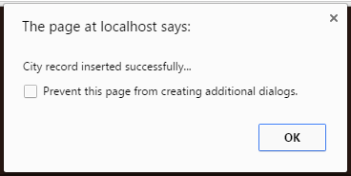

**View City:** This page displays all cities.

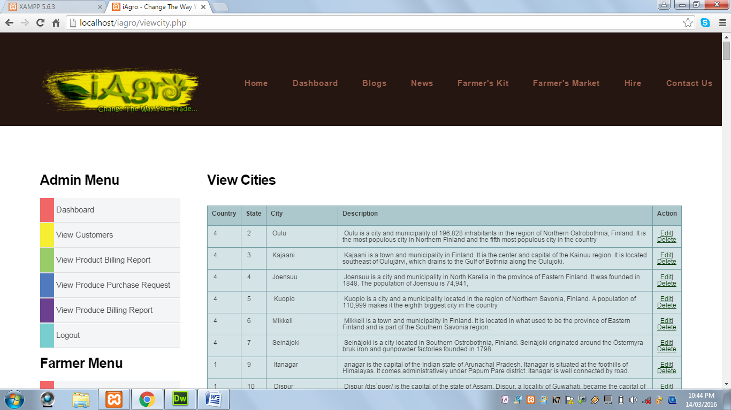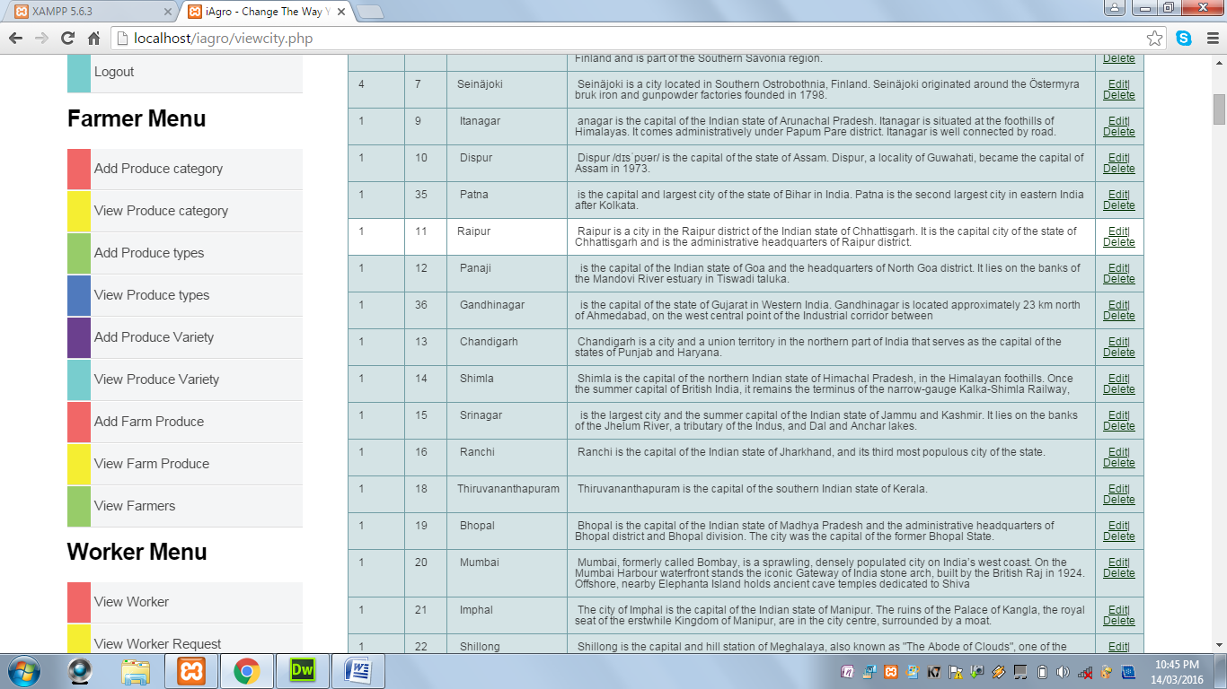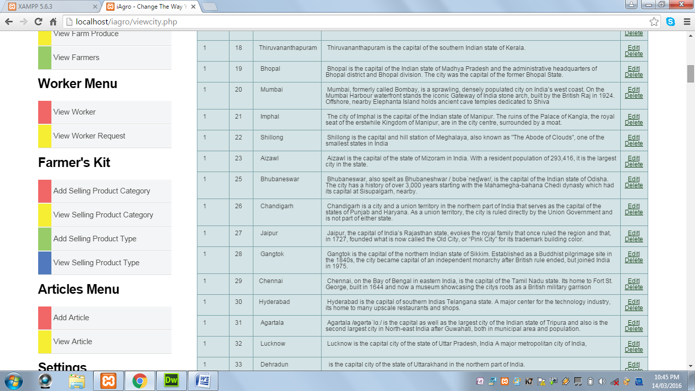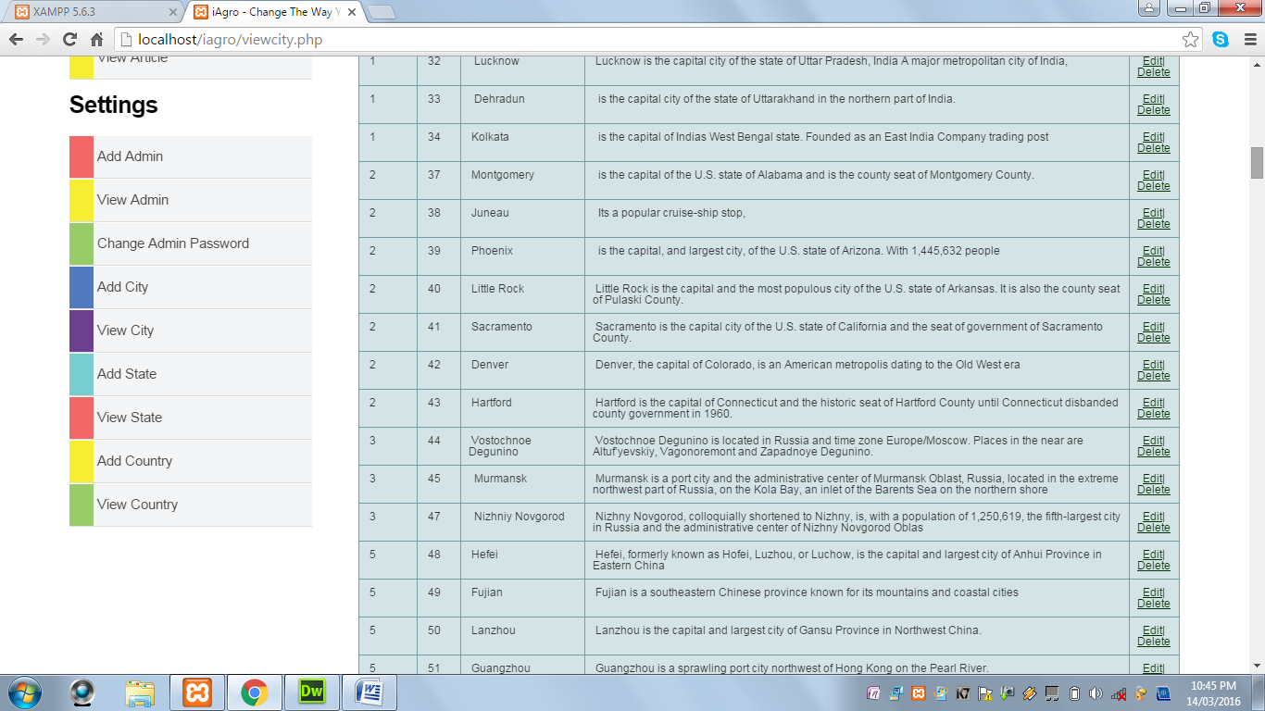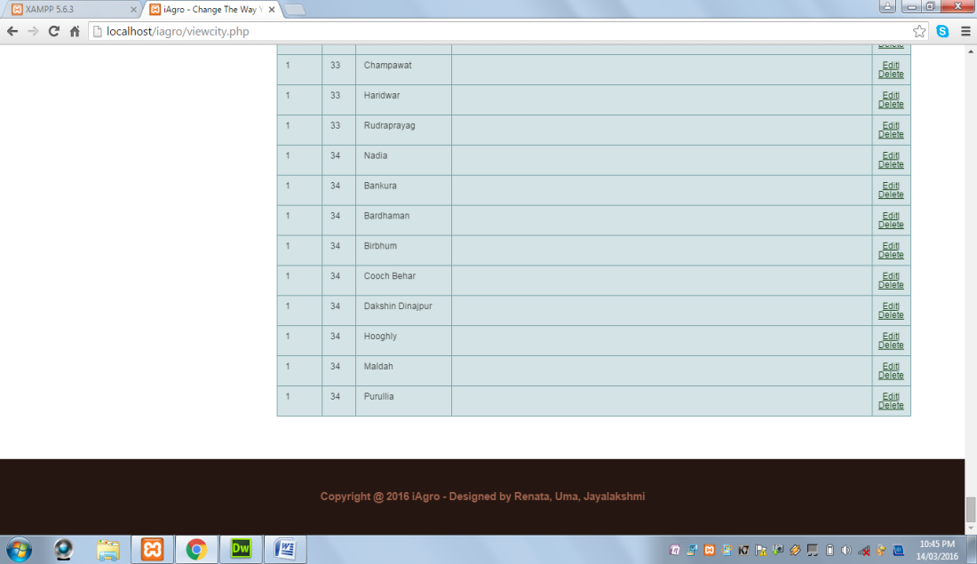

**Add State:** This page displays a form to add states.

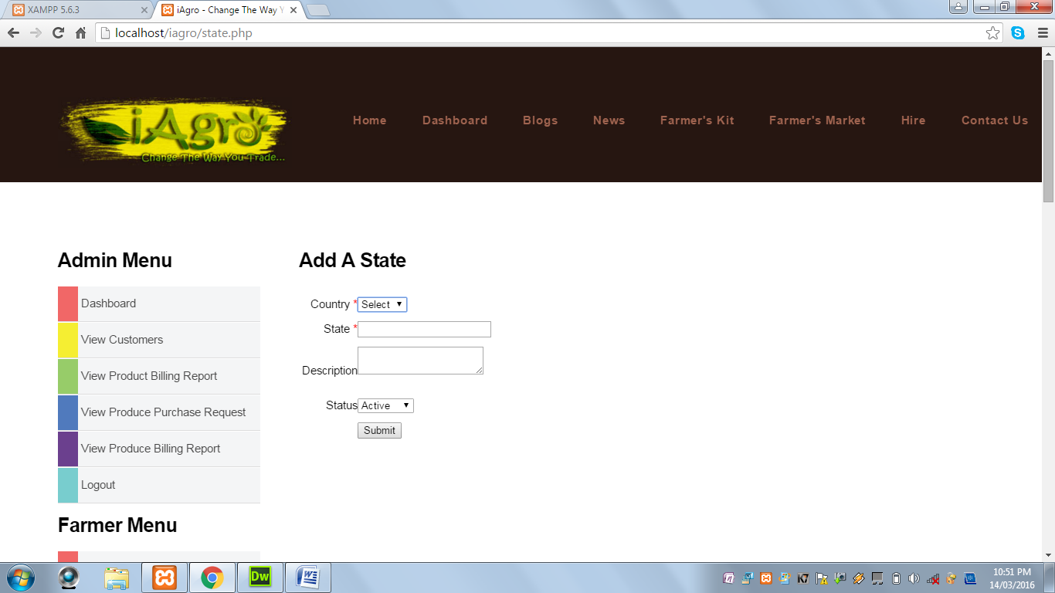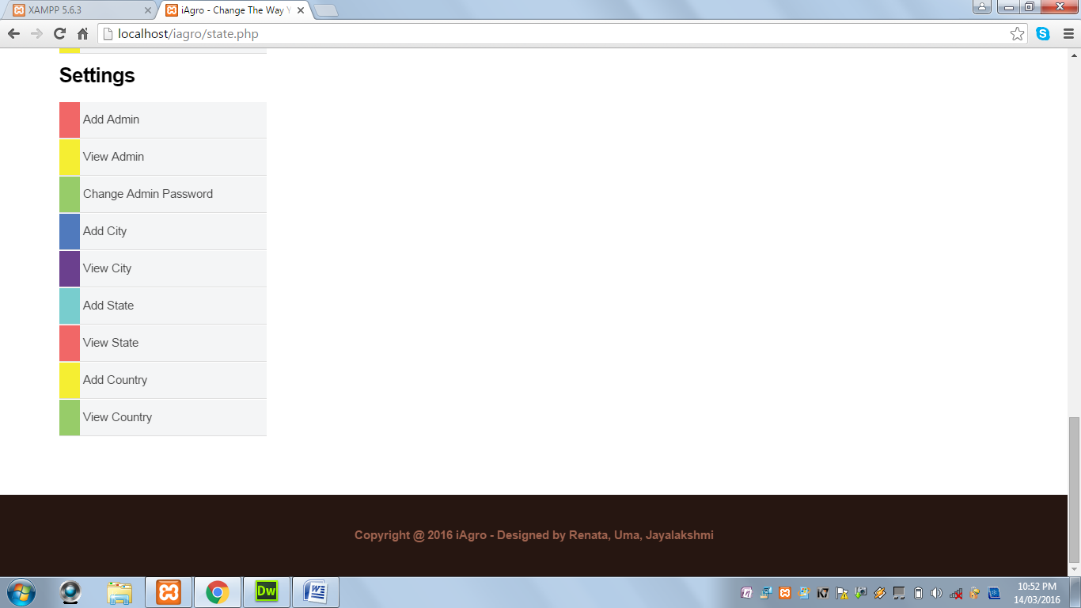

When Submit button is clicked and Country field is not selected, the following alert message is displayed:

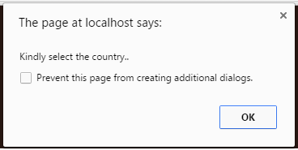

When Submit button is clicked and State field is not selected, the following alert message is displayed:



When Submit button is clicked and State field contains values other than alphabets and spaces, the following alert message is displayed:

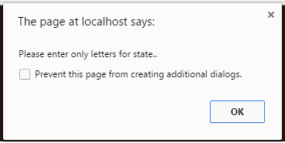

When Submit button is clicked and all the required fields are successfully, the following alert message is displayed:

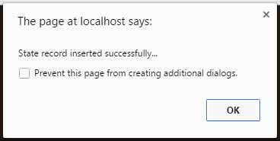

**View State:** This page displays all states.

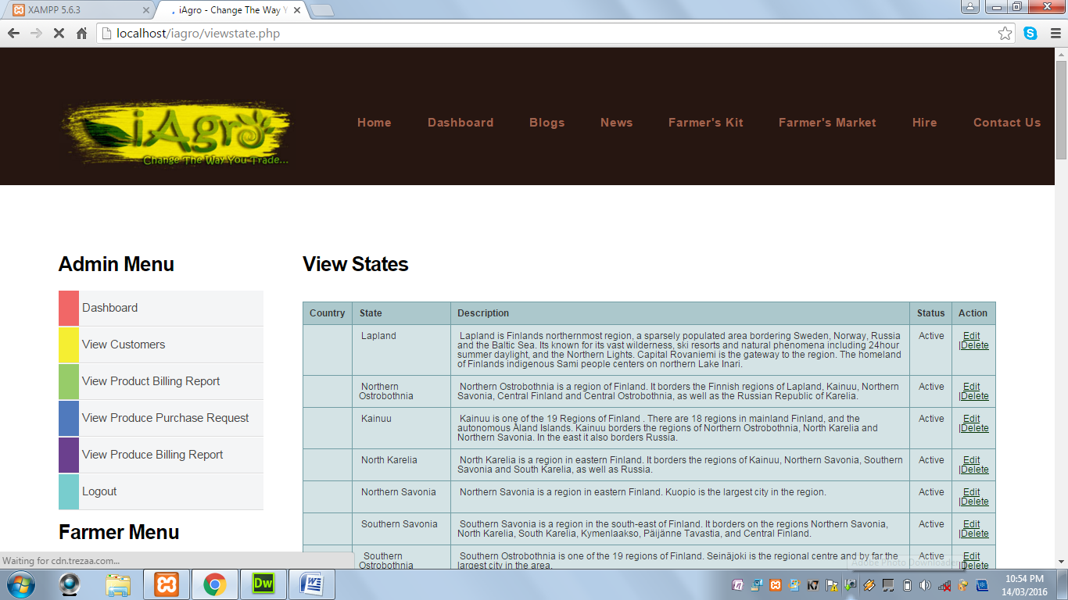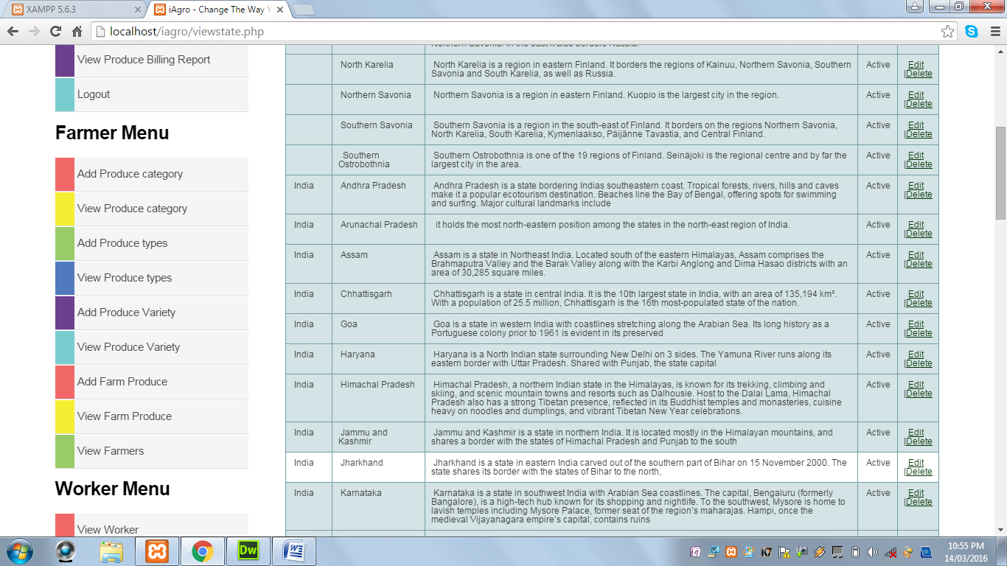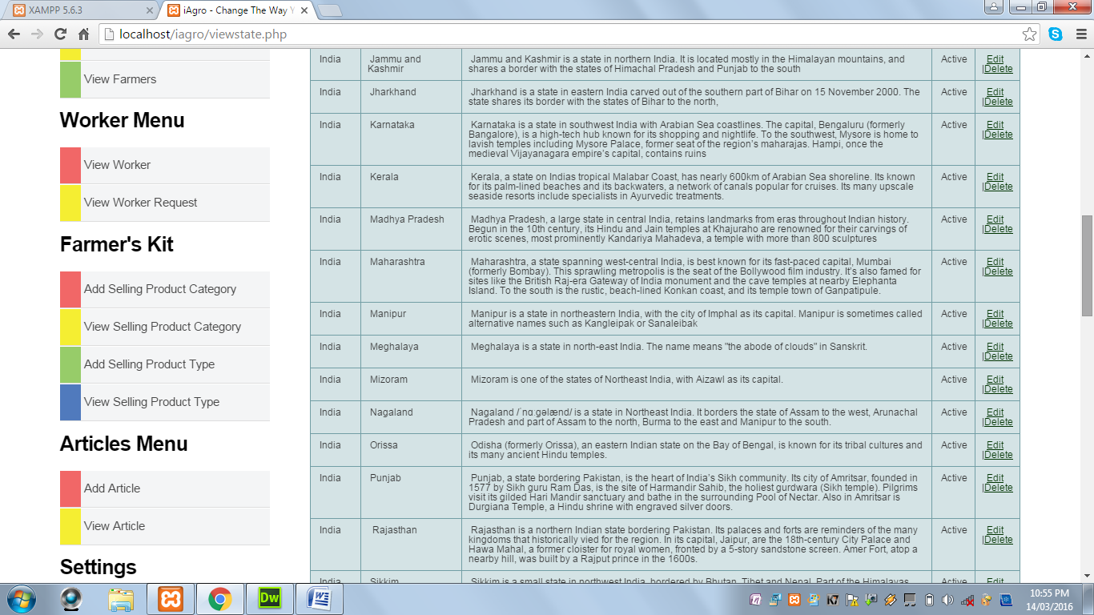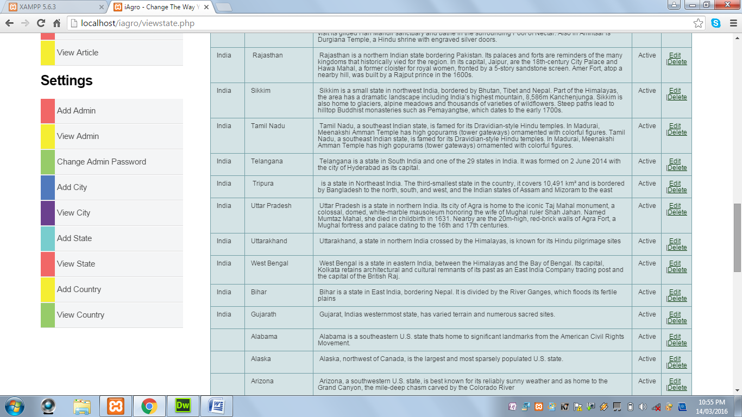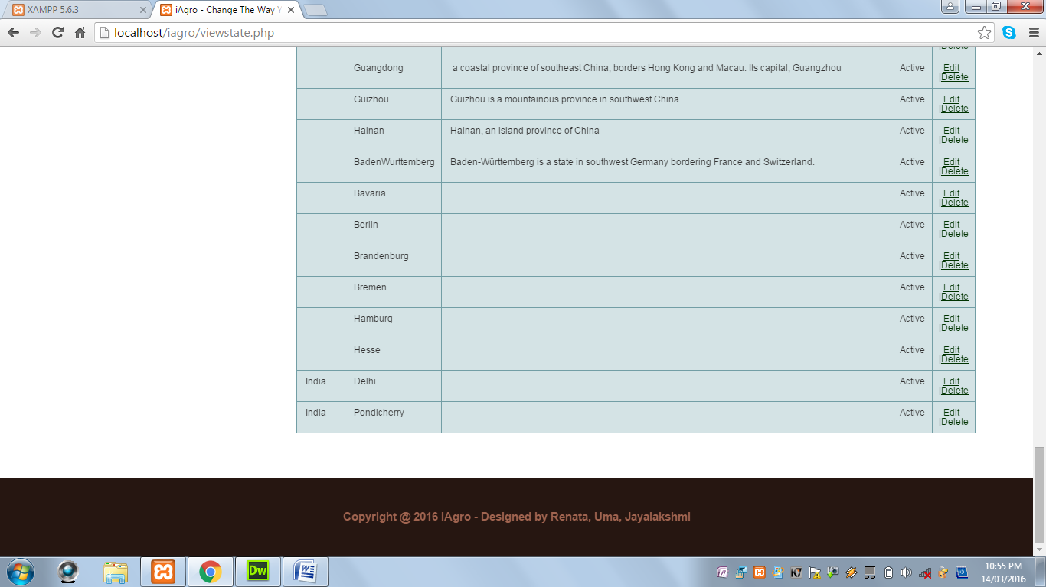

**Add Country:** This page displays a form to add country.

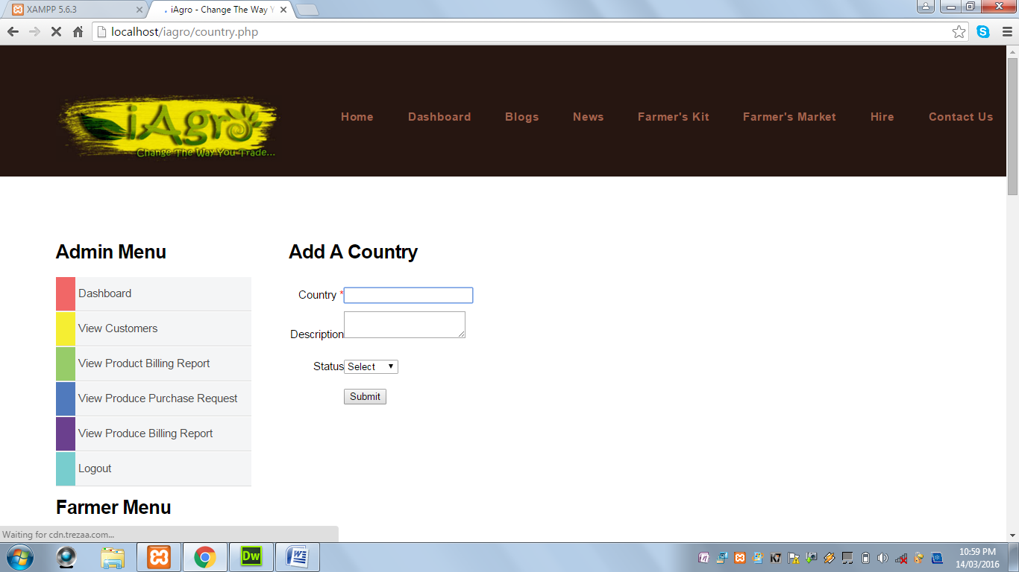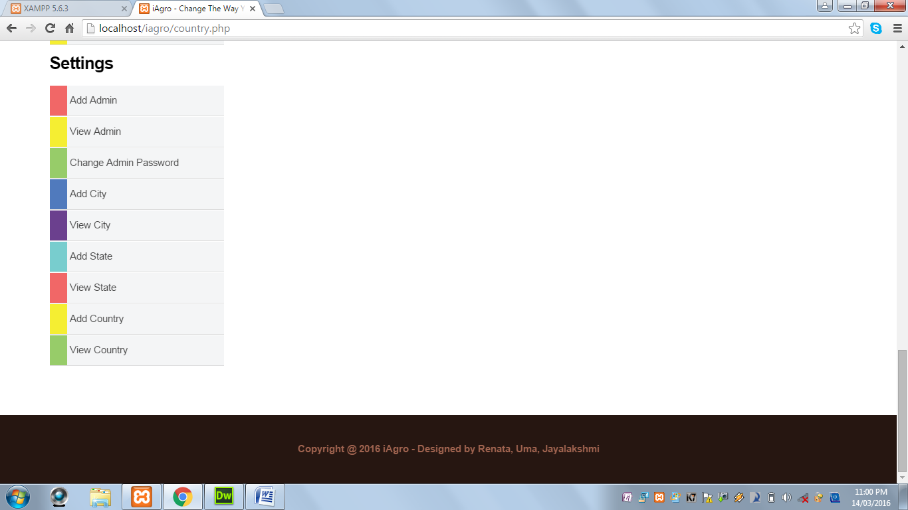

When Submit button is clicked and Country field is blank, the following alert message is displayed:

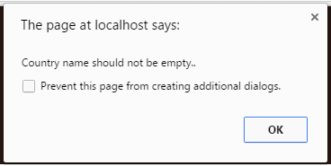

When Submit button is clicked and Country field contains values other than alphabets and spaces, the following alert message is displayed:

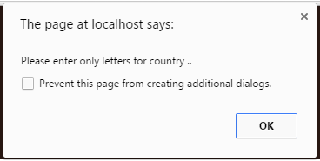

When Submit button is clicked and the required field is successfully validated, the following alert message is displayed:

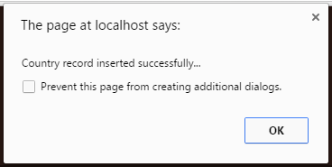

**View Country:** This page displays all countries.

